Development of Environmental Measures for Assessing Effects of Water Level Changes on Lakes and Wetlands in the Central Florida Water Initiative Area

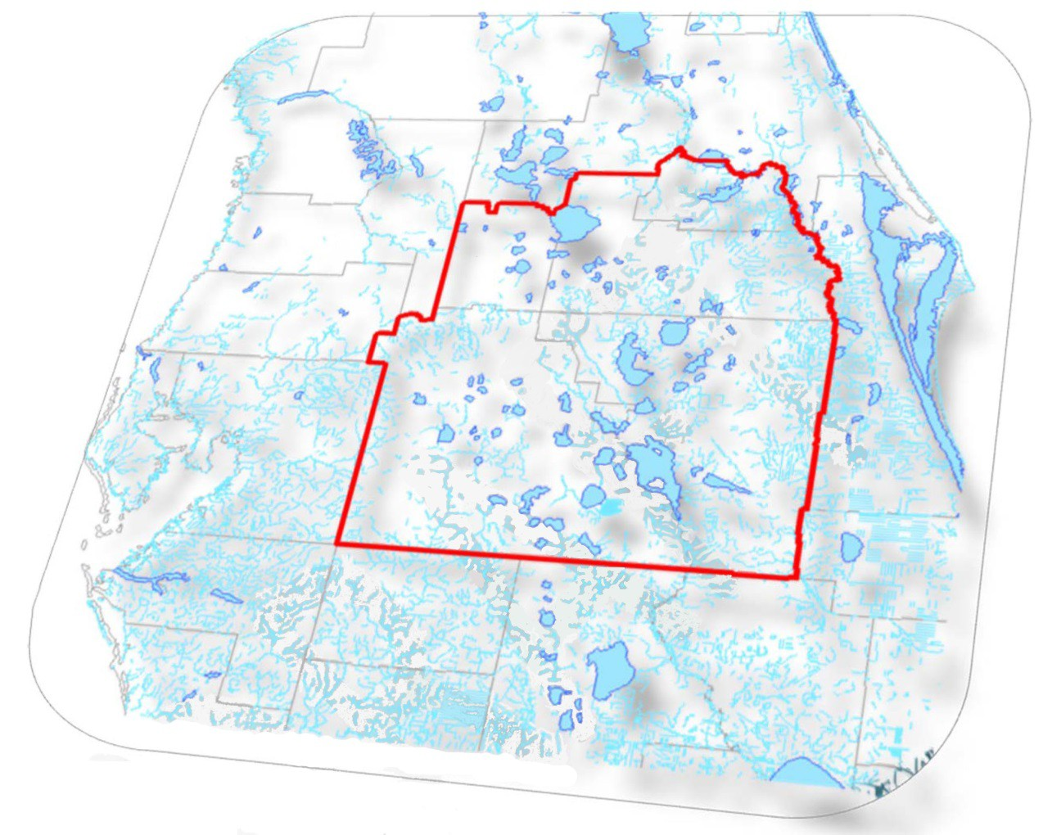

## Central Florida Water Initiative’s Environmental Measures Team

**Final Report November, 2013**

**Attachments A‐H**

*Environmental Measures Team Final Report*

*Attachment A –*

*Land Development Index (LDI) and Cross‐Walk of Florida Land Use Cover and Classification System (FLUCCS) Codes to LDI Values*

*November, 2013*

## Attachment A – Land Development Index (LDI)

Tony Janicki, Ph.D. Janicki Environmental, Inc.

#### Land Use and the Land Development Index

The Land Development Index (LDI) (Brown et al. 2003) was estimated for each of the EMT study sites using land use data and a development intensity measure derived from energy use per unit area. The LDI is an estimate of the potential impacts from human‐dominated activities that are experienced by ecological systems within those watersheds.

Initially, each of the wetland sites was overlain on the ECFT model grid. Then, the land uses (i.e., FLUCCS codes) within the ECFT model grid were identified and the contributing areas enumerated. Each of the land uses was assigned an LDI coefficient (**Table A‐1**). The overall LDI ranking was calculated as an area weighted average. Using the GIS, total area and percent of total area occupied by each of the land uses were determined and then the LDI was calculated as follows:

LDITotal = Σ %LUi * LDIi

Where: LDItotal = LDI ranking for wetland site, %LUi= percent of the total area of influence in land use I, and LDIi = landscape development intensity coefficient for land use i.

**Table A‐1 .Land Development Index coefficients for each land use classification (source: Brown, 2003).**

|  |  |  |  |
| --- | --- | --- | --- |
| Natural System | 1.0 | Single Family Residential (medium density) | 7.47 |
| Natural Open Water | 1.0 | Single Family Residential (high density) | 7.55 |
| Pine Plantation | 1.58 | Mobile Home (medium density) | 7.70 |
| Low Intensity Recreational/Open Space | 1.83 | Highway (2 lane) | 7.81 |
| Woodland Pasture | 2.02 | Low Density Commercial | 8.00 |
| Pasture (without livestock) | 2.77 | Institutional | 8.07 |
| Low Intensity Pasture (with livestock) | 3.41 | Highway (4 lane) | 8.28 |
| Citrus | 3.68 | Mobile Home (high density) | 8.29 |
| High Intensity Pasture (with livestock) | 3.74 | Industrial | 8.32 |
| Row Crops | 4.54 | Multi‐family Residential (low rise) | 8.66 |
| Single Family Residential (low density) | 6.79 | High Intensity Commercial | 9.18 |
| High Intensity Recreational/Open Space | 6.92 | Multi‐family Residential (high rise) | 9.19 |
| High Intensity Agriculture (dairy farm) | 7.00 | Central Business District (Average 2 stories) | 9.42 |
|  |  | Central Business District (Average 4 stories) | 10.00 |

The three water management districts with jurisdictions in the CFCA each maintain land use geospatial databases according to the Florida Land Use Cover Classification System (FLUCCS) established in 1971 by the Florida Department of Transportation with continued mapping by all five Water Management Districts and the Florida Department of Environmental Protection. Databases from the three WMDs were obtained and combined to create a single land use map of the CFWI study area. The extent of major land use types was determined for 1995 and 2009, and a comparison of land use changes between these years was calculated (see **Figure 3** in the main report).

#### Cross‐Walk Of Florida Land Use Cover and Classification System (FLUCCS) To Land Development Index (LDI) Values

**Table A‐2. FLUCCS Codes and Corresponding LDI Values used in EMT Analyses**

|  |  |  |  |
| --- | --- | --- | --- |
| FLUCCS | Description | LDI |  |
| 1000 | Urban and Built‐up |  | 7.39 |
| 1009 | Mobile home units any density |  | 6.79 |
| 1100 | Residential, Low Density <Less than two dwelling units per acre> |  | 6.79 |
| 1110 | Low density residential ‐ fixed single family units |  | 6.79 |
| 1120 | Low density residential ‐ mobile home units |  | 6.79 |
| 1130 | Low Density Residential ‐ Mixed Units <Fixed and mobile home units> |  | 6.79 |
| 1140 | Ranchettes ‐ fixed single family units |  | 6.79 |
| 1150 | Ranchettes ‐ mobile units |  | 6.79 |
| 1160 | Ranchettes ‐ mixed units |  | 6.79 |
| 1180 | Rural residential |  | 6.79 |
| 1190 | Low density under construction |  | 6.79 |
| 1200 | Residential, Medium Density <Two ‐ five dwelling units per acre> |  | 7.59 |
| 1210 | Medium density residential ‐ fixed single family units |  | 7.59 |
| 1220 | Medium density residential ‐ mobile home units |  | 7.59 |
| 1230 | Medium Density Residential ‐ Mixed Units <Fixed and mobile home units> |  | 7.59 |
| 1290 | Medium density under construction |  | 7.59 |
| 1300 | Residential, high density |  | 8.66 |
| 1310 | High Density Residential ‐ Fixed Single Family Units <Si or more |  | 7.99 |
| 1320 | High Density Residential ‐ Mobile Home Units <Si or more |  | 7.99 |
| 1330 | Multiple Dwelling Units ‐ Low Rise <Two stories or less> |  | 8.66 |
| 1340 | Multiple Dwelling Units ‐ High Rise <Three stories or more> |  | 9.19 |
| 1350 | High Density Residential ‐ Mixed Units <Fixed and mobile home units> |  | 7.99 |
| 1390 | High density under construction |  | 7.99 |
| 1400 | Commercial and Services |  | 8 |
| 1410 | Retail Sales and Services |  | 8 |
| 1411 | Shopping center |  | 9.18 |
| 1420 | Wholesale Sales and Services <excluding warehouses associated with |  | 8 |
| 1423 | Junk yard |  | 9.18 |
| 1424 | Farmers market |  | 8 |
| 1430 | Professional services |  | 8 |
| 1440 | Cultural and Entertainment |  | 8.07 |
| 1443 | Open air theater |  | 8.07 |
| 1450 | Tourist services |  | 8 |
| 1452 | Motel |  | 8 |
| 1453 | Travel trailer park |  | 8 |
| 1454 | Campground |  | 4.09 |
| 1460 | Oil and Gas Storage |  | 8 |

|  |  |  |
| --- | --- | --- |
| 1470 | Mixed Commercial and Services | 9.42 |
| 1480 | Cemeteries | 4.09 |
| 1490 | Commercial and Services Under Construction | 8 |
| 1500 | Industrial | 8.32 |
| 1510 | Food processing | 8.32 |
| 1513 | Seafood processing | 8.32 |
| 1514 | Meat packing facility | 8.32 |
| 1515 | Poultry and/or egg processing | 8.32 |
| 1516 | Grain and legume processing | 8.32 |
| 1520 | Timber processing | 8.32 |
| 1521 | Sawmill | 8.32 |
| 1522 | Plywood and veneer mill | 8.32 |
| 1523 | Pulp and paper mill | 8.32 |
| 1526 | Log home prefabrication | 8.32 |
| 1527 | Woodyard | 8.32 |
| 1530 | Mineral processing | 8.32 |
| 1532 | Phosphate processing | 8.32 |
| 1533 | Limerock processing | 8.32 |
| 1535 | Heavy minerals processing | 8.32 |
| 1540 | Oil and Gas Processing | 8.32 |
| 1544 | Liquified gases | 8.32 |
| 1545 | Asphalt plant | 8.32 |
| 1550 | Other light industrial | 8.32 |
| 1551 | Boat building and repair | 8.32 |
| 1552 | Electronics | 8.32 |
| 1554 | Aircraft building and repair | 8.32 |
| 1556 | Mobile home manufacturer | 8.32 |
| 1560 | Other heavy industrial | 8.32 |
| 1561 | Ship Building and Repair | 8.32 |
| 1562 | Prestressed concrete plants | 8.32 |
| 1564 | Cement plant | 8.32 |
| 1565 | Plastic pipe plant | 8.32 |
| 1570 | Chemical processing plants | 8.32 |
| 1580 | Industrial | 8.32 |
| 1590 | Industrial under construction | 8.32 |
| 1600 | Extractive | 8.32 |
| 1610 | Strip mines | 8.32 |
| 1611 | Clays | 8.32 |
| 1612 | Peat | 8.32 |
| 1613 | Heavy mineral mine | 8.32 |
| 1614 | Phosphate mine | 8.32 |
| 1620 | Sand and Gravel Pits | 8.32 |
| 1630 | Rock quarries | 8.32 |

|  |  |  |
| --- | --- | --- |
| 1631 | Limerock quarry | 8.32 |
| 1632 | Dolomite quarry | 8.32 |
| 1633 | Phosphate | 8.32 |
| 1640 | Oil and Gas Fields | 8.32 |
| 1650 | Reclaimed land | 8.32 |
| 1660 | Holding ponds | 8.32 |
| 1670 | Inactive Strip Mines/Rock Quarries or holding ponds | 8.32 |
| 1700 | Institutional | 8.07 |
| 1710 | Educational facilities | 8.07 |
| 1720 | Religious | 8.07 |
| 1730 | Military | 8.07 |
| 1736 | National guard installation | 8.07 |
| 1740 | Medical and Health Care | 8.07 |
| 1741 | Hospital | 8.07 |
| 1742 | Nursing home | 8.07 |
| 1750 | Governmental | 8.07 |
| 1756 | Maintenance yard | 8.07 |
| 1760 | Correctional facilities | 8.07 |
| 1761 | State prison | 8.07 |
| 1765 | Municipal prison | 8.07 |
| 1770 | Other institutional facilities | 8.07 |
| 1780 | Commercial child care | 8.07 |
| 1790 | Institutional under construction | 8.07 |
| 1800 | Recreational | 4.09 |
| 1810 | Swimming beach | 4.09 |
| 1820 | Golf courses | 6.92 |
| 1830 | Race tracks | 6.92 |
| 1831 | Automobile racing track | 6.92 |
| 1832 | Horse racing track | 6.92 |
| 1833 | Dog racing track | 6.92 |
| 1840 | Marinas and Fish Camps | 6.92 |
| 1850 | Parks and Zoos | 4.09 |
| 1851 | City park | 4.09 |
| 1852 | Zoo | 6.92 |
| 1860 | Community recreational facilities | 4.09 |
| 1870 | Stadiums | 6.92 |
| 1880 | Historical sites | 8.07 |
| 1890 | Under Construction or Other Recreational Facilities | 4.09 |
| 1900 | Open land | 1.85 |
| 1910 | Undeveloped urban land | 1.85 |
| 1920 | Inactive development land | 1.85 |
| 1923 | Inactive development land nonforested | 1.85 |
| 1924 | Inactive development land forested | 1.85 |

|  |  |  |
| --- | --- | --- |
| 1930 | Urban Land in Transition Without Positive Indicators of Intended Activity | 1.85 |
| 1940 | Other open land | 1.85 |
| 2000 | Agriculture | 3.88 |
| 2100 | Pastures and Fields | 3.51 |
| 2110 | Improved pastures | 3.51 |
| 2120 | Unimproved pastures | 2.06 |
| 2130 | Woodland pastures | 2.06 |
| 2140 | Row crops | 4.63 |
| 2141 | Potatoes and Cabbage | 4.63 |
| 2150 | Field crops | 4.63 |
| 2156 | Field crops ‐ sugar cane | 4.63 |
| 2160 | Mixed crops | 4.63 |
| 2200 | Tree crops | 4.06 |
| 2210 | Citrus groves | 4.06 |
| 2220 | Fruit orchards | 4.06 |
| 2221 | Peaches | 4.06 |
| 2224 | Blueberries | 4.06 |
| 2230 | Other groves | 1 |
| 2231 | Pecans | 1 |
| 2240 | Abandoned tree crops | 1 |
| 2300 | Feeding operations | 1 |
| 2310 | Cattle feeding operations | 1 |
| 2320 | Poultry feeding operations | 1 |
| 2330 | Swine feeding operations | 1 |
| 2400 | Nurseries and Vineyards | 1 |
| 2410 | Tree nurseries | 1 |
| 2420 | Sod farms | 1 |
| 2430 | Ornamental nurseries | 1 |
| 2431 | Shade ferns | 1 |
| 2432 | Hammock ferns | 1 |
| 2440 | Vineyards | 1.58 |
| 2450 | Floriculture | 1.58 |
| 2460 | Timber nursery | 1.58 |
| 2500 | Specialty farms | 1.58 |
| 2510 | Horse farms | 1.58 |
| 2520 | Dairies | 1.58 |
| 2530 | Kennels | 1 |
| 2540 | Aquaculture | 1 |
| 2550 | Tropical fish farms | 1 |
| 2590 | Other specialty farms | 1 |
| 2600 | Other open lands | 1 |
| 2610 | Fallow cropland | 1 |
| 2620 | Old field | 1 |

|  |  |  |
| --- | --- | --- |
| 3000 | Rangeland | 4.09 |
| 3100 | Herbaceous | 4.09 |
| 3200 | Shrub and Brushland | 4.09 |
| 3210 | Palmetto prairies | 4.09 |
| 3220 | Coastal scrub | 4.09 |
| 3290 | Other Shrubs and Brush | 1 |
| 3300 | Mixed rangeland | 1 |
| 4000 | Upland forests | 1 |
| 4100 | Upland coniferous forests | 1 |
| 4110 | Pine Flatwoods or Mesic Flatwoods | 1 |
| 4119 | Pine flatwoods ‐ melaleuca infested | 1 |
| 4120 | Longleaf Pine‐Xeric Oak or Longleaf Sandhill | 1 |
| 4130 | Sand Pine or Sand Pine Scrub | 1 |
| 4140 | Pine ‐ mesic oak | 1 |
| 4190 | Hunting plantation woodlands | 1 |
| 4200 | Upland hardwood forests | 1 |
| 4210 | Oak sandhill | 1 |
| 4220 | Brazilian pepper | 1 |
| 4230 | Oak ‐ pine ‐ hickory | 1 |
| 4240 | Melaleuca | 1 |
| 4250 | Temperate hardwood | 1 |
| 4260 | Tropical hardwoods | 1 |
| 4270 | Live oak | 1 |
| 4271 | Oak ‐ cabbage palm forest | 1 |
| 4280 | Cabbage palm | 1 |
| 4290 | Wax myrtle ‐ willow | 1 |
| 4300 | Upland hardwood forests continued | 1 |
| 4310 | Beech ‐ magnolia | 1 |
| 4320 | Oak scrub | 1 |
| 4330 | Western everglades hardwoods | 1 |
| 4340 | Hardwood ‐ conifer mixed | 1 |
| 4350 | Dead trees | 1 |
| 4370 | Australian pine | 1 |
| 4380 | Mixed hardwoods | 1 |
| 4390 | Maritime hammock | 1 |
| 4400 | Tree plantations | 1.58 |
| 4410 | Pine plantations | 1.58 |
| 4420 | Hardwood plantations | 1.58 |
| 4430 | Forest regeneration | 1.58 |
| 4440 | Experimental tree plots | 1.58 |
| 4450 | Seed tree plantations | 1.58 |
| 5000 | Water | 1 |
| 5100 | Streams and Waterways | 1 |

|  |  |  |
| --- | --- | --- |
|  | | 1 |
| 5120 | Streams and Waterways | 1 |
| 5200 | Lakes | 1 |
| 5210 | Lakes larger than 500 acres (202 hectares) | 1 |
| 5220 | Lakes Larger Than 100 Acres (40 Hectares), but Less Than 500 Acres | 1 |
| 5230 | Lakes Larger Than 10 Acres (4 Hectares), but Less Than 100 Acres | 1 |
| 5240 | Lakes Less Than 10 Acres (4 hectares) Which are Dominant Features | 1 |
| 5300 | Reservoirs | 4.09 |
| 5310 | Reservoirs larger than 500 acres (202 hectares) | 4.09 |
| 5320 | Reservoirs Larger Than 100 Acres (40 Hectares), but Less Than 500 Acres | 4.09 |
| 5330 | Reservoirs Larger Than 10 Acres (4 Hectares), but Less Than 100 Acres | 4.09 |
| 5340 | Reservoirs less than 10 Acres (4 Hectares) which are dominant features | 4.09 |
| 5400 | Bays and Estuaries | 1 |
| 5410 | Embayment Opening into the Gulf of Mexico or the Atlantic Ocean | 1 |
| 5420 | Embayment Not Opening into the Gulf of Mexico or the Atlantic Ocean | 1 |
| 5430 | Enclosed salt water Ponds within salt marsh | 1 |
| 5500 | Major springs | 1 |
| 5600 | Slough waters | 1 |
| 5720 | Gulf of Mexico | 1 |
| 6000 | Wetlands | 1 |
| 6100 | Wetland hardwood forests | 1 |
| 6110 | Bay swamps | 1 |
| 6111 | Bayhead | 1 |
| 6120 | Mangrove swamps | 1 |
| 6130 | Gum swamps | 1 |
| 6140 | Shrub swamps | 1 |
| 6150 | Bottomland hardwood forest | 1 |
| 6160 | Inland Ponds and Sloughs | 1 |
| 6170 | Mixed wetland hardwoods | 1 |
| 6171 | Mixed wetland hardwoods ‐ willows | 1 |
| 6172 | Mixed wetland hardwoods ‐ mixed shrubs | 1 |
| 6180 | Cabbage palm savanna | 1 |
| 6191 | Wet melaleuca | 1 |
| 6200 | Wetland coniferous forests | 1 |
| 6210 | Cypress | 1 |
| 6215 | Cypress ‐ domes/heads | 1 |
| 6216 | Cypress ‐ mixed hardwoods | 1 |
| 6218 | Cypress ‐ melaleuca infested | 1 |
| 6219 | Cypress ‐ with Wet Prairies | 1 |
| 6220 | Wet flatwoods | 1 |
| 6230 | Atlantic white cedar | 1 |
| 6240 | Cypress ‐ pine ‐ cabbage palm | 1 |
| 6250 | Wet pinelands hydric pine | 1 |

|  |  |  |
| --- | --- | --- |
| 6300 | Wetland mixed forest | 1 |
| 6310 | Hydric hammock | 1 |
| 6320 | Tidal swamp | 1 |
| 6400 | Vegetated Non‐forested Wetlands | 1 |
| 6410 | Freshwater marshes | 1 |
| 6411 | Freshwater marshes ‐ sawgrass | 1 |
| 6412 | Freshwater marshes ‐ cattail | 1 |
| 6420 | Salt marshes | 1 |
| 6430 | Wet prairies | 1 |
| 6439 | Wet Prairies ‐ with Pine | 1 |
| 6440 | Emergent aquatic vegetation | 1 |
| 6450 | Submergent aquatic vegetation | 1 |
| 6451 | Hydrilla | 1 |
| 6460 | Mixed scrub‐shrub wetland | 1 |
| 6500 | Non‐vegetated | 1 |
| 6510 | Salt barrens | 1 |
| 6520 | Intertidal areas | 1 |
| 6530 | Inland shores/ephemeral ponds | 1 |
| 6540 | Oyster bars | 1 |
| 6600 | Cut over Wetlands | 1.58 |
| 6900 | Wetland scrub | 1 |
| 7000 | Barren land | 1 |
| 7100 | Beaches | 1 |
| 7200 | Sand other than beaches | 1 |
| 7300 | Exposed rock | 1 |
| 7310 | Exposed Rock with Marsh Grasses | 1 |
| 7400 | Disturbed lands | 4.09 |
| 7410 | Rural Land in Transition Without Positive Indicators of Intended Activity | 4.09 |
| 7420 | Borrow areas | 4.09 |
| 7430 | Spoil areas | 4.09 |
| 7440 | Fill areas | 4.09 |
| 7450 | Burned areas | 1 |
| 7470 | Dikes and Levees | 4.09 |
| 7500 | Riverine sandbars | 1 |
| 8000 | Transportation, Communication and Utilities | 8.05 |
| 8100 | Transportation | 7.81 |
| 8110 | Airports | 8.28 |
| 8111 | Commercial airport | 8.28 |
| 8112 | General aviation | 8.28 |
| 8113 | Private airport | 8.28 |
| 8115 | Grass airport | 8.28 |
| 8120 | Railroads | 7.81 |
| 8130 | Bus and Truck Terminals | 8.28 |

|  |  |  |
| --- | --- | --- |
| 8132 | Bus terminal | 8.28 |
| 8133 | Truck terminal | 8.28 |
| 8140 | Roads and Highways | 8.28 |
| 8141 | Limited access highway (interstate) | 8.28 |
| 8142 | Divided highway (federal‐state) | 8.28 |
| 8143 | Two lane highway | 7.81 |
| 8147 | Transportation corridor | 7.81 |
| 8150 | Port facilities | 8.28 |
| 8160 | Canals and Locks | 8.28 |
| 8170 | Oil, Water, or Gas Long Distance Transmission Line | 8.28 |
| 8180 | Auto parking facilities (highway rest areas) | 8.28 |
| 8190 | Transportation facilities under construction | 8.28 |
| 8191 | Highways | 8.28 |
| 8192 | Railroads | 8.28 |
| 8200 | Communications | 8.32 |
| 8210 | Transmission towers | 8.32 |
| 8220 | Communication facilities | 8.32 |
| 8290 | Communication facilities under construction | 8.32 |
| 8300 | Utilities | 8.32 |
| 8310 | Electrical power facilities | 10 |
| 8311 | Thermal (coal‐fired) electrical power generating plant | 10 |
| 8315 | Electrical power substation | 10 |
| 8320 | Electrical power transmission lines | 1.85 |
| 8330 | Water supply plants | 8.32 |
| 8340 | Sewage treatment | 8.32 |
| 8350 | Solid waste disposal | 8.32 |
| 8390 | Utilities under construction | 8.32 |
| 9000 | Special classifications | 1 |
| 9100 | Vegetative | 1 |
| 9110 | Sea grass | 1 |

# Environmental Measures Team Final Report

*Attachment B*

*CFCA/CFWI Wetland Data Collection Methodology*

*Contractor Statement of Work, Location of Study Area*

*Key Used to Determine Abundance Index Values Wetland Assessment Form and Description of Entries, FLUCCS Codes Used in This Study*

*List of Hydrologic Indicators, Protected Species List*

*November, 2013*

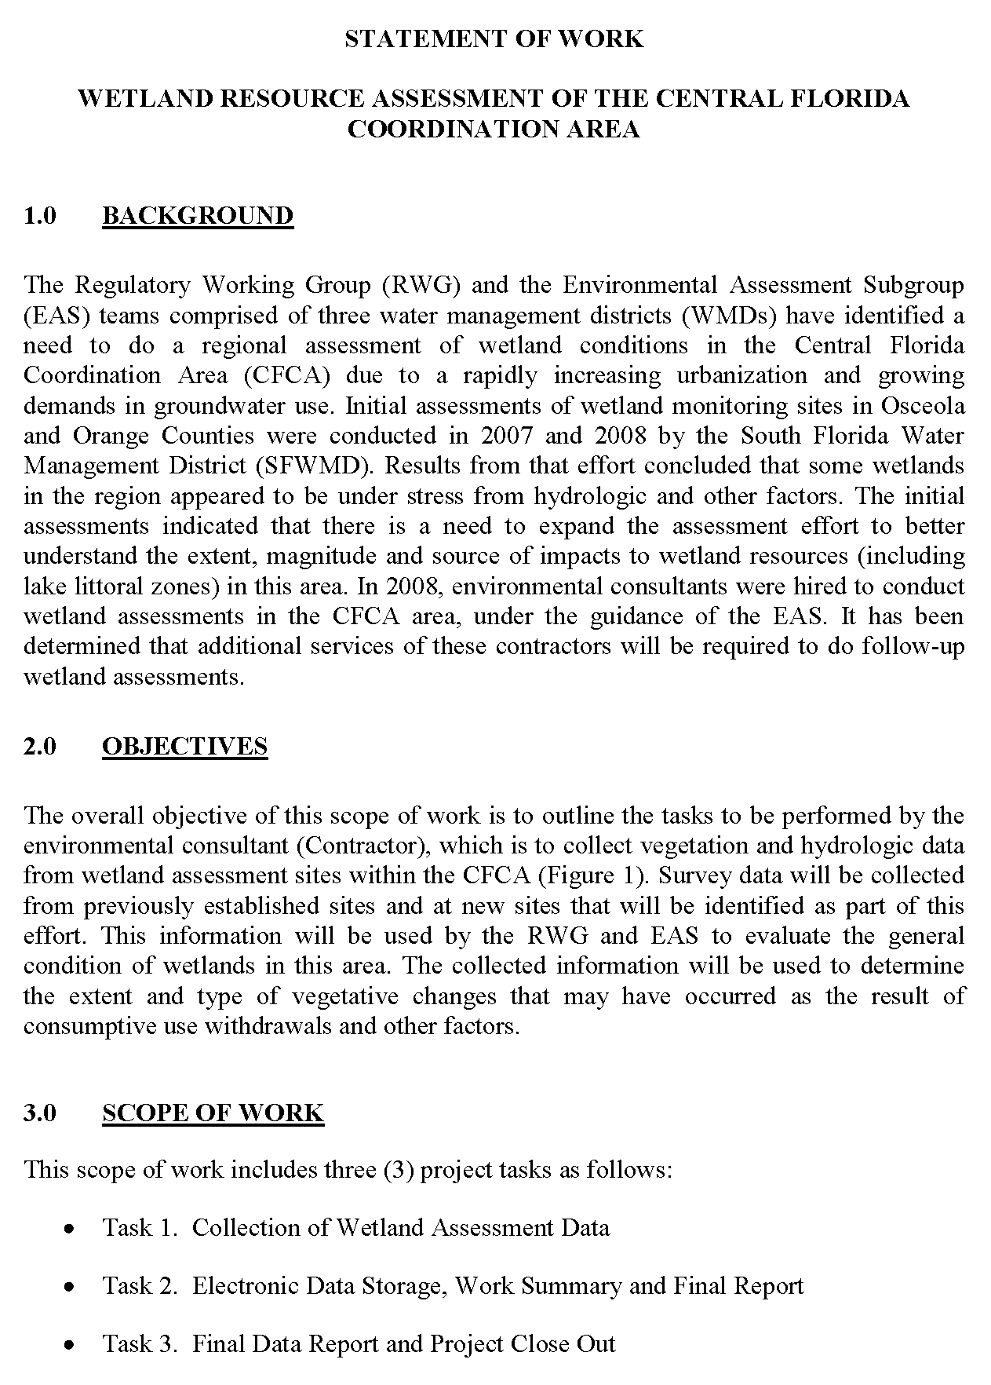





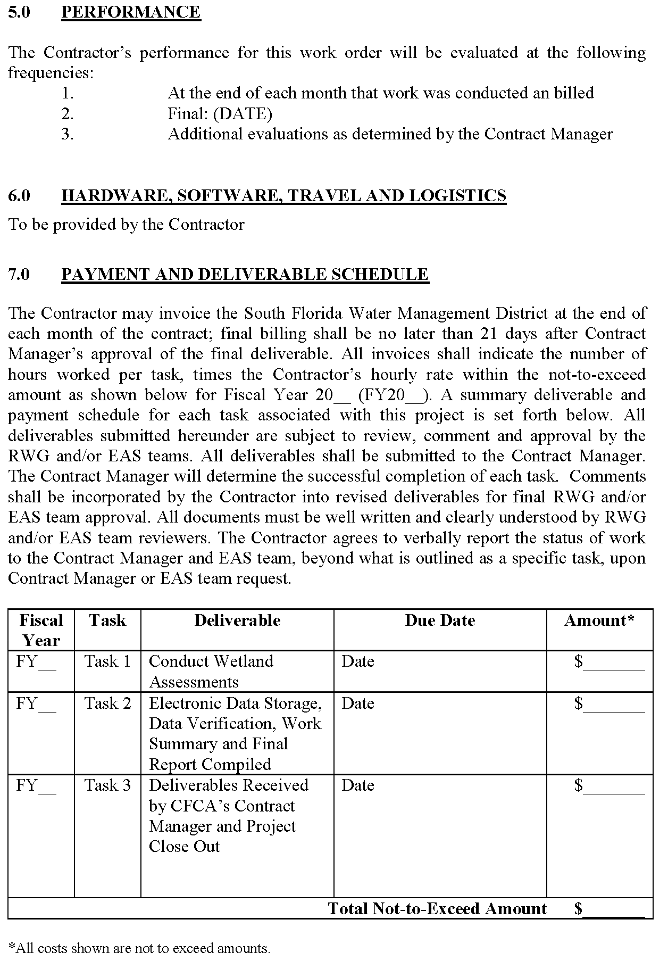



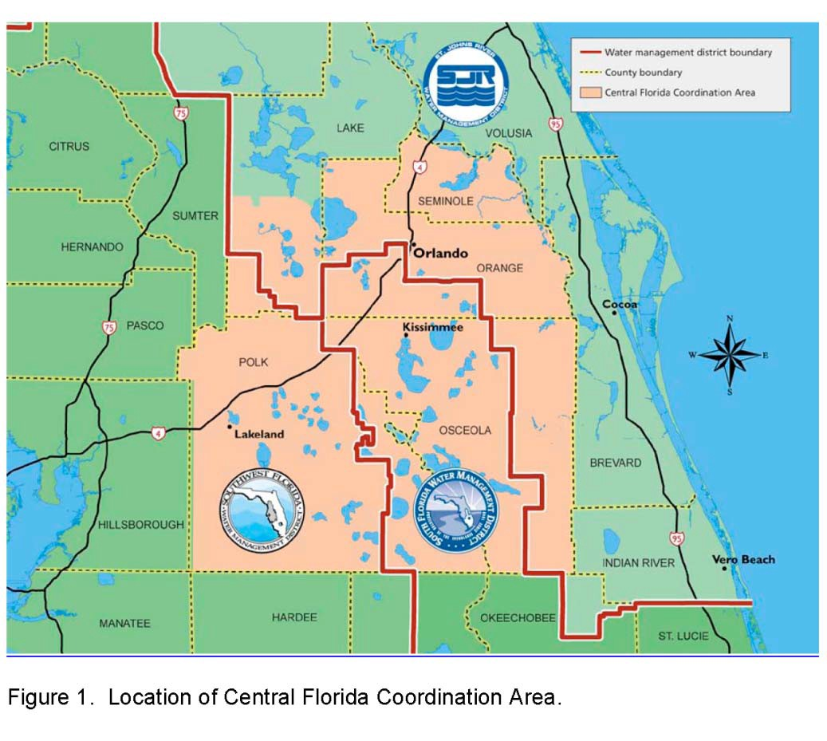

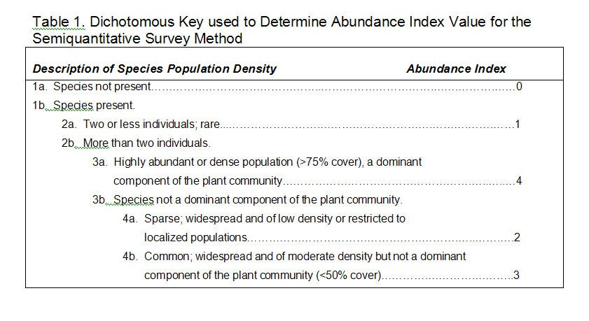

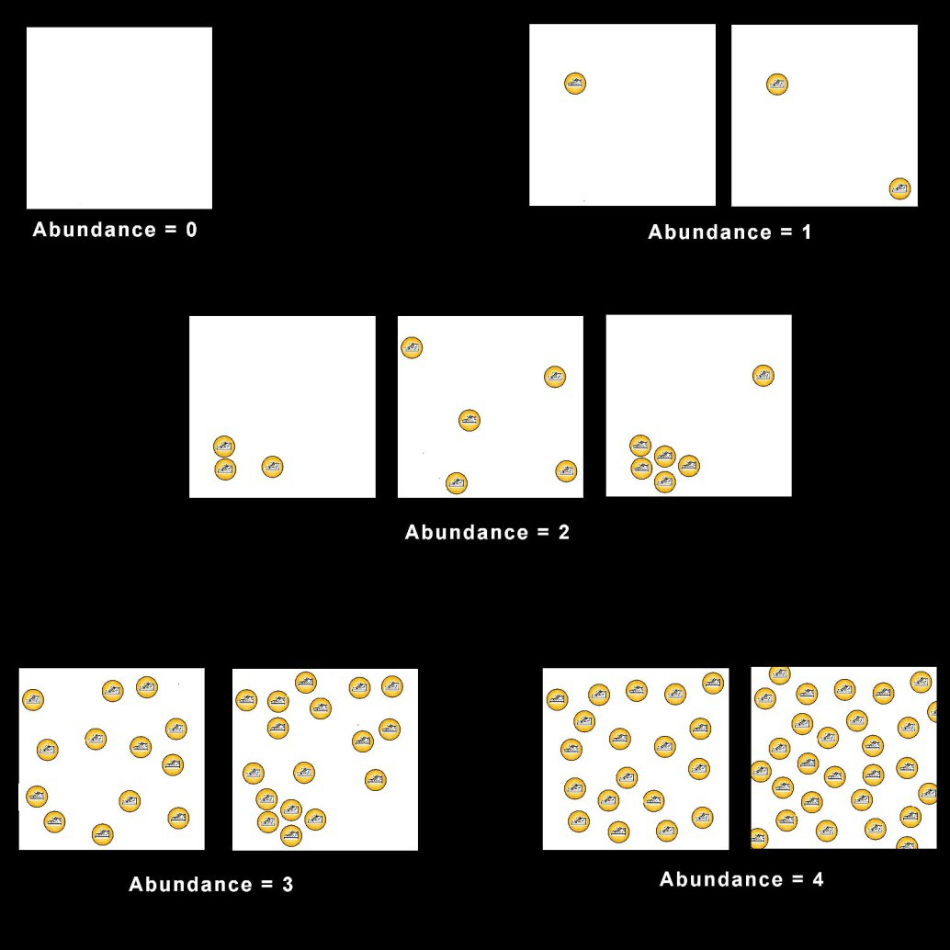

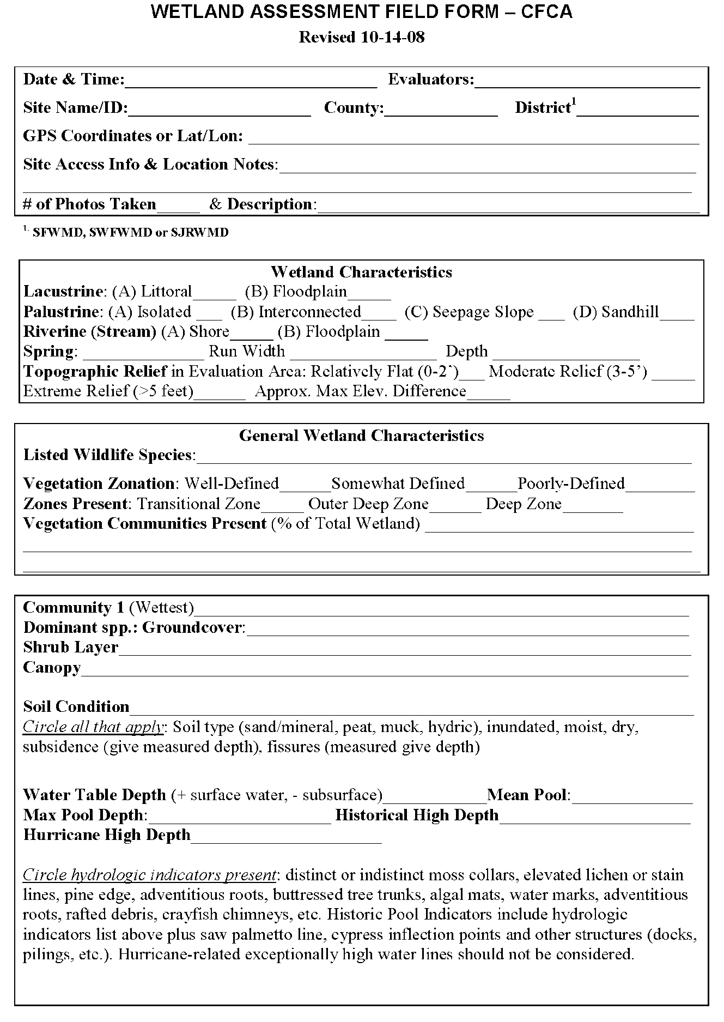

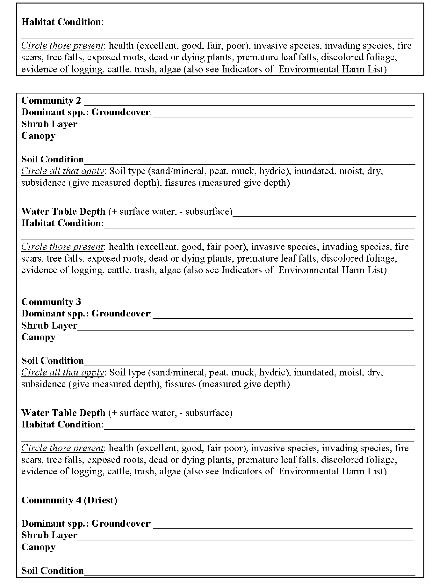



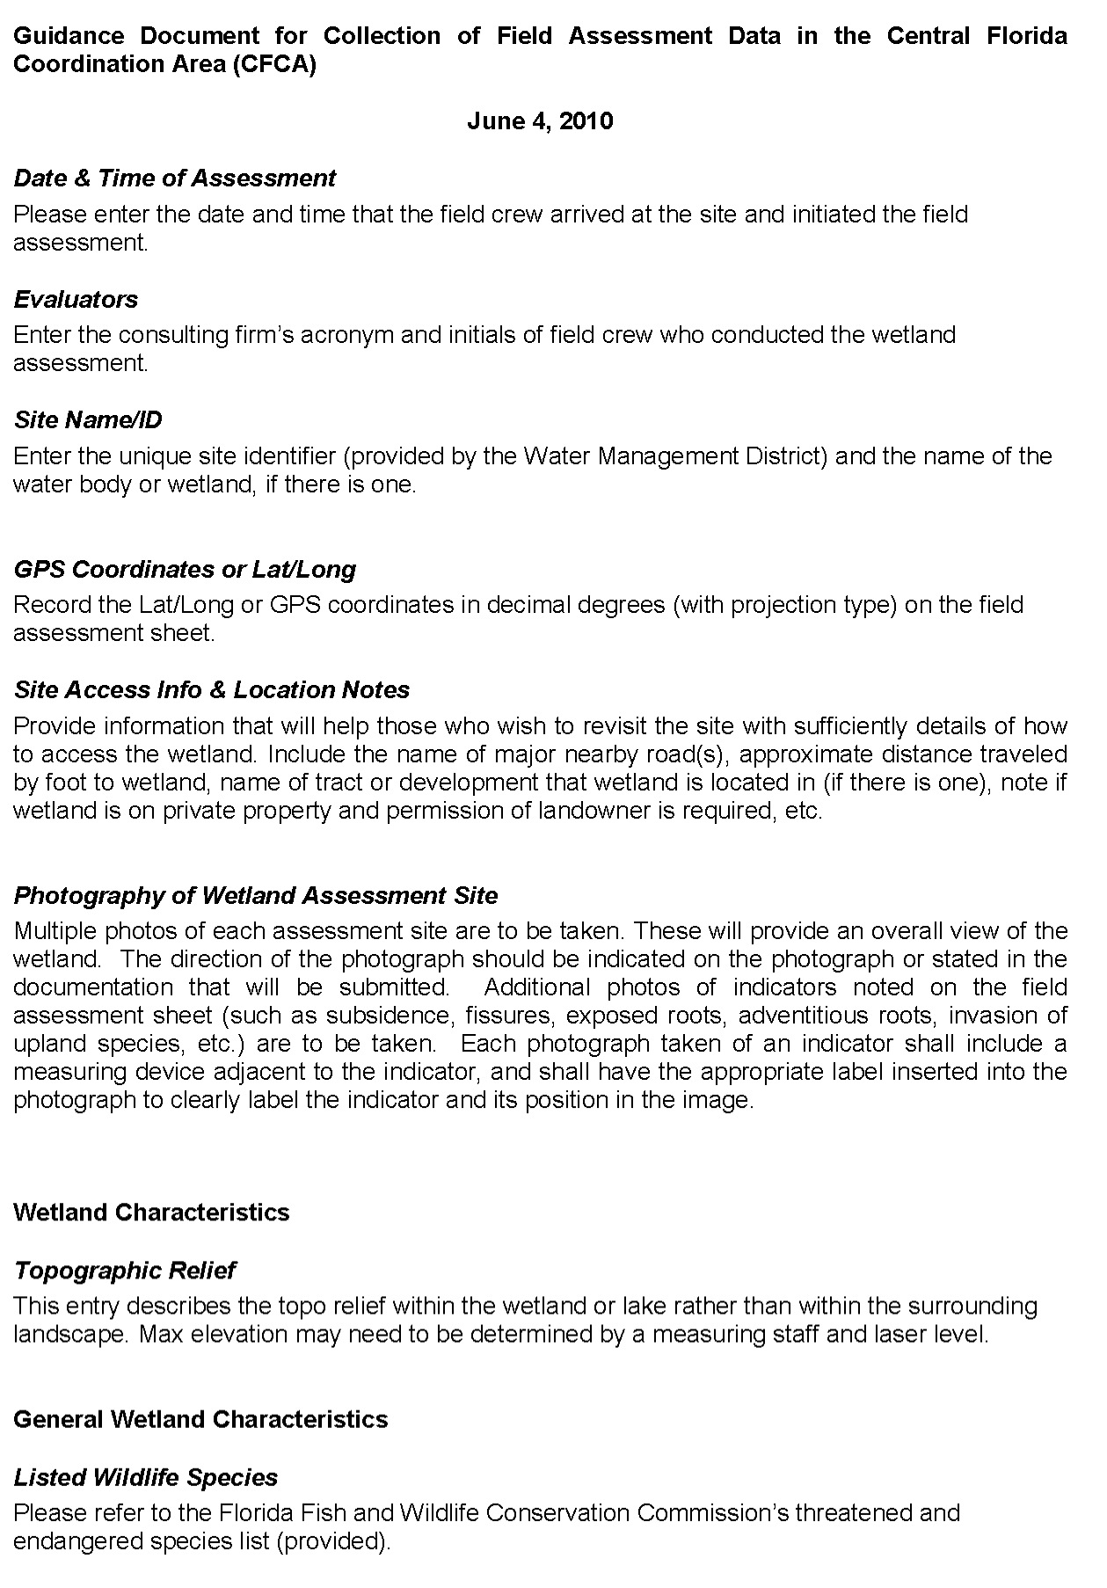

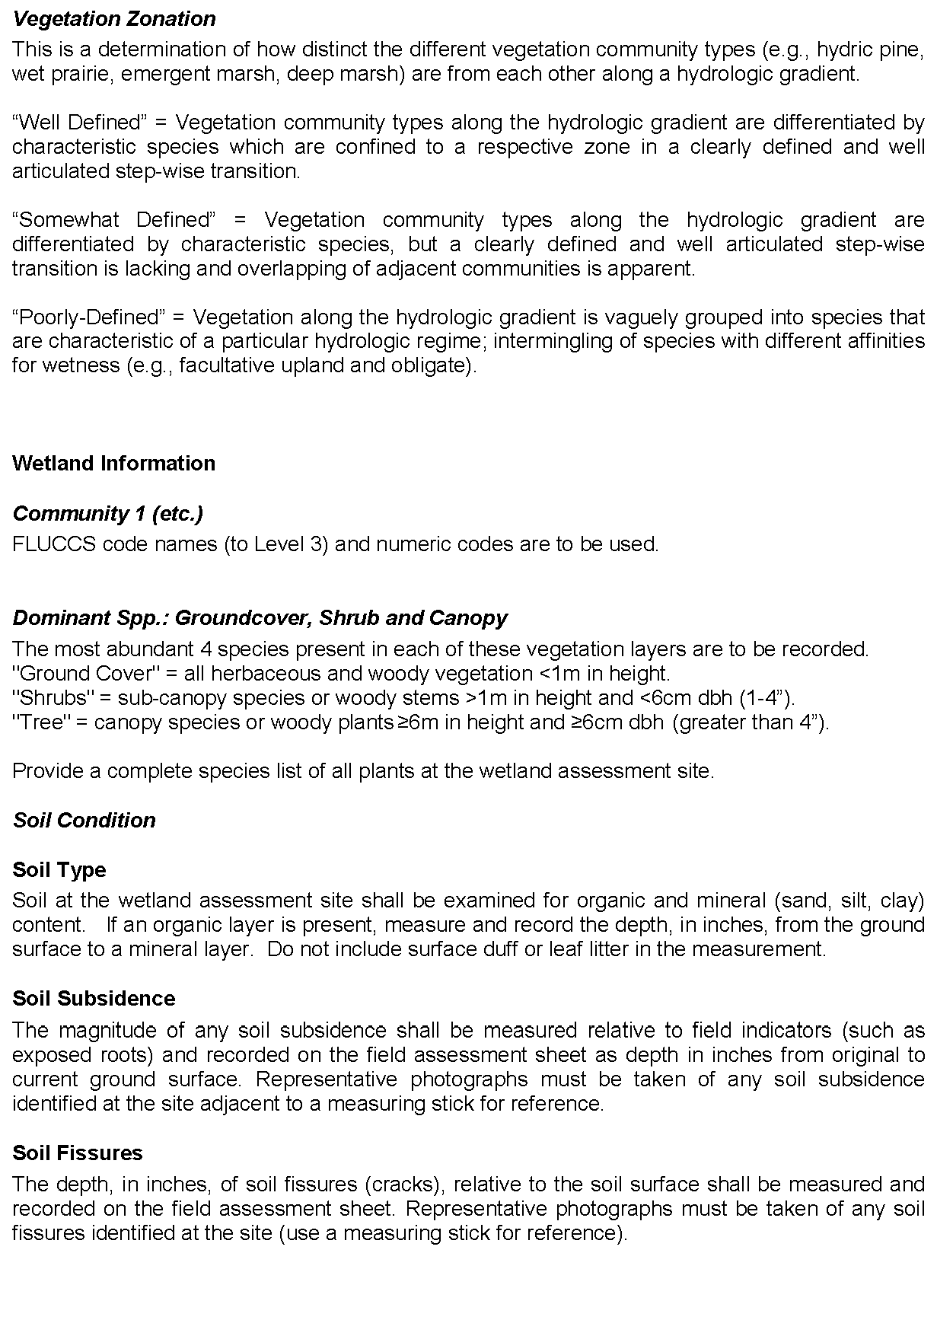

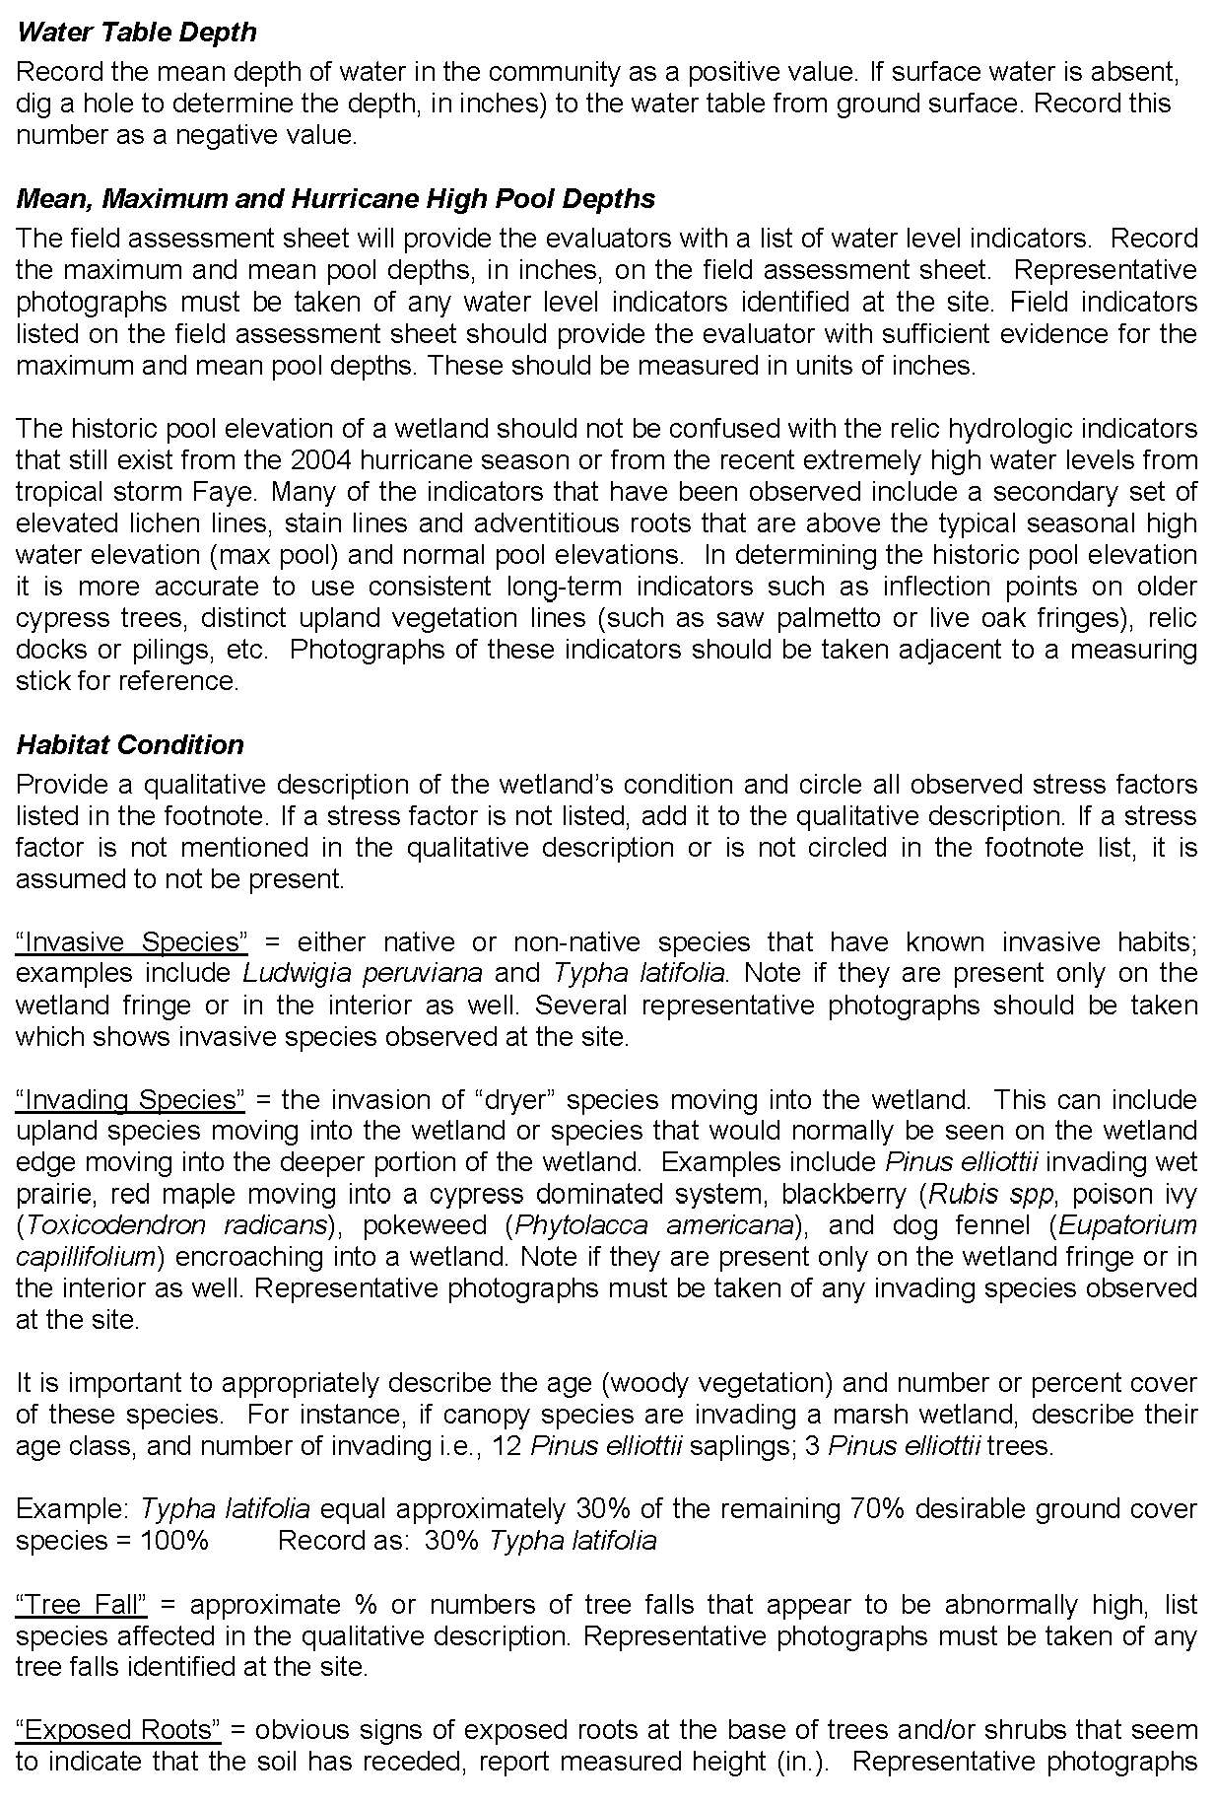

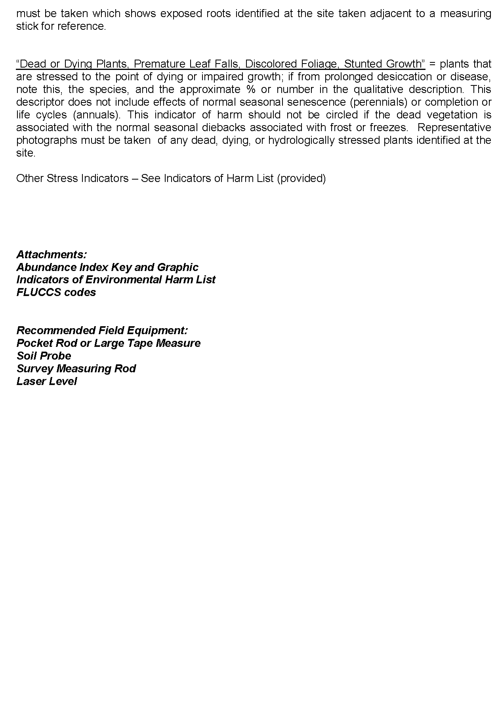

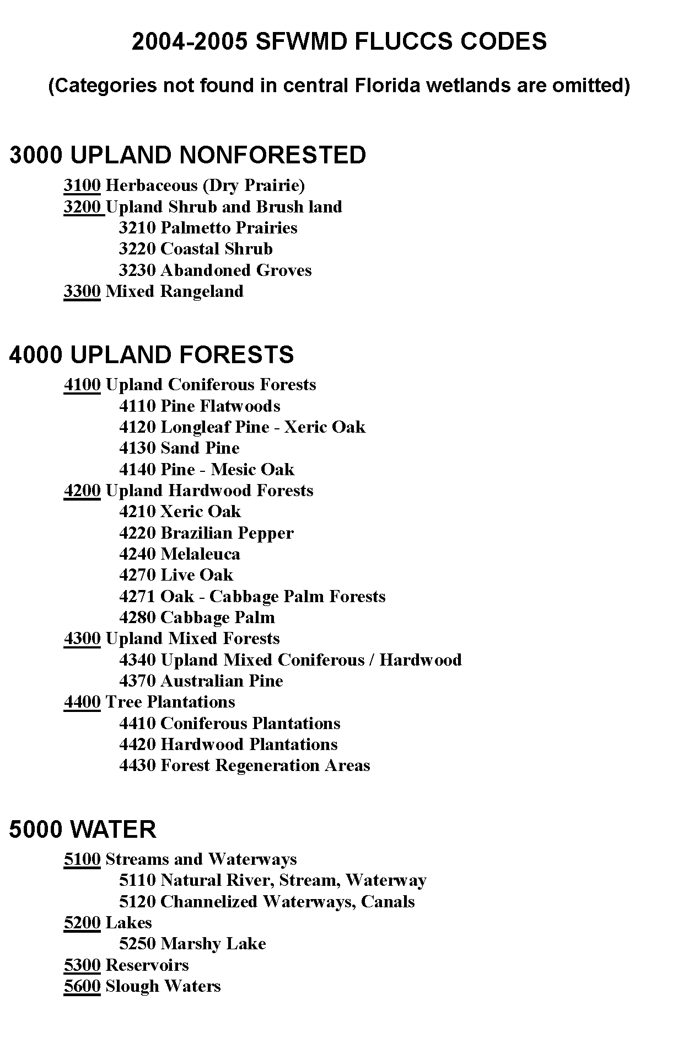

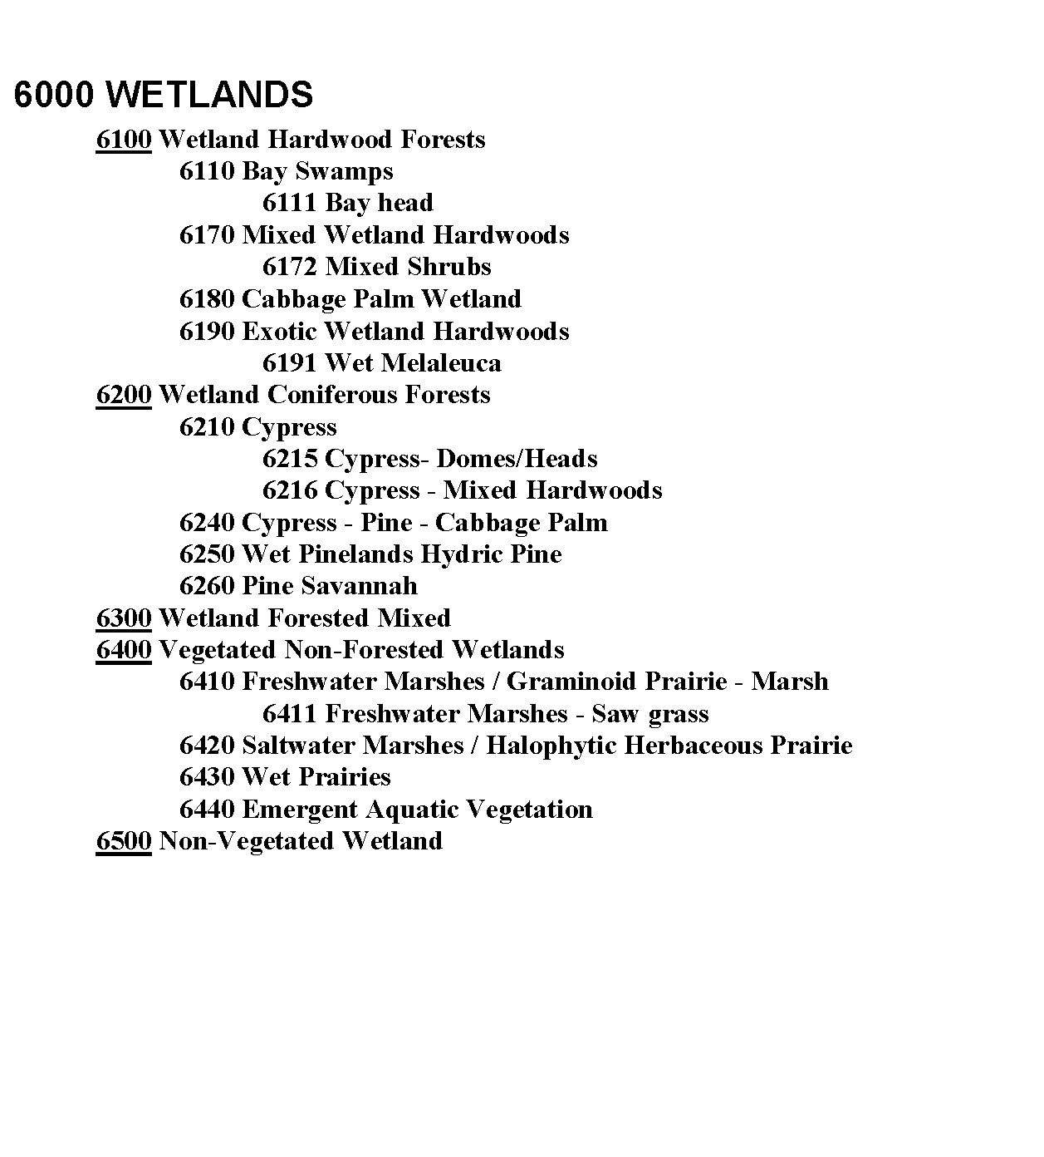

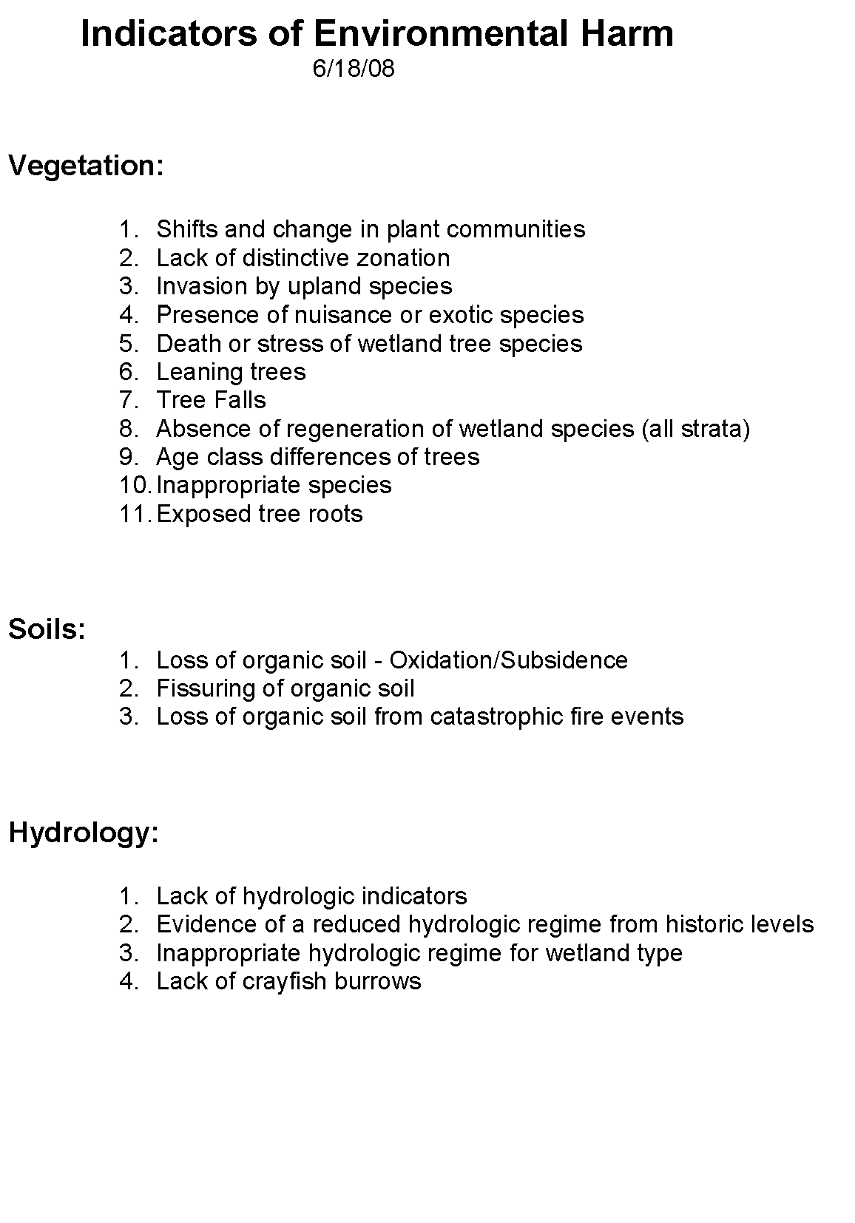

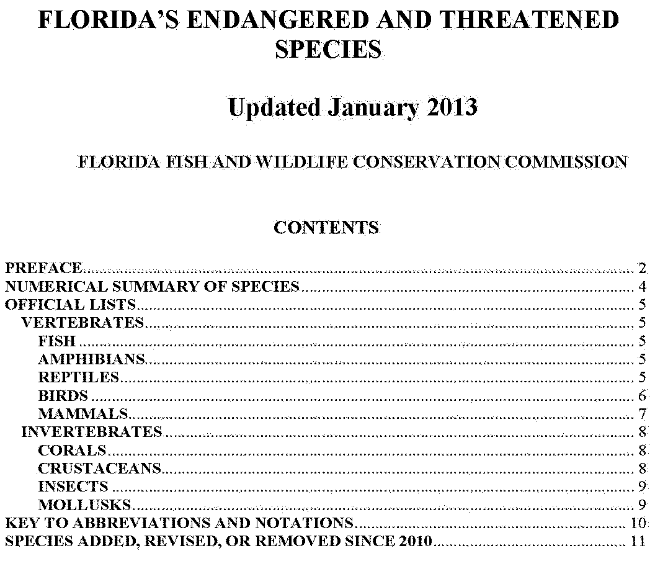

Source: <http://myfwc.com/media/1515251/threatened_endangered_species.pdf>

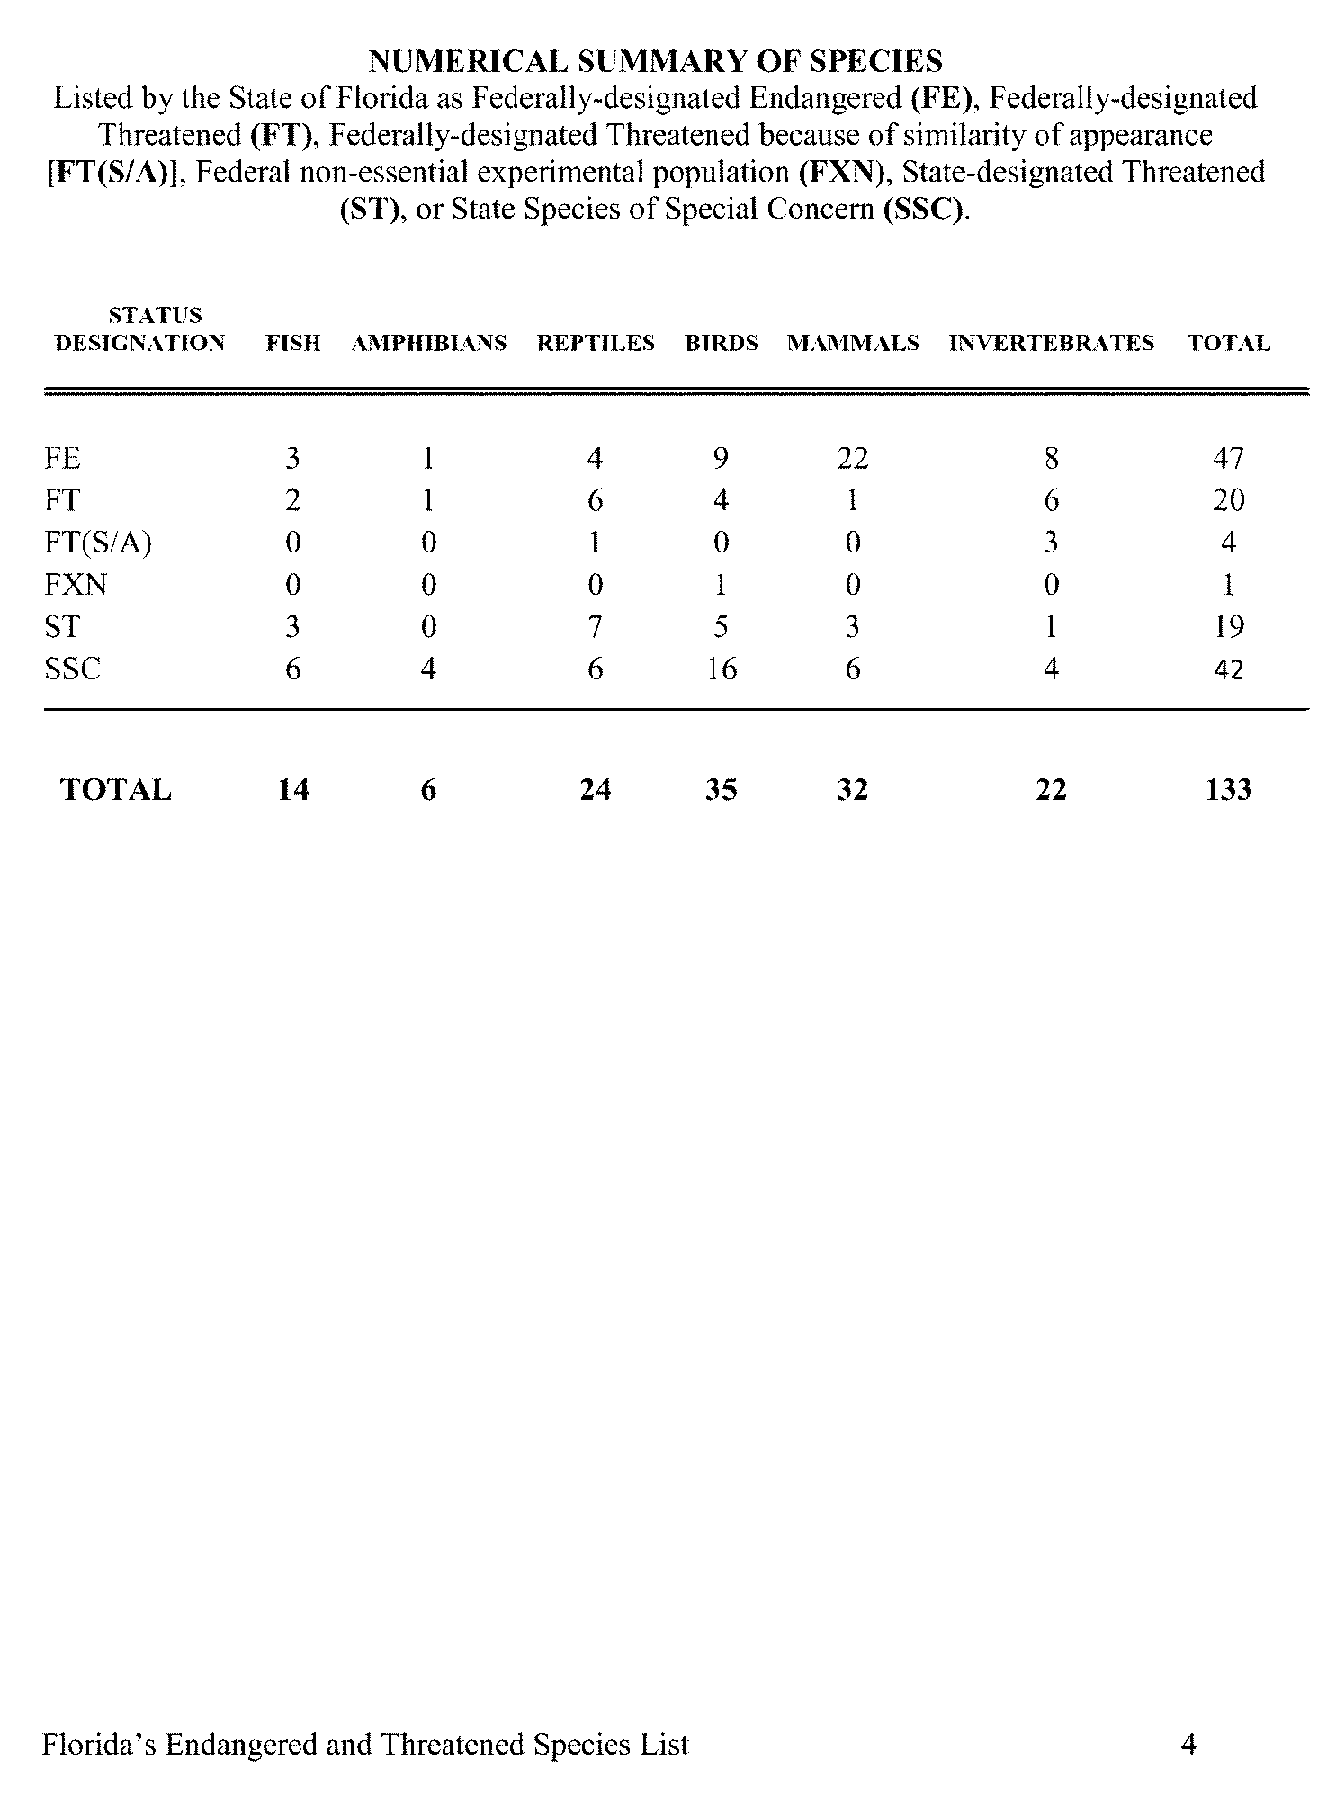

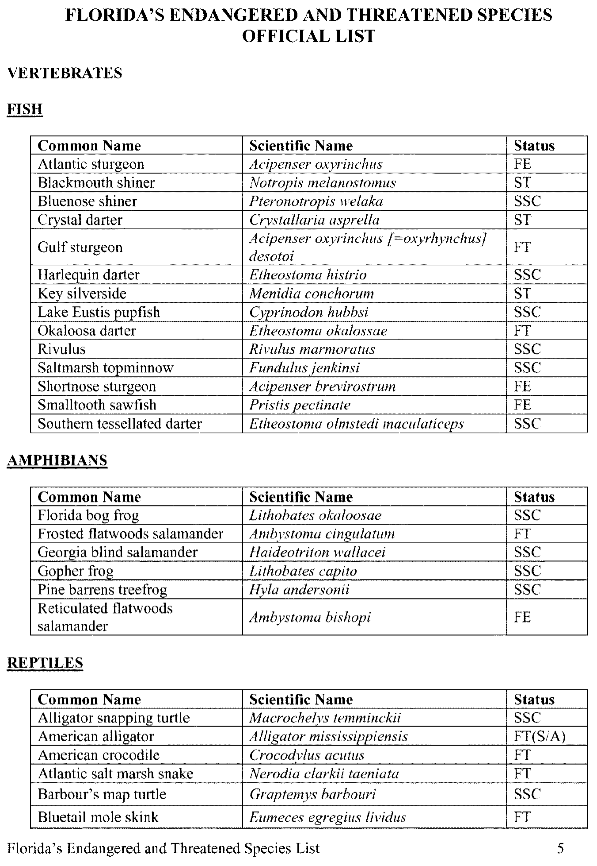

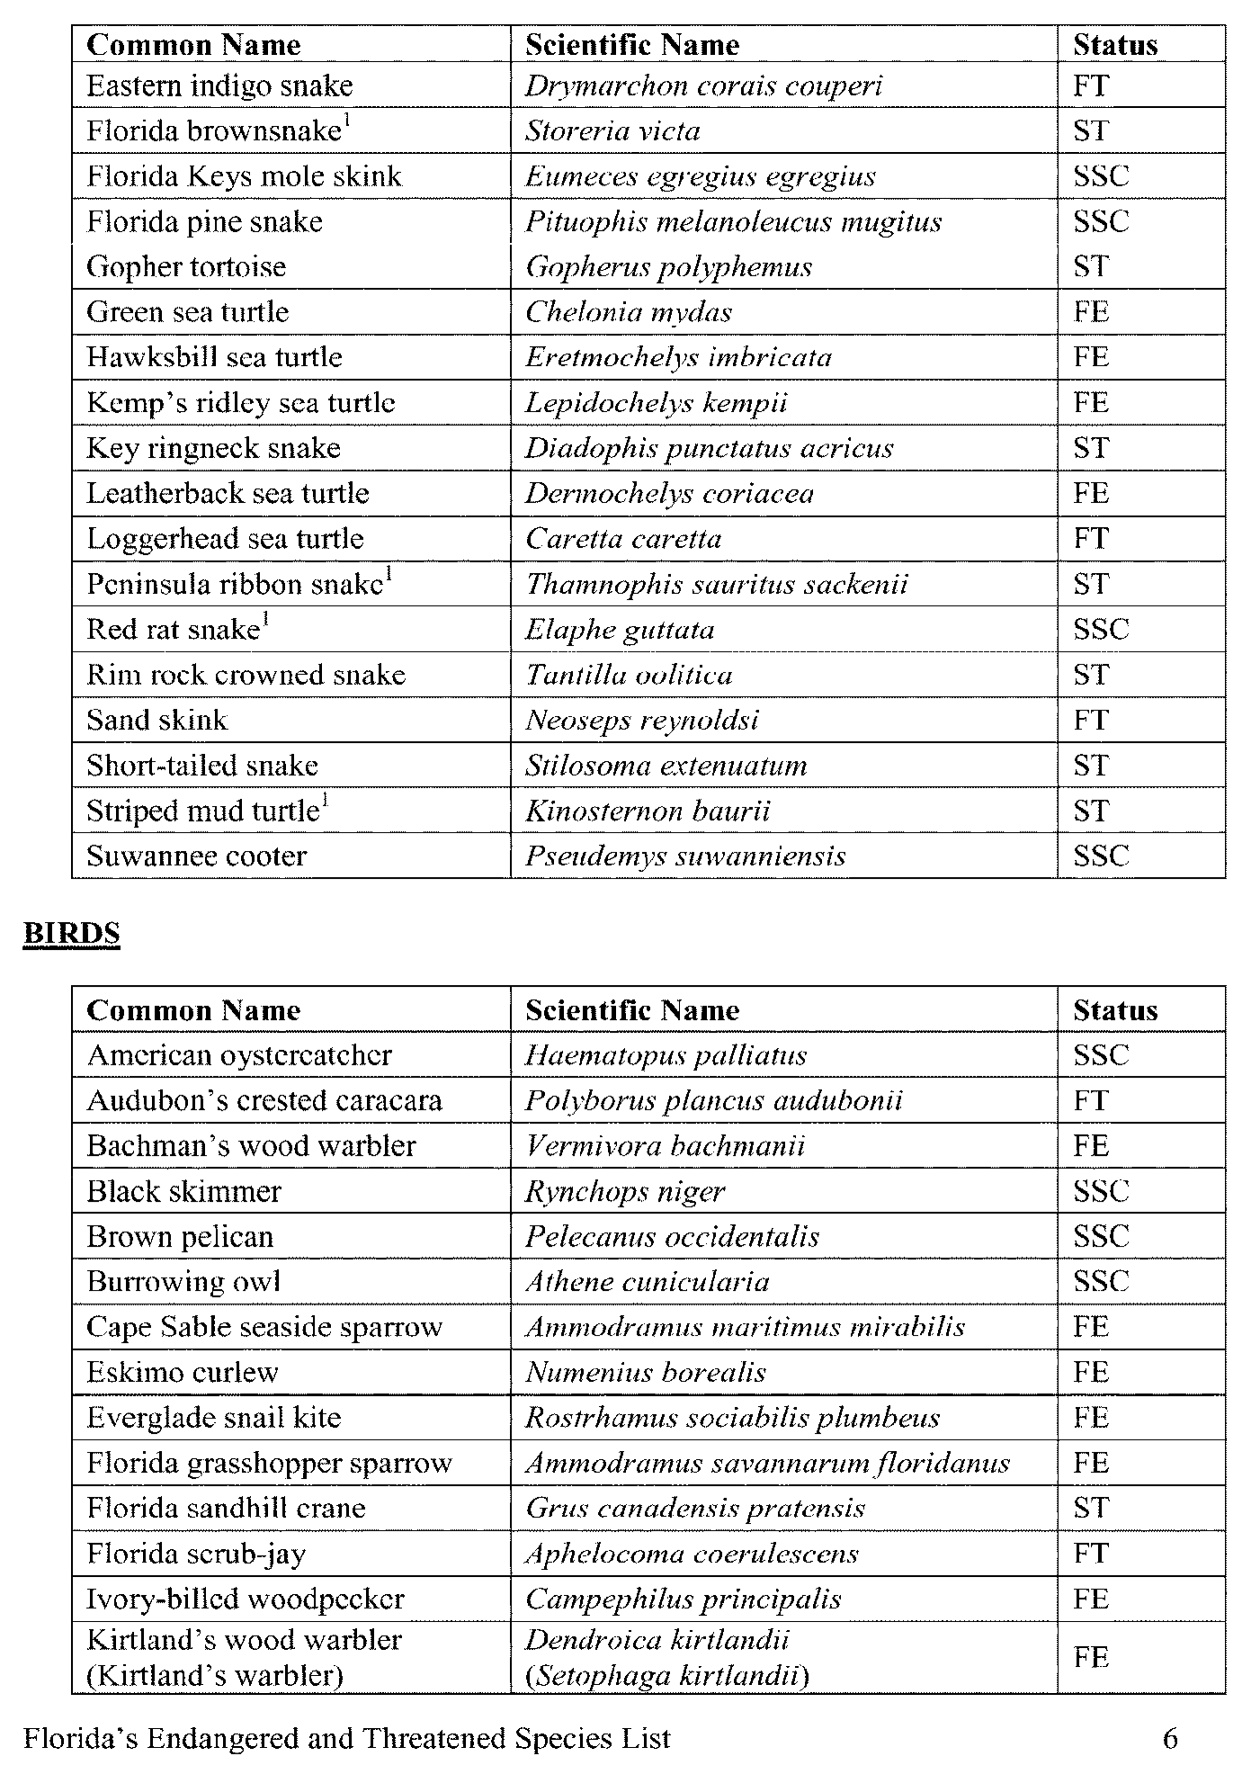

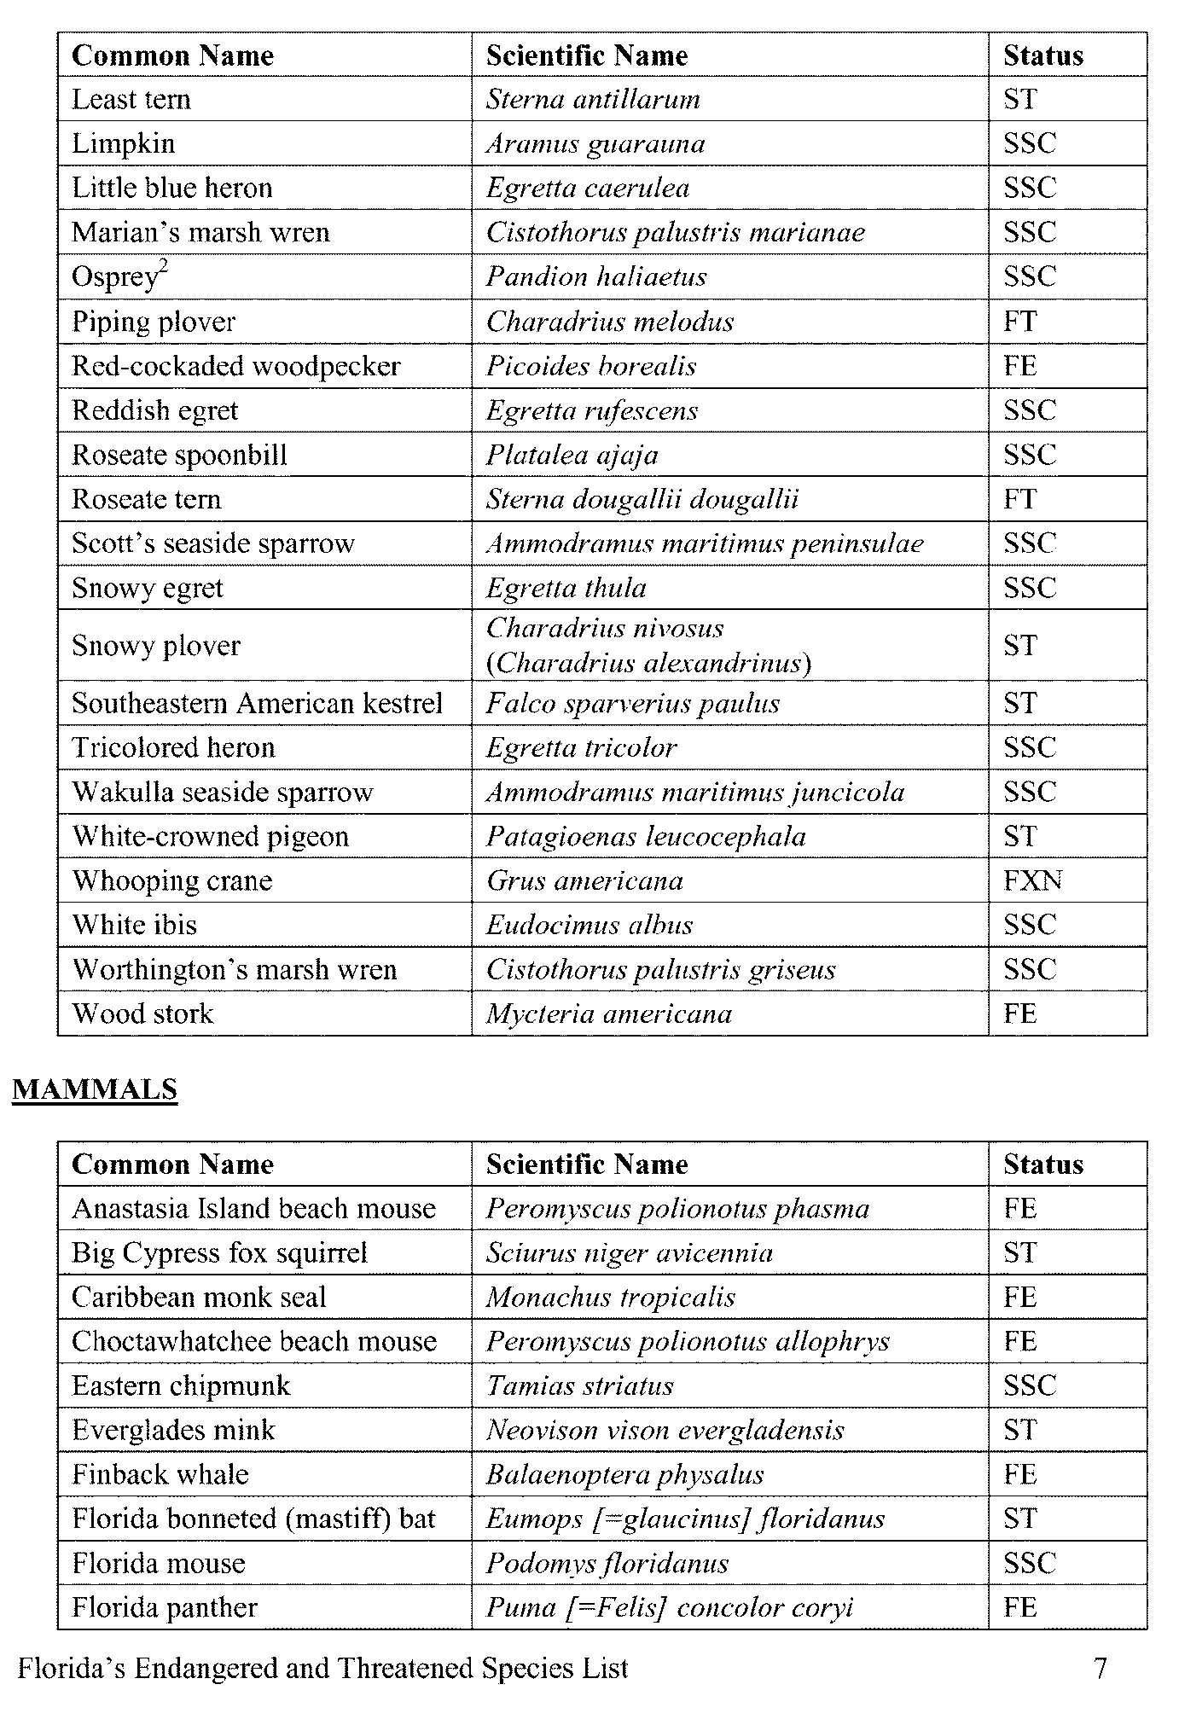

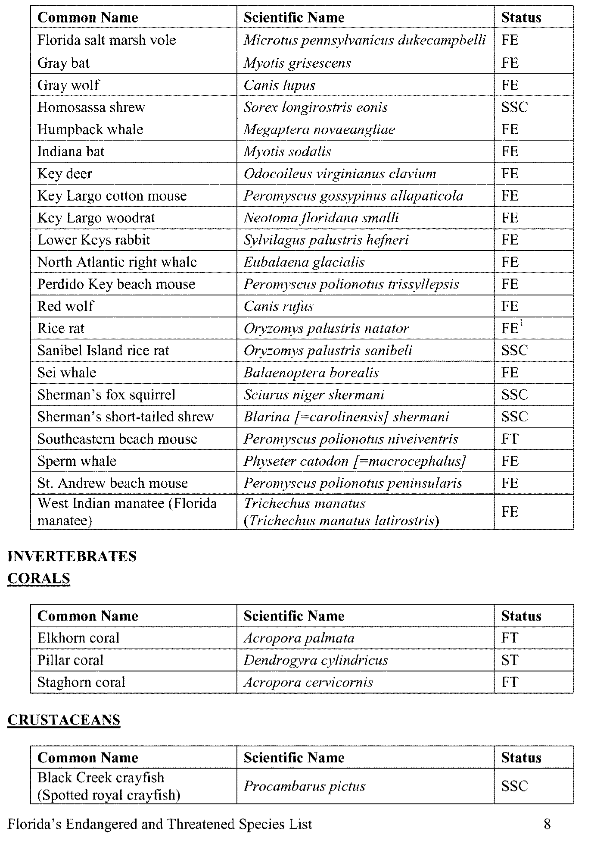

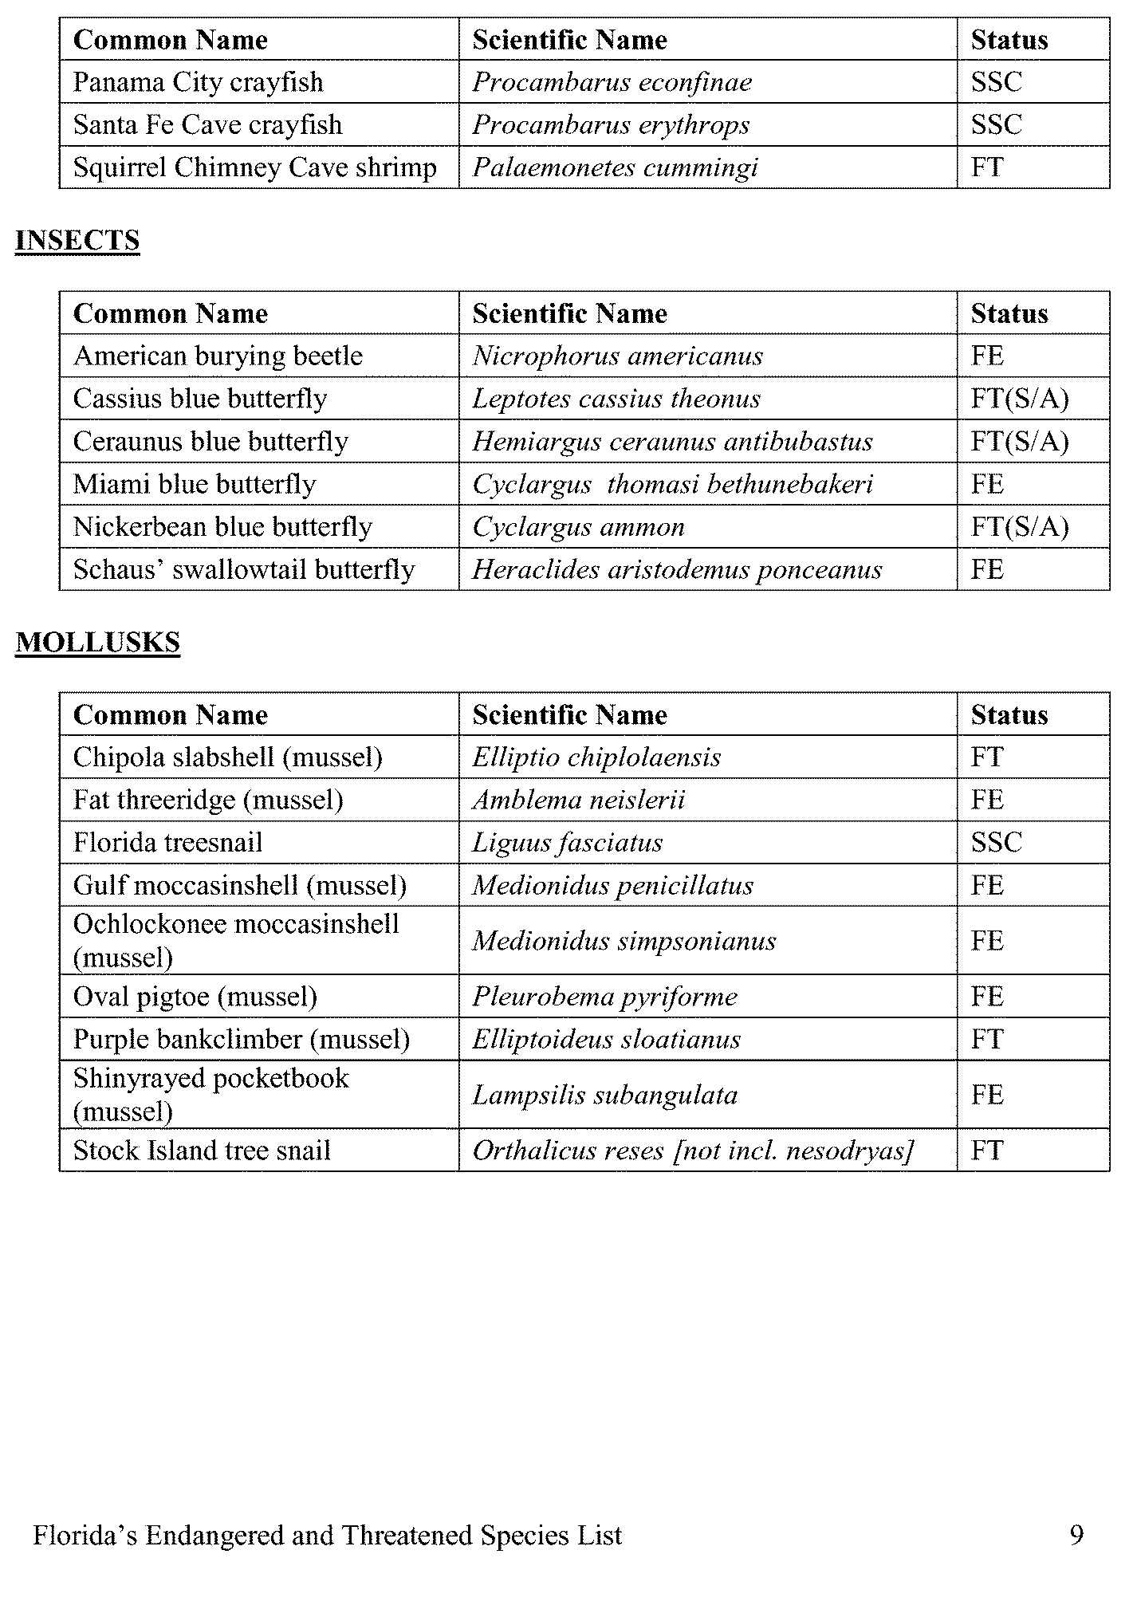

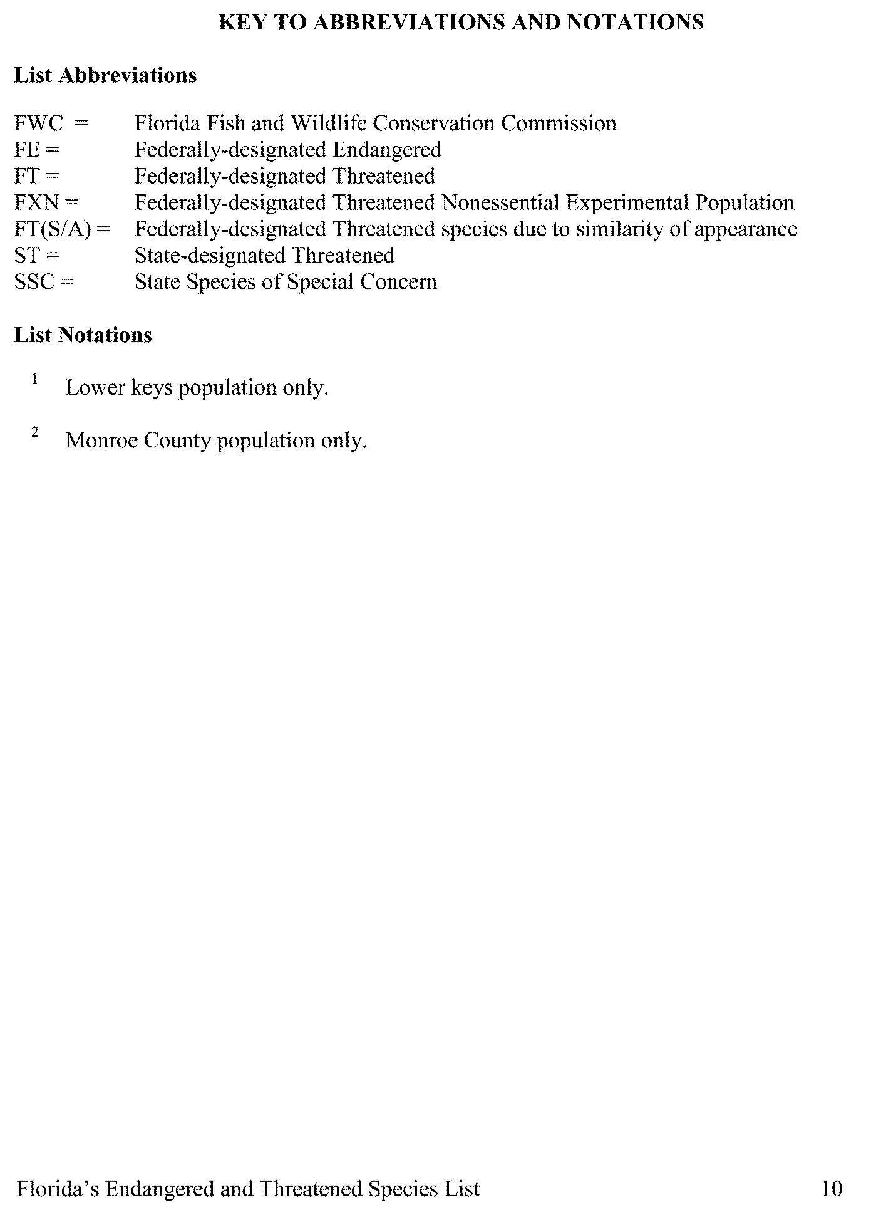

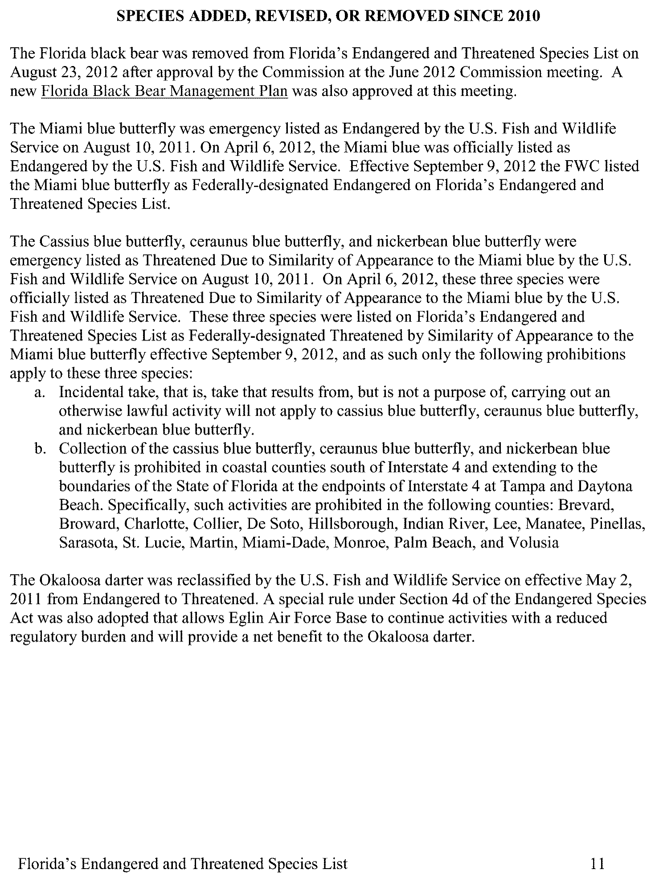

# Environmental Measures Team Final Report

*Attachment C – Soils Studies*

*November, 2013*

## Attachment C – Soils Studies at EMT Wetland Sites

Christina Uranowski, SWFWMD; Travis Richardson, SJRWMD; Gregory Sawka, Southeast Soil & Environmental Service, Inc.

### Introduction

Hydric soils are soils that formed under conditions of saturation, flooding, or ponding long enough during the growing season to develop anaerobic conditions in the upper part. These conditions result in specific soil morphologies, which are defined in Field Indicators of Hydric Soils in the United States (USDA, NRCS 2010). Hydric soils are generally characterized by the accumulation of organic matter or by the presence of redoximorphic features that result from the reduction and translocation of iron or manganese.

Accumulation of organic matter typically occurs in wetlands where frequent saturation or inundation (and associated anaerobic conditions) result in lower decomposition rates. The accumulation of organic matter is a slow process, due to the multiple factors and processes involved, and can take more than 100 years to form 1” of muck. The same amount of muck can be lost in a single year through oxidation when organic soils are drained.

Redoximorphic features near the soil surface also typically occur within wetlands because this soil morphology will only form in anaerobic conditions. Iron and manganese are immobile in aerobic conditions, but mobile in anaerobic conditions. Under anaerobic conditions iron and manganese are removed from some areas and concentrate in others resulting in the depletions and concentrations characteristic of redoximorphic features.

Accumulation of organic matter and formation of redoximorphic features are directly related to hydrology and, therefore, are a critical component to consider when assessing the hydrology of a wetland system.

### Subsequent Soil Studies

A complete hydric soils assessment was completed for 44 wetlands investigated for the CFWI. This process was initiated by assessing the data needs and developing a field data sheet (**Figure C‐1**) with input from the CFWI EMT, an independent soil scientist, and a SJRWMD soil scientist. The field data sheet was created to facilitate consistency between the two field data collection teams and ensure that all necessary data was collected. Each site was then researched to obtain elevations and datums for known benchmarks or staff gages and aerial imagery and other maps were reviewed to identify potential field sites. In general, field sites were established on public lands in areas with unaltered soils and relatively short distances between the wetland and adjacent uplands.

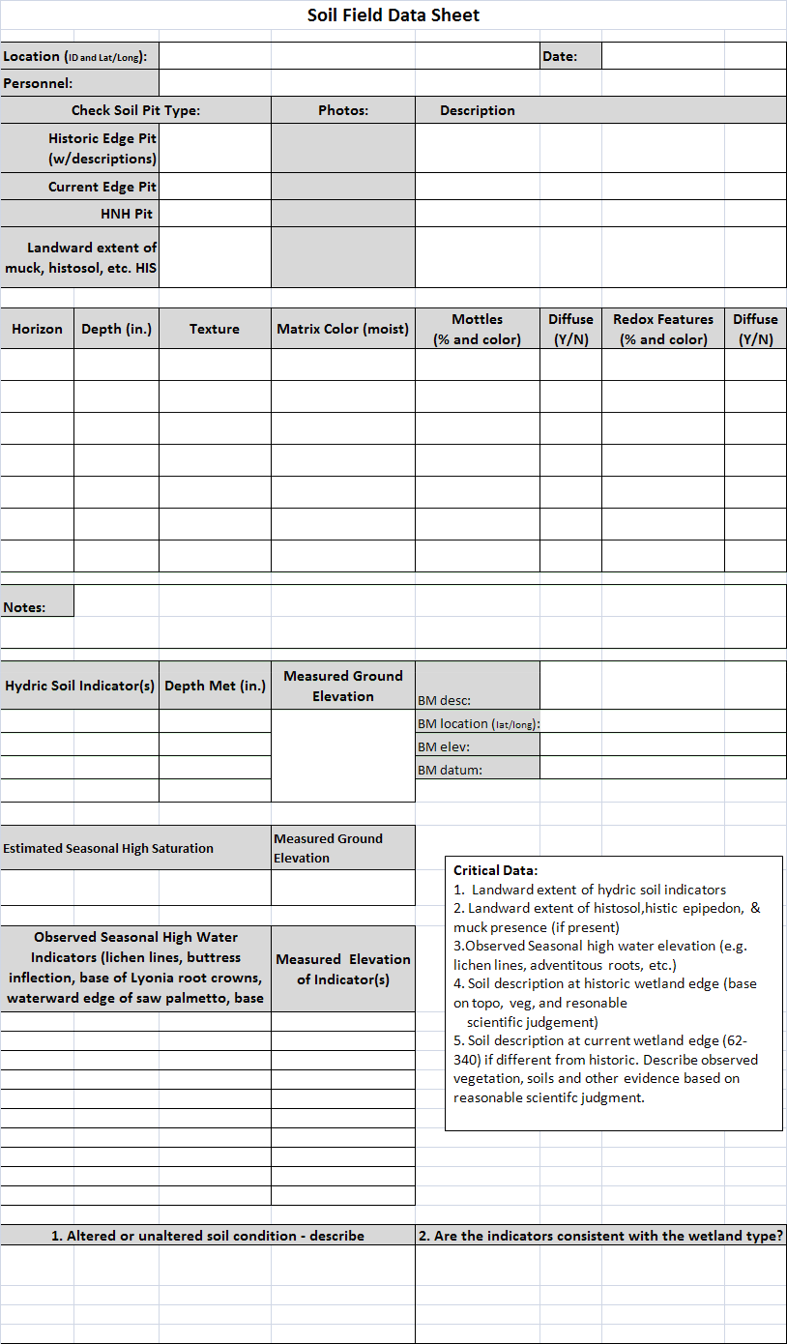

**Figure C‐1. Sample of the field data sheet for collecting soils information**

The two field data collection teams completed joint assessments on Lake Rosalie and Big Gum Lake as a calibration exercise. Soils were described at the historic wetland/upland edge, the current upland/wetland edge (if different from historic), the hydric/non‐hydric soil boundary, the landward

extent of muck, landward extent of histic epipedon (8” of organic soil), and landward extent of histosols (16” of organic soil). The landward extent of other hydric soil indicators were also described at some locations, but was not required. Hydric soil indicators (see below) were observed at the 44 wetlands and lakes investigated. Soil descriptions followed standard USDA, NRCS procedures (Schoeneberger et. al. 2012) for describing and sampling soils that includes the depth, color, texture, and other pertinent characteristic of each soil horizon. Ground elevations were determined at the location of each soil pit.

The two field data collection teams assessed indicators of seasonal high water, composition of vegetative communities, and the observed soils to determine if the hydrology suggested by each of these components was consistent. If inconsistencies or alterations were observed these were documented on the field sheets.

### Select Hydric Soil Field Indicators

*A7. 5 cm Mucky Mineral.* For use in LRRs P, T, U, and Z. *A mucky modified mineral surface layer 5 cm (2 in) or more thick starting within 15 cm (6 in) of the soil surface.*

**5 cm Mucky Mineral User Notes:** *Mucky* is a USDA texture modifier for mineral soil. The organic carbon content is at least 5 percent and ranges to as high as 18 percent. The percentage requirement is dependent upon the clay content of the soil; the higher the clay content, the higher the organic carbon requirement. An example is mucky fine sand that has at least 5 percent organic carbon, but not more than about 12 percent organic carbon. Another example is mucky sandy loam that has at least 7 percent organic carbon, but not more than about 14 percent organic carbon. See the glossary for the definition of mucky modified mineral texture.

*A8. Muck Presence.* For use in LRRs U, V, and Z.*A layer of muck that has a value 3 or less and chroma 1 or less within 15 cm (6 in) of the soil surface.*

**Muck Presence User Notes:** The presence of muck of any thickness within 15 cm (6 in) is the only requirement. Normally this expression of anaerobiosis is at the soil surface; however, it may occur at any depth within 15 cm (6 in). Muck is sapric soil material with at least 12 to 18 percent organic carbon. Organic soil material is called muck (sapric soil material) if virtually all of the material has under‐gone sufficient decomposition such that plant parts cannot be identified. Hemic (mucky peat) and fibric (peat) soil materials do not qualify. To determine if muck is present, first remove loose leaves, needles, bark, and other easily identified plant remains. This is sometimes called a leaf/root mat. Then examine for decomposed organic soil material. Generally, muck is black and has a greasy feel; sand grains should not be evident. Hydric soil indicator determinations are made below the leaf or root mat; how‐ever, root mats that meet the definition of hemic or fibric soil material are included in the decision‐ making process for Mucky Peat, Peat, Organic Bodies, or Histic Indicators.

*S5. Sandy Redox.* For use in all LRRs except V, W, X, and Y. *A layer starting within 15 cm (6 in) of the soil surface that is at least 10 cm (4 in) thick and has a matrix with 60 percent or more chroma 2 or less with 2 percent or more distinct or prominent redox concentrations as soft masses and/or pore linings.*

**Sandy Redox User Notes:** Distinct and prominent are defined in the glossary. Redox concentrations include iron and manganese masses (reddish mottles) and pore linings (Vepraskas, 1994). Included within this concept of redox concentrations are iron/manganese bodies as soft masses with diffuse boundaries. Common (2 to less than 20 percent) or many (20 percent or more)redox concentrations are

required (USDA, NRCS, 2002). If the soil is saturated at the time of sampling, it may be necessary to let it dry to a moist condition for redox features to become visible.

*S6. Stripped Matrix.* For use in all LRRs except V, W, X, and Y. *A layer starting within 15 cm (6 in) of the soil surface in which iron/manganese oxides and/or organic matter have been stripped from the matrix exposing the primary base color of soil materials. The stripped areas and translocated oxides and/or organic matter form a diffuse splotchy pattern of two or more colors. The stripped zones are 10 percent or more of the volume; they are rounded and approximately 1 to 3 cm (0.5 to 1 in) in diameter.*

**Stripped Matrix User Notes:** This indicator includes the indicator previously named *polychromatic matrix* as well as the term *streaking*. Common to many areas of stripped (unmasked) soil materials are required. The stripped areas are typically 1 to 3 cm (0.5 to 1 in) in size but may be larger or smaller.

Commonly the stripped areas have a value of 5 or more and chroma of 1 and/or 2 and the unstrapped areas have chroma of 3 and/or 4. The matrix (predominant color) may not have the material with chroma of 3 and/or 4. The mobilization and translocation of oxides and/or organic matter is the important process and should result in splotchy masked and unmasked soil areas. This may be a difficult pattern to recognize and is more evident when a horizontal slice is observed.

*S7. Dark Surface.* For use in LRRs N, P, R, S, T, U, V, and Z. *A layer 10 cm (4 in) or more thick starting within the upper 15 cm (6 in) of the soil surface with a matrix value 3 or less and chroma 1 or less. At least 70 percent of the visible soil particles must be covered, coated, or similarly masked with organic material. The matrix color of the layer immediately below the dark layer must have chroma 2 or less.*

**Dark Surface User Notes:** The organic carbon content of this indicator is slightly less than required for mucky. An undisturbed sample must be observed. A 10X or 15X hand lens is an excellent tool to aid this decision. Many wet soils have a ratio of about 50 percent soil particles that are covered or coated with organic matter and about 50 percent uncoated or uncovered soil particles, giving the soil a salt and pepper appearance. Where the percent of coverage is less than 70 percent, a Dark Surface indicator is not present

Field Soil Study Results

Field Study results are summarized in Table C‐1 in terms of defining elevations of the wetland edge. Additional work by the EMT determined whether systems were stressed or hydrologically altered (see main document). Analyses of historical hydrologic data were used to determine p80 values.

Table C‐1. Data from the 44 CFWI EMT Class 1 Wetlands. Soils studies were used to determine the edge reference elevation for each site. Hydrologic analyses provided the p80 values. Additional studies were conducted by the EMT to determine whether sites were hydrologically stressed (see main report).

|  |  |  |  |  |  |  |  |  |
| --- | --- | --- | --- | --- | --- | --- | --- | --- |
| **No.** | **Site Name** | **CFCA ID** | **Physio‐ Region** | **P80 (2006‐ 2011) (ft. NGVD 29)** | **Edge Reference Elevation**  **(ft. NGVD 29)** | **θ (ft.)** | **Stressed** | **Hydro Altered** |
| 1 | Unnamed Cypress | SJ‐LA | Plain | 69.26 | 70.44 | 1.18 | No | No |
| 2 | Green Swamp Marsh #304 | SW‐LI | Plain | 92.64 | 93.90 | 1.26 | No | No |
| 3 | Green Swamp #1, #298 | SW‐LM | Plain | 98.43 | 100.60 | 2.17 | No | No |
| 4 | City of Cocoa, Well 9T | SJ‐LL | Plain | 71.38 | 74.14 | 2.76 | No | No |
| 5 | Walker Ranch ‐ WR9 | SF‐XZ | Plain | 65.57 | 68.34 | 2.77 | No | No |
| 6 | Green Swamp 7 | SW‐AA | Plain | 103.19 | 106.37 | 3.18 | No | No |
| 7 | Walker Ranch ‐ WR6 | SF‐LB | Plain | 61.00 | 64.47 | 3.47 | No | No |
| 8 | Green Swamp #5, #302 | SW‐LK | Plain | 95.28 | 98.80 | 3.52 | No | No |
| 9 | Walker Ranch ‐ WR11 | SF‐LA | Plain | 63.79 | 67.68 | 3.89 | No | No |
| 10 | Green Swamp #6, #303 | SW‐LJ | Plain | 94.07 | 98.10 | 4.03 | No | No |
| 11 | Cypress Creek #199, W17 | SW‐LE | Plain | 63.34 | 64.95 | 1.61 | Yes | No |
| 12 | Tibet Butler ‐ TB2*** | SF‐YK | Plain | 98.72 | 102.63 | 3.91 | Yes | No |
| 13 | Lake Gem | SJ‐AJ | Plain | 48.74 | 53.39 | 4.65 | Yes | Yes |
| 14 | Cypress Creek #221, W33 | SW‐LH | Plain | 65.92 | 70.79 | 4.87 | Yes | No |
| 15 | Boggy Marsh | SJ‐LC | Plain | 113.82 | 118.82 | 5.00 | Yes | No |
| 16 | Island Lake ‐ 2774 | SJ‐LH | Plain | 81.86 | 87.49 | 5.63 | Yes | No |
| 17 | Cypress Creek #190 "E" Marsh | SW‐LF | Plain | 65.09 | 72.03 | 6.94 | Yes | No |
| 18 | Cypress Creek #223 "B" W46 | SW‐LG | Plain | 60.87 | 68.93 | 8.06 | Yes | No |
| 19 | Lake Leonore (Patrick) | SW‐QH | Ridge | 85.08 | 86.23 | 1.15 | No | No |
| 20 | Lake Annie (Highlands) | SW‐QE | Ridge | 109.95 | 111.49 | 1.54 | No | No |
| 21 | Gator Lake | SW‐QD | Ridge | 129.89 | 131.80 | 1.91 | No | No |
| 22 | Lake Apthorpe | SW‐QF | Ridge | 68.93 | 71.28 | 2.35 | No | Yes |
| 23 | Lake Van* | SW‐QK | Ridge | 131.08 | 134.32 | 3.24 | No | No |
| 24 | Lake Streety | SW‐QJ | Ridge | 103.21 | 105.95 | 2.74 | No | No |
| 25 | Bonnet Lake | SW‐QB | Ridge | 89.29 | 92.04 | 2.75 | No | No |
| 26 | Parks Lake | SW‐QO | Ridge | 99.83 | 102.81 | 2.98 | No | No |
| 27 | Surveyors Lake | SW‐QH | Ridge | 130.30 | 133.36 | 3.06 | No | No |
| 28 | Lake Garfield* | SW‐JJ | Ridge | 101.39 | 105.53 | 4.14 | No | Yes |
| 29 | Hopkins Prairie | SJ‐LD | Ridge | 23.71 | 27.50 | 3.79 | No | No |
| 30 | Johns Lake* | SJ‐QB | Ridge | 93.39 | 97.4 | 4.03 | No | No |
| 31 | Buck Lake (Highlands) | SW‐QC | Ridge | 89.87 | 95.05 | 5.18 | No | No |
| 32 | Lake Placid | SW‐QI | Ridge | 89.44 | 94.91 | 5.47 | No | No |
| 33 | Trout Lake* | SJ‐QC | Ridge | 90.59 | 97.60 | 7.01 | No | No |
| 34 | Polecat Lake | SW‐QM | Ridge | 139.50 | 144.37 | 4.87 | Yes | No** |
| 35 | Lake Louisa* | SJ‐LJ | Ridge | 92.41 | 97.29 | 4.88 | Yes | No |
| 36 | Big Gum Lake | SW‐QA | Ridge | 89.96 | 95.95 | 5.99 | Yes | Yes |
| 37 | Crooked Lake | SW‐QQ | Ridge | 115.12 | 121.29 | 6.17 | Yes | Yes* |
| 38 | Lake Apshawa | SJ‐LF | Ridge | 81.13 | 87.65 | 6.52 | Yes | No |
| 39 | Church Lake | SJ‐QA | Ridge | 82.66 | 90.37 | 7.71 | Yes | Yes* |
| 40 | Unnamed Wetland | SJ‐LB | Ridge | 61.41 | 69.37 | 7.96 | Yes | No |
| 41 | Lake Wales | SW‐MM | Ridge | 102.65 | 111.35 | 8.70 | Yes | No |
| 42 | Long Lake* | SJ‐QD | Ridge | 58.43 | 68.81 | 10.38 | Yes | No |
| 43 | Lake Avalon | SJ‐LE | Ridge | 86.30 | 96.68 | 10.38 | Yes | No |
| 44 | Lake Walker | SW‐QL | Ridge | 137.36 | 150.28 | 12.92 | Yes | No** |

*ERE and θ values were modified to values shown in the table per subsequent staff discussions.

### References

Schoeneberger, P.J., Wysocki, D.A., and Benham, E.C. (editors), 2012. Field book for describing and sampling soils, Version 3.0. Natural Resources Conservation Service, National Soil Survey Center, Lincoln, NE.

USDA, NRCS. 2002. Field Indicators of Hydric Soils in the United States, Version 5.0. G.W. Hurt, P.M. Whited, and R.F. Pringle (eds.). USDA, NRCS, in cooperation with the National Technical Committee for Hydric Soils,

USDA, NRCS. 2010. Field Indicators of Hydric Soils in the United States, Version 7.0. L.M. Vasilas, G.W. Hurt, and C.V. Noble (eds). USDA, NRCS, in cooperation with the National Technical Committee for Hydric Soils, Fort Worth, TX.

Vepraskas, M.J. 1994. Redoximorphic features for identifying aquic conditions. Tech. Bull. 301, NC Agric.

Res. Serv., Raleigh, NC.

# Environmental Measures Team Final Report

*Attachment D – Literature Review to Support EMT Tasks*

*November, 2013*

## Attachment D ‐ Literature Review to Support EMT Tasks

Joel VanArman, South Florida Water Management District Shirley Denton, Cardno‐ENTRIX, Inc.

## Introduction

The Environmental Measures Team (EMT), as part of the Central Florida Water Initiative (CFWI) was tasked with reviewing previous environmental assessments conducted within the region, performing additional assessments of wetlands, and other related work needed to support determination of sustainable groundwater withdrawals in the CFWI. As part of this effort, the team initiated a review of relevant published scientific literature.

The purpose of this review was to assist in determining whether the methods and tools used and developed by the EMT are appropriate and suitable for their purpose and consistent with methods and tools used in other similar studies from Florida and elsewhere. This was not intended to be a detailed review of the literature, but rather a targeted survey to determine the extent to which existing scientific studies provided support for the “critical assumptions” that were the basis for the EMT investigations and analyses. These assumptions were as follows:

1. Wetland ecology is a function of hydrology, past conditions, and non‐hydrological changes (such as land use changes in the watershed and availability of native and non‐native species for colonization) and other factors that affect wetland structure, species composition and ecosystem functions.
2. Wetland vegetation and soils largely respond in predictable ways to changes in hydrology, regardless of the cause of the change. Responses to change may vary depending on system type.
3. Non‐hydrological changes can also alter wetland condition and need to be considered in any assessment of wetland condition relative to hydrology.
4. The time duration over which hydrologic (and other) stresses are applied to a wetland affects the extent to which changes to wetland vegetation and soils are apparent.
5. The extent to which changes to the Upper Floridan Aquifer or surficial aquifer system are translated into changes to surface feature hydrology varies with physiography and underlying geology.

Several other literature reviews have been conducted in recent years related to these topics. Results of these reviews were incorporated. Emphasis was placed on identifying other more recent studies that may not have been included in the prior literature reviews.

## Scope, Method and Approach

Two types of wetland systems were the major focus of this investigation. Lacustrine wetlands occupy shallow areas of lakes, along the perimeter or on the edges of islands. Palustrine wetlands include all freshwater, non‐tidal wetlands that are substantially covered with emergent vegetation‐‐trees, shrubs, moss, etc. The review mostly excluded studies of brackish or saltwater wetlands, riverine wetlands

(floodplains), wetlands located on seepage slopes, and extensive, interconnected wetland systems such as strands.

Scientific studies conducted to determine effects of reduced water levels in lakes and wetlands were the primary focus. Reduced water levels may occur periodically due to low rainfall conditions during the dry season or droughts. Drawdowns may also occur suddenly as the result of substrate collapse and sinkhole formation or less rapidly due to drainage, water withdrawals for human use or surface water management practices. In addition to water level reductions that occur naturally or incidentally due to human activities, periodic drawdowns are sometimes employed for effective lake or wetland management, or to facilitate mining or construction activities on adjacent lands.

In wetlands, reductions in water levels may result in migration of wetland plant community zones down slope to a lower elevation, leading to degradation or loss of the existing wetland and potential for the conversion of open lakes to wetlands. Even though some wetlands are destroyed and some new wetlands are created, the net result may be a net loss in areal extent of wetlands, a change in abundance and distribution of species, and a loss, shift or reduction of wetland functions and benefits, especially while the system is adjusting to the new water regime. The resulting disturbance may favor the influx or expansion of both native and non‐native nuisance species. In lakes, water level reductions may lead to an expansion of the littoral zone and submerged vegetation into areas that were formerly open water. These problems can be exacerbated by water level stabilization and increased influx of nutrients. Changes in wetland hydropattern (frequency and duration of minimum, maximum and intermediate water levels) can lead to dramatic changes in the composition and distribution of plant communities, soil characteristics and habitat.

Most wetland studies focus on the plant communities. Plants are the basis of the wetland food chain and provide both nutrition and habitat for associated animal communities. Major wetland types (e.g. prairies, marshes, swamps) are usually named primarily on the basis of their associated plant species assemblages and key environmental factors. Within a given geographic region such as Central Florida, the species composition of the wetlands in similar physiographic and hydrologic settings tends to be similar. A “plains” marsh on inorganic soils in the eastern part of the region will typically contain plants that are similar to those found in a plains marsh on inorganic soil in the western part of the region.

Exceptions occur with respect to a plant species that may have very specialized habitat or reproductive requirements.

The presence and abundance of macroinvertebrates and small fishes are often studied, since they can be seasonally abundant in shallow wetlands or occur year‐round in systems that remain hydrated.

Many types of macroinvertebrates have fairly specific requirements in terms of food sources, substrate and seasonal reproductive and larval development requirements, but have widespread distribution wherever these conditions occur. Some amphibians have very specific requirements for water presence during their breeding seasons and adequate time for tadpoles to mature into adults, sometimes coupled with a need for the wetland to dry down to eliminate predators (fish). Because of this specificity, certain species of vertebrates and invertebrates are useful as “indicators.” Some species are indicators of polluted or disturbed conditions, while others are found only in undisturbed or pristine environments.

By contrast, populations of larger animals such as birds and mammals can show extreme variations spatially, seasonally and from year‐to‐year. This can be especially true of migratory and/or threatened or endangered species. Birds, for example, may be very abundant in a particular lake or wetland one year and then absent the next year. Since these species are more difficult to observe and measure, there is much less literature available concerning the use of wetlands by birds and mammals.

In addition to their ecological impacts on lake wetlands, reduced water levels also affect navigation, recreation, fisheries, aesthetics, water quality and aquatic weed population dynamics. Studies of such factors were also noted in the literature review. These considerations have been used when establishing Minimum Flow and Level criteria (as outlined in Ch 373.042 F.S.) for water bodies, especially systems surrounded by development. The reviewers also looked for studies that employed innovative ways to sample or analyze data and/or determine stress or harm based on statistical characteristics of populations

Most of the literature search was conducted in the period from November 2012 to January 2013. The following databases were queried to conduct this review:

* Google Scholar, <http://www.google.com/intl/en/scholar/about.html>
* Palm Beach Atlantic University, West Palm Beach, FL <http://www.pba.edu/the>‐warren‐library
* University of Florida Wetlands Center in Gainesville, <http://www.cfw.ufl.edu/publications.shtml>
* The University of Florida/IFAS Center for Aquatic and Invasive Plants (APIRS) database, <http://plants.ifas.ufl.edu/APIRS/>
* South Florida Water Management District library facilities and publications, <http://www.sfwmd.gov/portal/pls/portal/portal_apps.repository_lib_pkg.repository_browse>
* St Johns River Water Management District reports, <http://floridaswater.com/technicalreports/> and [http://www.sjrwmd.com/minimumflowsandlevels/,](http://www.sjrwmd.com/minimumflowsandlevels/)
* Southwest Florida Water Management District, <http://www.swfwmd.state.fl.us/documents/> and [http://www.swfwmd.state.fl.us/projects/mfl/mfl_reports.php,Science](http://www.swfwmd.state.fl.us/projects/mfl/mfl_reports.php%2CScience) Direct, <http://www.info.sciverse.com/sciencedirect>
* Proquest, <http://www.proquest.com/en>‐US/access/connect.shtml
* Florida geological Society Publications, <http://www.dep.state.fl.us/geology/publications/listofpubs.htm>
* National Academy of Sciences Publications <http://dels.nas.edu/>
* United States Geological Survey (USGS) Florida Water Science Center, <http://fl.water.usgs.gov/publications/bibliography/bibliography.html>
* Association of State Wetland Managers (ASWM) <http://www.aswm.org/wetland>‐ science/wetland‐science/825‐publicationsreports

EMT team members developed several lists of key words and concepts that were used as the basis for document database queries:

* Aquifer‐lake interaction
* Aquifer‐wetland interaction
* Biodiversity change hydroperiod reduction
* Cypress growth rates hydroperiod reduction
* Cypress root rot hydroperiod
* Drawdown/drought/reduced water level and hydroperiod effects on wetlands and lake littoral zones
* Fish reproduction effects of lake area and littoral shelf
* Lake area reduction – effects on aesthetic acceptability or recreational use
* Effects of hydrologic changes on Wetland species diseases and growth rates
* Effects of water levels on dissolved oxygen concentrations in lakes and wetlands
* Lake littoral shelf or wetland/marsh area effect on plant or animal biodiversity
* Lake or wetland drawdown
* Lake or Wetland hydrology
* Lake or wetland relationship to aquifer or groundwater levels
* Lake or wetland/marsh animal (fish, birds, macro‐invertebrates, amphibians) habitats reduced water levels
* Marsh species hydroperiod reduction
* Modeling lake or wetland response to water levels
* Plant or animal stress, damage or harm due to lake or wetland drawdown
* Soil oxidation, loss, subsidence due to decreased water levels
* Soil subsidence relationship to saturation and duration of inundation
* Water level regulation of lakes or wetlands
* Wetland water level or hydroperiod reduction effects nutrient cycling
* Wetland water level or hydroperiod reduction effects on plants or animals
* Wetland/Lake Statistical analysis of hydrology related to biota

## Results

#### Types of Studies

A large number of literature citations (> 10,000) were initially identified that relate to the subject matter. Efforts were made to reduce and refine the search parameters and to place priority on studies that seemed to be most relevant to the EMT efforts and for which physical copies or electronic versions of the study could be obtained with available resources.

Emphasis was placed on the following types of investigations, although some additional studies that seemed particularly relevant or interesting were included:

* Studies conducted in the last 20 years (1992‐2013), and especially in the last seven years (2005‐ 2013).
* Studies conducted over multiple systems, watershed or regions as well as site‐specific investigations
* Studies conducted in the southern United States, especially central and southern Florida and studies conducted on similar geological settings such as coastal plains as opposed to temperate prairies, mountainous or arid regions, etc.
* Studies conducted in palustrine and lacustrine wetlands rather than riverine, seepage‐driven and coastal wetland systems, which were generally excluded.

**Table D‐1** provides a summary of the investigations. A total of 367 citations from the selected literature were compiled in a simple spreadsheet database and categorized by date, author, system type (wetland, lake, other), and study type (hydrology, vegetation, invertebrates, groundwater, water quality, modeling, etc.). Electronic copies of most of these papers are compiled in a separate archive.

Of the total number of citations examined, more than half represented studies conducted in Florida. More than half of the studies were conducted in palustrine wetlands. More than 100 additional studies were conducted in lacustrine wetlands or a mixture of both palustrine and lacustrine wetlands.

Approximately 20% of the studies were conducted in association with the Minimum Flows and Levels programs of the water management districts. The Florida studies were considered to be the most relevant, since they most informed the methods developed by the EMT. Studies from other areas were generally less useful because they have different species of plants and animals as well as different climate and hydrology, topography, soils and geology, and deal with somewhat different water management issues than are typically encountered in Central Florida.

**Table D‐1. References Related to Wetlands Compiled for the EMT Literature Review**

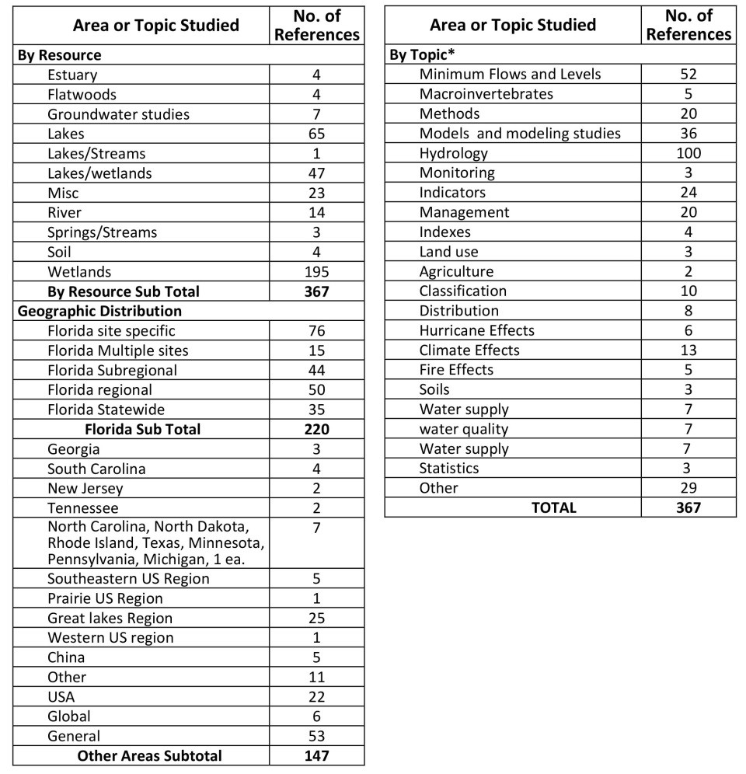

Nevertheless, some of these less obviously relevant studies provided additional insight into new or emerging issues, and methods that may be potentially useful for application in the CFWI region.

#### Support for EMT Critical Assumptions and Approaches

Results of the search were analyzed to determine the extent to which existing scientific studies provide support for the six “critical assumptions” (see above) of the EMT investigations and analyses.

**Conditions that affect wetland ecology**

Wetland ecology is a function of hydrology, past conditions, and non‐hydrological changes (such as land use changes in the watershed and availability of native and non‐native species for colonization) that

affect wetland species composition and function. Most of the wetland studies reviewed were based on this same or similar assumptions, which may or may not have been explicitly stated, so there is excellent support in the literature for this assumption (for instance, Lentz and Dunson, 2006; Gregory, et al., 2006; Brown and Vivas, 2005).

**Wetlands may change over time in response to changes in climate regime**

A number of studies indicate that wetlands that exist in Florida today have been shaped by many cycles of natural climate change, including periods of warmer temperatures, glaciation and a wide range of sea‐level fluctuation. The distribution, extent and species composition of wetlands are natural occurrences and the species that live in Florida today represent communities that have evolved, adapted, and/or been selected for these conditions (Gaiser et al., 2009; Bernhardt and Willard, 2009) .

Wetlands respond to short‐term extreme events. Extreme events whose effects are often localized and of short duration, such as hurricanes, tornadoes, fires, floods and freezes impact Florida’s wetlands (see for example Wade et al., 1980, Brandt and Ewel, 1989; Lovelace and McPherson, 1997; Deng et al., 2010). The damage caused by these events can sometimes persists for a long time, especially if they alter overall hydrologic conditions (Smith et al., 2009; Morton and Barras, 2011; Farris et al., 2007).

However, climatic stressors and extreme events are a normal part of wetland ecology (e.g., decadal wet and dry cycles, periodic drought, fire or freezes) and are essential for maintaining wetland health (Frederickson, 1991; Shipley and Parent, 1991). The importance of periodic extremes has been emphasized in the lake and stream MFL methods of the SJRWMD (Neubauer et al., 2008).

**Wetlands respond to hydrologic change**

Wetland vegetation and soils largely respond in predictable ways to changes in hydrology, regardless of the cause of the change. The nature of the may vary depending on system type (for instance, Palanisamy and Chui, 2012; Webb et al., 2012; Lee, 2002).

**Wetlands respond to global‐scale phenomena and climate change**

Hydrologic conditions vary over long periods that reflect changes in global‐scale phenomena, including solar activity, changes in orbital distance from the sun, global temperature cycles, changing sea levels and major oceanic currents (IPCC, 2001). These changes may act over periods of decades or longer.

Atmospheric temperatures and hydrologic conditions are affected by cyclic, multi‐year or multi‐decadal global weather phenomena such as the Atlantic Multidecadal Oscillation (AMO )(Kelly and Gore, 2008) the El‐Niño – Southern Oscillation (ENSO) (Donders et al., 2005) and others (Obeysekera et al., 2011), and by changes in the chemical composition of the atmosphere (IPCC, 2007), and by global events such as large volcanic eruptions (Neely et al., 2013).

**Time Required for wetlands to respond to changing conditions**

The time duration over which hydrologic (and other) stresses are applied to a wetland affects the extent to which changes to wetland vegetation and soils are apparent (for instance, Odland and Moral, 2002; Smith et al., 2008; Wilcox, 2004; Busch et al., 1998; SFWMD, 2000; Rochow, 1985). The species composition of a mature swamp canopy may not change for decades or longer after hydrologic conditions change. However, composition of the understory may change rapidly and dramatically as aquatic species disappear, seeds of wetland species fail to germinate and terrestrial species invade the

system (David, 1996; Armentano et al., 2006). Unnaturally dry conditions, which lead to desiccation of organic soils and proliferation of inappropriate understory vegetation, may eventually lead to complete loss of the swamp by tree collapse and more frequent fires (SFWMD, 2000). Rates of change and dependencies on hydrological regime have been estimated for some factors, such as soil subsidence (Stephen and Johnson, 1951; Shih et al., 1998); but are less well known for others.

**Wetland relationships to groundwater**

The extents to which changes to the Upper Floridan aquifer or surficial aquifer system are translated into changes to surface feature hydrology vary with physiography and variations in the underlying geology, including sinkhole formation. (for instance Sacks, 2002; Sanderson and Cooper, 2008; Tobias et al., 2001; SFWMD, 1995; SWFWMD, 1999; Swancar and Lee, 2003; Swancar et al., 2000; Sun et al., 2006; Whitman et al., 1999)

#### Other Issues and Concerns Related to Wetland Values and Impacts

In addition, we also looked for support for other methodological decisions, approaches selected, wetland values and impacts assessed during the study, including the development of the wetland classification scheme; stress determination; statistical approaches, water quality considerations and wetland‐associated animal communities.

**Strengths and weaknesses of modeling applied to wetlands**

Modeling of current and future hydrology is a useful tool, but model limitations and the nature of the output provided to the EMT limit how the tool can appropriately be applied. For the regional‐scale model developed for the CFWI, the EMT chose to use a probabilistic approach. This type of approach has been demonstrated in several other studies (Wilcox and Xie, 2007; 2008; Nilsson et al., 2013) to be effective and appropriate.

**GIS and modeling approaches**

Many studies applied GIS tools at various points in their investigations as a means to organize and compile data and visually represent wetland features obtained from aerial photography, remote sensing, land use studies, ground surveys and other sources of information (for instance Williams and Lyon, 1997; Dronova et al., 2011; Kinser and Minno, 1995; Dunn et al., 2008; Cole and Korfmacher, 2010; Wilcox et al., 2008). Aerial photography and satellite imagery combined with soil survey data can provide a basis for estimating the boundaries and extent of major wetlands), but ground‐truthing is needed to determine species composition, hydration, the degree to which connections exist to adjacent lakes or wetlands, more subtle features that might indicate stress or harm, whether the system has been hydrologically altered by land use changes, construction or drainage activities.

GIS tools are often used as a means to organize and present data for planning and decision‐making and for input to, and representation of, output data from modeling studies, by using the capability to overlay multiple data sets such as soil, water quality, water depth , land use, etc. GIS tools also provide a basis for Landscape modeling – the applications of GIS and modeling tools to predict wetland/ vegetation changes in response to changes in hydrology, water quality, etc. over large areas (for example deAngelis, 1998; Zhang et al., 2011)..

Conceptual models can provide a useful planning tool for organizing information related to a wetland and identifying what is known from what is unknown about ecosystem dynamics, stressors, etc. (for example, Pyzoha et al., 2008; Ogden et al., 2005).

Mathematical models were used in 35 of the studies reviewed, primarily to predict hydrologic conditions and system responses. Models are often the tools of choice for studies that cover large areas or in cases where multiple scenarios need to be evaluated. This has become a common practice for analyses of future impacts caused by circumstances ranging from surface and groundwater withdrawals, construction of drainage and flood control projects, to assessment of potential effects of climate change (for example, Fan and Miguez‐Macho 2011; Lee, 2005).

There appears to be widespread acceptance in the science and engineering communities that despite the limitations of models to represent real‐world conditions, and the uncertainty of such predictions, models provide a highly useful and practical means to conduct these types of assessments (for example, Bengston and Padmanabhan, 1999; Loftin et al., 1990; USACE and SFWMD, 1999)..

The assumptions and limitations of any modeling approach need to be clearly stated and understood by decision‐makers. When using models as the basis for planning, it is typically emphasized that actions need to be implemented in an adaptive management context that includes monitoring and periodic review to verify hydrologic model predictions, verify resource response over time, and modify plans or designs to eliminate or compensate for unforeseen impacts (allowable withdrawals or structural features) in the future if wetland degradation becomes apparent. (for example, Manno et al., 2008; Richards et al., 2010; Yin and Yang, 2012; RECOVER, 2010; SFWMD and USACE 2011).

Groundwater‐surface water linked models have generally been used for site specific evaluations, such as to simulate the effects of well field withdrawals, etc. rather than across large regions. Models are used in this context to represent surface water‐groundwater interactions and relationship to evapotranspiration, rainfall, runoff, streamflow, seepage, drawdowns and other environmental factors (Reynolds and Spruill, 1995; Lopez et al., 1999; Schmutz and Willis, 2004; Merritt, 2001; Cheng and Anderson, 2003; Bradley, 2002; Wilcox and Xie, 2007; Hudon et al., 2006).

Output from hydrologic models has been used extensively in water resource planning to generate future hydrologic regimes as a basis to predict impacts on wetlands, for example to support development of Minimum Flows and Levels criteria (Kinser et al. 2003; SJRWMD, 2004; Ellison 2007) as well as to simulate transpiration effects (Liu et al., 1998; Sun et al., 1998; Lu et al., 2009). There are also some examples using models to simulate responses of animal communities, notably birds (Desgranges et al.

2006; Bolduc and Alton, 2008, fish (niekand 2006) and overall productivity (Grant et al. 2012). More broadly‐based, ecosystem‐level, modeling examples include eco‐response models (Limnotech, 2005; Chiu et al., 2011) and Landscape Models (deAngelis et al., 1998; Fitz and Paudel, 2012).

**Classification of wetlands.**

A number of studies develop or apply classification schemes as a means to place wetlands into logical groups. Such groupings help to simplify the analysis by not having to consider each wetland individually. The classification scheme generally considers some combination of geography, landscape position, geomorphology, hydropattern, climate, physical/chemical variables, and biogeographic processes

(Doherty et al., 2000a). Classification systems are typically developed by compiling or synthesizing data from the literature or from studies of individual systems and attempting to organize the data based on common features, such as dominant plant species (cypress swamps, sawgrass marshes), combined hydrologic and plant features (wet prairies, sloughs) nutrient status (oligotrophic lakes) water source (spring fed lakes, floodplains) etc.

Thus there are systems that are used globally (RAMSAR, 2006; Lehner and Doll, 2004), nationwide (Cowardin et al., 1979; Tiner, 2013), at the state level (FNAI, 2010; FDOT, 1999; Doherty et al., 2000; Lane et al, 2000) and at regional or subregional levels (Brinson, 1993; Wilcox, 2005; see review by Dunn, 2005). The nature of the classification system often depends on the diversity and uniqueness of the resources in the area, the likely changes or impacts that need to be assessed and the scale of the project, and specific project goals and accuracy needs.

A number of authors have recognized the relationship between groundwater‐fed and surface water fed systems as a distinguishing characteristic of wetlands (Bertrand et al., 2011; Almendinger, 1990; Harvey and McCormick, 2009; Skaggs et al., 2005) generally with respect to systems that receive direct groundwater seepage. Sensitivity to water level reductions in most wetland systems is based on vegetation type and soil conditions, especially in areas where there is no apparent hydrologic separation of the wetland from underlying aquifers (Shaw and Huffman, 1998). A major feature of concern to the CFWI study is the nature and degree of connection between lakes or wetlands and underlying surficial and deep aquifer systems, which were used as one of the bases for the classification system used in this study.

**Assessing wetland response to hydrologic changes**

A number of investigators have discussed the issue of assessing the “health” or condition of a wetland and making a determination of whether the system is experiencing stress or damage (USEPA, 2008; Pederson, 1998). Stress is generally perceived to occur when characteristics of the wetland change, but before the system has adjusted to the new environmental regime to the extent that the initial regime is no longer recognized. The most notable changes generally consist of shifts in the distribution or abundance of major plant species, changes in soil composition and structures, or changes in hydrology. Other, more subtle changes can also be monitored that provide prior indications of existing or pending impacts.

**Vegetation**. Various methods to assess changes in wetlands that have been used by the water management districts are discussed by Dunn, 2005. The kinds of changes that occur in vegetation communities include changes in dominant species, shifts from species that prefer wetter conditions to plants that prefer drier conditions (Black and Black, 1989) and changes in the location of species or features that indicate water level elevations (Carr et al., 2006)

**Soils.** Changes in soil conditions that occur in response to water level changes include soil oxidation and loss, sometimes leading to increased risk of fire and falling trees (Stephens and Stewart, 1977; Reddy et al. 2006; SFWMD, 2000; SWFWMD 1999).

**Hydrology.** Apparent changes in hydrology are also used as indicators of changes in the condition of wetlands, whether or not other effects have become apparent (Miao et el., 2009; Pelczar, 2011). In a

number of studies, changes in water levels due to declines in groundwater levels have been perceived as the primary factor causing changes to occur in wetlands (Mortellaro et al., 1995; Odland and del Moral, 2002). Even apparently small changes in average water depth and hydroperiod have been associated with changes in vegetation communities in natural wetlands (Dunn, 2005; Shaw and Huffman, 1996; SFWMD, 1995). Indicators have been developed and applied to infer recent hydrological conditions and whether changes are occurring, or have occurred, in the past (e.g. Carr et al., 2006). Some have been used to quantitatively determine surface water inundation requirements for wetland protection (Neubauer et al., 2008).

**Other Factors**. Other factors used as indicators include microbial communities (Sims et al., 2013 ) sugar content of cypress trees (Bacchus et al., 2000), carbon isotopes (Anderson et al., 2005), effects on birds breeding and nesting success (Brazner et al., 2007; Petersen and Niemi, 2007; Emery et al., 2009) changes in fish populations and abundance (Hoyer et al., 2006; Slater and Hall, 2010; Walsh et al., 2009; Ciborowski et al., 2009) and changes to macroinvertebrate communities (Carly et al., 2012; Silver et al., 2012).

A number of studies have developed indexes that combine a variety different observed features to with the intent to characterize overall condition for wetlands (Reiss, 2005a,b; Reiss, 2006; Lane et al., 2003; Brazner et al., 2007; Wilcox et al., 2002) and lakes (Gerritsen et al., 2000, Fore et al., 2007; Wilson and Bayley, 2007; Grabas et al., 2012; SWFWMD and Tampa Bay Water, 1995).

**Wetland relationships to water quality**

Wetlands have a significant capacity to provide water quality treatment for surface water runoff and wastewater (Schiffer, 1989; Zahina et al., 2001; Dierberg and Brezonik, 1985; Bulc et al., 2009; Brandt and Ewel, 1989), and many systems within the CFWI area have become hydrologically altered to receive discharge from adjacent development or from Rapid Infiltration Basin systems (RIBs). Wetlands also release nutrients into the water column when vegetation dies back during dry periods or droughts, or after fires occur.

Changes in wetland water depths and hydroperiod can affect water quality conditions, including temperature, oxygen saturation and nutrient cycling, as well as rates of soil accretion and loss of organic materials by oxidation. Water quality in Florida wetlands changes continually depending on predominant water source and biological activity (Haag and Lee, 2010). Generally, lower water levels in wetlands will result in higher temperatures, which lead to lower concentrations of dissolved oxygen in the remaining water and which, depending on temperature, may result in stress conditions for many aquatic species (Reiss et al., 2009). An increased proportion of groundwater contribution results in may lower levels of dissolved oxygen , (Phelps et al., 1996); however, in areas where groundwater is recharged rapidly by rainfall, DO in groundwater may be high (up to 7.3 ml/l per Adamski and Knowles, 1998). Groundwater is typically low in nutrients in non‐agricultural, non‐urban areas (Adamski and Knowles (1998). However, for urban areas with high connectivity to the aquifer system, groundwater may be higher in nutrients, especially nitrogen, and discharge to wetlands may result in higher nutrient levels, especially nitrogen (Phelps et al., 1996 for the Winter Park Chain of Lakes). Increased groundwater inflow in areas with limestone aquifers may also result in increased water clarity and

higher concentration of calcium carbonate (Metz and Sachs, 2002) as well as increased hardness, pH and alkalinity (Lee et al., 2009; Harvey and McCormick, 2009.)

Nutrient enrichment can accelerate the natural processes of eutrophication and peat formation. In subtropical systems this may be balanced by increased oxidation of organic materials (Reddy et al., 2007). Cypress swamps and other wetlands are used for advanced treatment of wastewater in a number of sites throughout Florida (Brandt and Ewel, 1989), and wetlands are frequently used for stormwater retention and treatment. Long‐term changes may occur from such practices that may be detrimental not only to the general condition of the wetland ecosystem but also to its long‐term effectiveness as a treatment system (Elder, 1988).

Plant species composition of wetlands can change as a function of water quality parameters such as hardness (mineral content), pH and alkalinity. Increase in mineralization is associated with changes in the composition of emergent marsh wet prairies and submerged aquatic vegetation and periphyton communities (Lee et al., 2009; Harvey and McCormick, 2009). Lentz‐Cipollini and Dunson (2006) demonstrated that differences in water quality between surface water and subsurface water sources affect wetland species composition and quality in seasonal ponds.

Release of nutrients from wetlands due to disturbance, dry conditions or fires can lead to periodic degradation of water quality in receiving lakes, rivers or wetlands (Galloway et al., 1999; White et al., 2008, Smith et al., 2001; Neary et al., 2008, Wright, 2013). These issues are of particular concern within wetlands that are managed for agriculture or as Stormwater Treatment Areas, where periodic drying, removal or disking of soil and plants may be a component of the management plan (Moustafa et al., 2012; Gesch et al., 2007)

**Animal communities.**

Animal populations and communities also respond over different time periods to changes in their environment. Macroinvertebrates and small fishes may complete several life cycles each year and thus tend to respond within weeks or months to changes in their environment, but stable and consistent communities of these organisms may take several years to form. Larger fishes may take two or more years to reach sexual maturity. Stable populations may require six years or more to form (SFWMD, 2006). Fish depend on seasonal availability of wetlands for spawning and to provide food and protection for larvae and juveniles. Many of the larger reptiles, birds and mammals seek out areas that meet their seasonal or annual habitat, feeding and reproductive requirements (Limnotech, 2005; Bolduc and Afton, 2008). Emery et al. (2009) found that birds seemed to be preferentially attracted to large lakes and that different bird species utilized different plant communities in the littoral zone. Successful feeding, reproduction and survival of many wading birds is often a reflection of seasonal timing, duration and extent of water level drawdowns (Bolduc and Afton, 2008)

Changes in hydrologic or water quality conditions within a wetland can lead to changes in habitat conditions and change the balance among food sources, prey and predator relationships in animal communities (Wilcox and Meeker, 1992). The population dynamics of macroinvertebrate communities are studied as means to assess habitat (wetland) quality and health (Sharma and Rawat, 2009), duration of wetland hydration (Silver et al., 2012) and especially water quality (Water and Air Research, 2000).

Leslie et al. (1977) studied the effects of wetland drying on macroinvertebrate populations in pond

cypress wetlands. Amphibians – notably frogs, tadpoles and salamanders depend on seasonal availability of water for egg laying and larval survival and the availability of insect larvae and adults as food sources (Surdick, 2005). Other examples studies of macroinvertebrate populations in wetlands include work by Hayworth (2000) in cypress forests, Sharma & Rawat (2009) in the Central Himalayas and Brazner et al. (2007) in the Great Lakes.

## Bibliography

Adamski, J.E. and L. Knowles, Jr. 1998. Ground‐water quality of the surficial aquifer system and the upper Floridan aquifer, Ocala National Forest and Lake County, Florida, 1990‐99. Water‐ Resources Investigations Report 01‐4008. U.S. Geological Survey in cooperation with the Lake County Water Authority. <http://fl.water.usgs.gov/PDF_files/wri01_4008_adamski.pdf>

Almendinger, I.E., 1990. Groundwater control of closed‐basin lake levels under steady‐state conditions.

Hydrology 112: 293‐318.

Anderson, W. and G.H. Hughes. 1975. Hydrology of three sinkhole basins in southwestern Seminole County, Florida. Florida Department of Natural Resources, Division of Resource Management Bureau of Geology, Report of Investigations No. 81. Tallahassee, FL, 45 pp.

Anderson, W.T., L.S.L. Sternbergc, M.C. Pinzon, T.Gann‐Troxler, D.L. Childers and M.Duever. 2005. Carbon isotopic composition of cypress trees from South Florida and changing hydrologic conditions. Dendrochronologia 23: 1–10.

Anonymous, No Date. MFLs determinations Johns Lake, Orange/Lake Counties. CFWI presentation (no author/date). 18 slides.

Armentano, Thomas V., Jay P. Sah, Michael S. Ross, David T. Jones, Hillary C. Cooley, and Craig S. Smith.

2006. Rapid responses of vegetation to hydrological changes in Taylor Slough, Everglades National Park, Florida, USA. Hydrobiologia 569(1): 293‐309.

Bacchus, Sydney T. 2000. Uncalculated impacts of unsustainable aquifer yield including evidence of subsurface interbasin flow. Journal of the American Water Resources Association 36(3): 457‐ 481.

Bacchus, Sydney T., Toshihide Harnazald, Kerry O. Britton, and Bruce L. Haines. 2000. Soluble sugar composition of pond‐cypress: a potential hydroecological indicator of ground water perturbations. Journal of the American Water Resources Association 36(1): 55‐65.

Beckelhimer, S. L. and T. E. Weaks. 1984. The Effects of periodic inundation and sedimentation on lichens occurring on *Acer saccharinum* L. The Bryologist 87(3): 193‐196.<http://www.jstor.org/stable/3242791>

Belanger, T. V. and R. A. Kirkner. 1994. Groundwater/surface water interaction in a Florida augmentation lake. Lake and Reservoir Management 8(2): 165‐174.

Bengtson, Melanie L. and G. Padmanabhan. 1999. A review of models for investigating the influence of wetlands on flooding. Report submitted to International Joint Commission Red River Task Force, North Dakota State Water Commission, Minnesota Department of Natural Resources, Division of Waters. North Dakota Water Resources Research Institute, North Dakota State University.

Fargo, ND, 57 pp.

Bernhardt, Christopher E. and Debra A. Willard. 2009. Response of the Everglades ridge and slough landscape to climate variability and 20th‐century water management. Ecological Applications 19(7): 1723–1738.

Berryman & Henigar, Inc. 2005. Vertical distribution of vegetation species relative to normal pool elevations in ten isolated wetlands in the northern Tampa Bay area. Draft report prepared for: Tampa Bay Water, Clearwater, FL. Berryman & Henigar, Inc., Tampa, FL, June 2005, 32 pp.

Bertrand, Guillaume, Nico Goldscheider, Jean‐Michel Gobat, and Daniel Hunkeler. 2011. Review: From multi‐scale conceptualization to a classification system for inland groundwater‐dependent

ecosystems. Hydrogeology Journal. Published online 03 November 2011. DOI 10.1007/s10040‐ 011‐0791‐5. 21 pp.

Black, Sally E. and David W. Black. 1989. Wetland vegetation changes resulting from drainage of south Florida flatwoods. In Fiske, D. (ed.) Proceedings of the symposium on wetlands: concerns and successes. American Water Resources Association. Bethesda, MD. Sept 17‐22, 1989, Tampa, FL, pp 391‐ 400.

Boer, Aaron M. and Joy B. Zedler. 2008. Stabilized Water Levels and Typha Invasiveness. Wetlands 28(3): 676–685.

Bolduc, Francois and Alan D. Afton. 2008. Monitoring waterbird abundance in wetlands: The importance of controlling results for variation in water depth. Ecological Modeling 216: 402–408.

Bradley, C. 2002. Simulation of the annual water table dynamics of a floodplain wetland, Narborough Bog, UK. Journal of Hydrology 261: 150‐172.

Brandt, Karla and Katherine C. Ewel. 1989. Ecology and management of cypress swamps: a review.

Florida Cooperative Extension Service, Institute of Food and Agricultural Sciences, University of Florida, Gainesville, FL. Bulletin 252 , May 1989, 21 pp.

Brazner, John C., Nicolas P. Danz, Anett S. Trebitz, Gerald J. Niemi, Ronald R. Regal, Tom Hollenhorst, George E. Host, Euan D. Reavie, Terry N. Brown, JoAnn M. Hanowski, Carol A. Johnston, Lucinda

B. Johnson, Robert W. Howe, and Jan J.H. Ciborowski. 2007. Responsiveness of Great Lakes wetland indicators to human disturbances at multiple spatial scales: a multi‐assemblage assessment. Journal of Great Lakes Research 33(3): 42‐66.

Brenner, M., T.J. Whitmore, M.S. Flannery and M.W. Binford. 1993. Paleolimnological methods for defining target conditions in lake restoration: Florida case studies. Lake and Reservoir Management 7(2): 209‐217.

Brinson, Mark M., 1993. A hydrogeomorphic classification for wetlands. Wetlands Research Program Technical Report WRP‐DE‐4. U.S. Army Corps of Engineers, Waterways Experiment Station, Vicksburg, MS.

Brody, Robert W. 1994. Lower St. Johns River basin reconnaissance, Volume 6: Biological resources. St. Johns River Water Management District, Palatka, Florida. Technical Publication SJ94‐2, 113 pp.

Brooks, H.K. 1981a. Guide to the physiographic divisions of Florida. Institute of Food and Agricultural Sciences. University of Florida. Gainesville, FL, 14 pp.

Brooks, H.K. 1981b. Physiographic divisions of Florida (map). Institute of Food and Agricultural Sciences.

University of Florida. Gainesville, FL, 1 p.

Brown, Sandra L. 1975. A comparison of cypress ecosystem in the landscape of Florida. PhD Dissertation University Of Florida, Gainesville, FL, 596 pp.

Brown, Sandra. 1981. A comparison of the structure, primary productivity, and transpiration of cypress ecosystems in Florida. Ecological Monographs 51(4): 403‐427.

Brown, Mark T. and M. Benjamin Vivas. 2005. Landscape development intensity index. Environmental Monitoring and Assessment 101: 289–309.

Brown, Mark T., Charles S. Luthin, Joseph Schaefer, John Tucker, Richard Hamann, Lucy Wayne, and Martin Dickinson. 1990. Natural resources development and protection plan Volume I resource inventories; Volume II: Regulatory framework of the Econlockhatchee River; and Volume III:

Critical areas management and protection plan. Final Report to St. Johns River Water Management District, 276 pp.

Brown, Mark, Karla Brandt, and Paul Adamus. 1989. Indicators of wetland ecological condition: Proposals for a national ecological monitoring and assessment program. Proposal to Office of Research and Development, U.S. Environmental Protection Agency from Center for Wetlands, University of Florida Gainesville, FL, Seventh Draft, October 1989, 6 pp.

Buckeridge, John. 2007. Gauging priorities for the ethical use of water. Issues 79: 23‐26.

Bulc, Tjasˇa Griessler and Alenka Sajn Slak. 2009. Ecoremediations – a new concept in multifunctional ecosystem technologies for environmental protection. Desalination 24: 2–10.

Bullock, Andy and Mike Acreman. 2003. The role of wetlands in the hydrologic cycle. Hydrology and Earth System Sciences 7(3): 358‐389.

Busch, Wolf‐Dieter N., Ronald G. Osborn and Gregor T. Auble. 1990. The Effects of water levels on two Lake Ontario wetlands. Proc. Wetlands of the Great Lakes protection and restoration policies; status of the science. Niagara Falls, New York, May 16‐18, 1990, 92‐96 pp.

Busch, David E., William R. Loftus, and Oron L. Bass, Jr. 1998. Long‐term hydrologic effects on marsh plant community structure in the southern Everglades. Wetlands 18(2): 230‐241.

Canepa, Alfred P. and Rosanne Prager. 2002. Wetlands augmentation ‐avoiding environmental impacts resulting from groundwater withdrawals. Proc. Ground Water/Surface Water Interactions AWRA Summer Specialty Conference 2002, p 259‐264.

Carr, David W., Douglas A. Leeper, and Theodore F. Rochow. 2006. Comparison of six biologic indicators of hydrology and the landward extent of hydric soils in west‐central Florida, USA cypress domes. Wetlands 26(4): 1012–1019.

Central Florida Water Initiative (CFWI) 2013. Central Florida Water Initiative Guiding Document. August 2013, 30 pp. <http://cfwiwater.com/pdfs/CFWI_Guiding_Document_04>‐15‐2013.pdf

CH2M Hill, Inc. 1996. Water supply needs and sources assessment alternative water supply strategies investigation wetlands impact, mitigation, and planning‐level cost estimating procedure. St.

Johns River Water Management District, Palatka, FL, Special Publication SJ96‐SP7. July, 1996, 214 pp.

CH2M Hill, Inc. 2005. Evaluation of wetland and lake constraint sites in Lake, Orange, Osceola, Seminole and Volusia counties. St. Johns River Water Management District, Palatka, FL. Spec. Publ.

SJ2005‐SP21FL. September 2005, 140 pp.

CH2M Hill, Inc. 2009. Summary of results wetland augmentation demonstration program St. Johns River Water Management District Palatka, FL Special Publication SJ2009‐SP13. August 2009 (Originally prepared September 2008), 148 pp.

CH2M Hill, Inc. 2003. Preliminary evaluation criteria in support of minimum flows and levels for sandhill lakes. St. Johns River Water Management District. Special Publication SJ2005‐SP7. October 2003, 47 pp.

Chaubey, I. and G. M. Ward. 2006. Hydrologic budget analysis of a small natural wetland in southeast USA. Journal of Environmental Informatics 8(1): 10‐21.

Cheng, Xiangxue and Mary P. Anderson. 2003. Numerical simulation of ground‐water interaction with lakes allowing for fluctuating lake levels. Ground Water 31(6): 929‐933.

Chui, Ting Fong May, Swee Yang Low, and Shie‐Yui Liong. 2011. An ecohydrological model for studying groundwater–vegetation interactions in wetlands. Journal of Hydrology 409(1–2): 291‐304.

Ciborowski, Jan J.H., Gerald J. Niemi, Valerie J. Brady, Susan E. Doka, Lucinda B. Johnson, Janet R. Keough, Scudder D. Mackey, and Donald G. Uzarski. 2009. Ecosystem responses to regulation‐ based water level changes in the upper Great Lakes. March 31, 2009, 56 pp.

Cole, J.A. and K.F. Korfmacher, 2010. Modeling coastal wetland change due to lake level fluctuations.

Paper No. UC1091, 16 pp. ESRI User Conference, 2010.

Cole, Charles Andrew, Christopher A. Urban, Paul Russoc, Jason Murrayd, Dave Hoyte, and Robert P. Brooks. Comparison of the long‐term water levels of created and natural reference wetlands in northern New York, USA. Ecological Engineering 27: 166–172.

Collins, M.E. 1985. Key to soil orders in Florida. Soil and Water Science Department, Florida Cooperative Extension Service, Institute of Food and Agricultural Sciences, University of Florida. Publication No. SL43, August 1985, 4 pp. <http://edis.ifas.ufl.edu/pdffiles/ss/ss11300.pdf>

Colmer, T.D. and L. A. C. J. Voesenek. 2009. Flooding tolerance: suites of plant traits in variable environments. Functional Plant Biology 36: 665–681.

Conner, William F., Thomas W. Doyle and Ken Krauss (eds.). 2007. Ecology of tidal freshwater forested wetlands of the southeastern United States. William H. Springer, Dordrecht, The Netherlands. ISBN 978‐1‐4020‐5094‐7 (HB) also ISBN 978‐1‐4020‐5095‐4 (e‐book) from [www.springer.com.](http://www.springer.com/)

Conner, William H., James G. Gosselink, and Roland T. Parrando. 1981. Comparison of the vegetation of three Louisiana swamp sites with different flooding regimes. American Journal of Botany 68(3): 320‐331.

Cooper, David J., John S. Sanderson , David I. Stannard, and David P. Groeneveld. 2006. Effects of long‐ term water table drawdown on evapotranspiration and vegetation in an arid region phreatophyte community. Journal of Hydrology 325: 21–34.

Cowardin, L. M., V. Carter, F. C. Golet, and E. T. LaRoe. 1979. Classification of wetlands and deepwater habitats of the United States. USDI, US Fish and Wildlife Service, Office of Biological Services, Washington, DC.

Cui, Baoshan, Na Tang, Xinsheng Zhao, and Junhong Bai. 2009. A management‐oriented valuation method to determine ecological water requirement for wetlands in the Yellow River Delta of China. J. Nature Conservation 17: 129—141.

Dahl, T.E. 2005. Florida’s wetlands: An update on status and trends 1985 to 1996: Washington D.C., U.S. Fish and Wildlife Service report, 80 p. <http://www.fws.gov/wetlands/Documents/Floridas>‐ Wetlands‐An‐Update‐on‐Status‐and‐Trends‐1985‐to‐1996.pdf

Darst, M.R., and H.M. Light. 2008. Drier forest composition associated with hydrologic change in the Apalachicola River floodplain, Florida: U.S. Geological Survey Scientific Investigations Report 2008–5062, 81 p., plus 12 apps. <http://pubs.usgs.gov/sir/2008/5062/pdf/sir2008>‐5062.pdf

David, P. G. 1996. Changes in plant communities relative to hydrologic conditions in the Florida Everglades. Wetlands 16: 15‐23.

Dawson Terry P., Pam M. Berry & E. Kampa. 2003. Climate change impacts on freshwater wetland habitats. Journal for Nature Conservation. 11:25–30.

Day, Frank P., Jr., J. Patrick Megonigal and Lyndon C. Lee. 1989. Cypress root decomposition in experimental wetland mesocosms. Wetlands 9:263‐282.

DeAngelis, Donald L., Louis J. Gross, Michael A. Huston, Wilfried F. Wolff, D. Martin Fleming, E. Jane Comiskey, and Scott M. Sylvester. 1998. Landscape modeling for Everglades ecosystem restoration. Ecosystems 1(1):64‐75.

Deevey, E.S. 1988. Trophic dynmaics. Limnology and Oceanography 33(1):1308‐1320.

Deng, Yang, Helena M. Solo‐Gabriele, Michael Laas, Lynn Leonard, Daniel L. Childers, Guoqing He, and Victor Engel. 2010. Impacts of hurricanes on surface water flow within a wetland. Journal of Hydrology 392:164–173.

Denton, Shirley. (personal Communication). 2010. Memorandum from Shirley Denton (ENTRIX, Inc.

Riverview, FL), February 5, 2010 to: Keith Browning Re: Project Number: 4544‐006 T750, OUC MFL Review – Lake Hiawassee MFLs, 3 pp.

Desgranges, Jean‐Luc, Joel Ingram, Bruno Drolet, Jean Morin, Caroline Savage and Daniel Borcard. 2006. Modelling wetland bird response to water level changes in the Lake Ontario – St. Lawrence River hydrosystem. Environmental Monitoring and Assessment 113: 329–365.

Dierberg, Forrest E. and Patrick L. Brezonik. 1981. Nitrogen fixation (acetylene reduction) associated with decaying leaves of pond cypress (*Taxodium distichum* var. *nutans*) in a natural and sewage‐ enriched cypress dome. Applied Environmental Microbiology 41(6):1413‐1418.

Dierberg, Forrest E. and Patrick L. Brezonik. 1985. Water, nitrogen and phosphorus removal by cypress swamp sediments. Water, Air and Soil Pollution 24 (1985) 207‐213.

Dierberg, Forrest E. and Kenneth J. Wagner. 2001. A Review of “A multiple‐parameter approach for establishing minimum levels for category 3 lakes of the Southwest Florida Water Management District”. June 2001 Draft by D. Leeper, M. Kelly, A. Munson and R. Gant. Peer Review Report to the Southwest Florida Water Management District, Brooksville, FL, 53 pp.

Doherty, Steven, Matt Cohen, Chuck Lane, Laura Line and Jim Surdick, 2000a. Biological criteria for inland freshwater wetlands in Florida: A review of technical & scientific literature (1990‐1999). Report to: United States Environmental Protection Agency, Biological Assessment of Wetlands Workgroup. Center for Wetlands, University of Florida, Gainesville, FL, December 2000, 147 pp.

Doherty, S.J., C.R. Lane, and M.T. Brown. 2000b. Proposed classification for biological assessment of Florida inland freshwater wetlands. Center for Wetlands, University of Florida, Gainesville, FL. Report to: Florida Department of Environmental Protection. Contract No. WM68. May 2000, 38 pp.

Dolan, Thomas J. L , T. Albert, J. Hermann, Suzanne E. Bayley and John Zoltek, Jr. 1984.

Evapotranspiration of a Florida, U.S.A., freshwater wetland. Journal of Hydrology 74:355‐371.

Donders, Timme, H. Friederike Wagner, David L. Dilcher, and Henk Visscher. 2005. Mid‐ to late‐ Holocene El Niño‐Southern Oscillation dynamics reflected in the subtropical terrestrial realm. Proceedings of the National Academy of Sciences, USA 102(31):10904–10908.

Dove, F. Harvey and Peter J. Schreuder. 1979. Location of municipal well fields in an environmentally sensitive region. Water Resources Bulletin 15(2):326‐336.

Dronova , I., Peng Gong and Lin Wang. 2011. Object‐based analysis and change detection of major wetland cover types and their classification uncertainty during the low water period at Poyang Lake, China. Remote Sensing of Environment 115:3220–3236.

Dunn, William. 2005. Comparative review of use of wetland constraints in the water supply planning process. Memorandum to Barbara Vergara, St. Johns River Water Management District, revised July 20, 2000. St. Johns River Water Management District, Palatka, FL, Special Publication SJ2005‐SP20, 35 pp.

Dunn, William, Ron Wycoff, Bob Epting and Sonny Hall. 2006. Minimum flows and levels candidate site selection and prioritization processes for east‐central Florida. St. Johns River Water Management District, Palatka, Fl, Special Publication SJ2006‐SP16, 125 pp.

Dunn, William, Patrick Burger, Steve Brown, and Marc C. Minno. 2008. Development and application of a modified Kinser‐Minno method for assessing the likelihood of harm to native vegetation and lakes in areas with an unconfined Floridan aquifer. St. Johns River Water Management District, Palatka, FL, Special Publication SJ2008‐SP24, 21 pp.

Elder, John. 1988. Factors affecting wetland retention of nutrients, metals, and organic materials. In: Kusler, J.A. and G. Brooks (eds), Proceedings of the National Wetland Symposium, Wetland Hydrology. Sept 16‐17, 1987. Chicago, IL. State Assoc. Wetland Managers, Tech. Report 6, p. 178‐184.

Ellison, Donald L. 2007. Modeling long‐term historic lake stage fluctuations for lake MFL assessments.

Presentation 2 of 3 given to NTB II (LTPRG) February 13, 2007, 65 pp.

Ellison, Donald L. 2008. Discussion on lake minimum level compliance evaluation. Presentation 3 of 3 given to NTB II (LTPRG). April 9, 2008, 91 pp.

Emery, Scott, Dean Martin, Dave Sumpter, Reed Bowman, and Rich Paul. 2009. Lake surface area and bird species richness: Analyses for minimum flows and levels rule review. Report Prepared for Southwest Florida Water Management District Brooksville, FL. Report Prepared under Agreement 03CON000136. Institute for Environmental Studies, University of South Florida, Gainesville, August 21, 2009, 79 pp.

Emery, Scott, Ken Watson, Mike Dennis, and Mark Luther. 2005. Final report of the scientific peer review panel on the data and methodologies supporting the proposed MFLs for the lower Suwannee River including Fanning and Manatee springs. Contract 03/04‐137 for Suwannee River Water Management District, Live Oak, FL. Department of Water Resources Publication No. WR03/04‐ 06, October 17, 2005, 79 pp.

Epting, Robert J. 2007. An assessment of the hydrologic signatures of hydric soil and wetland community indicators from a network of natural plant communities in northeastern Florida. St. Johns River Water Management District, Palatka, FL. Special Publication SJ2007‐SP14, August 10, 2007, 130 pp.

Epting, Robert J., C. Price Robison, and Ravi C. Reddi. 2008. Gauge record hydrologic statistics: Indicators for lake classification. Environmental Bioindicators 3:193‐204.

Ewel, Katherine C. and William J. Mitsch. 1978. The effects of fire on species composition in cypress dome ecosystems. Florida Scientist 41(1):25‐31.

Ewel, Katherine C. and Joel E. Smith. 1992. Evapotranspiration from Florida pondcypress swamps.

Water Resources Bulletin 28(2):299‐304.

Fan, Ying and Gonzalo Miguez‐Macho. 2011. A simple hydrologic framework for simulating wetlands in climate and earth system models. Climate Dynamics 37:253‐278.

Farrell, Mark D., John Good, David Hornsby, Anthony Janicki, Rob Mattson, and Sam Upchurch. 2005.

MFL establishment for the Lower Suwannee River & Estuary, Little Fanning, Fanning & Manatee Springs. Water Resource Associates, Inc. and SDII Global ∙ Janicki Environmental, Report to Suwannee River Water Management District, Suwannee, FL, 424 pp.

Farrell, John M., Brent A. Murry, Donald J. Leopold, Alison Halpern, Molly Beland Rippke, Kevin S. Godwin, and Sasha D. Hafner. 2010. Water‐level regulation and coastal wetland vegetation in the upper St. Lawrence River: Inferences from historical aerial imagery, seed banks, and Typha dynamics. Hydrobiologia 647(1):127‐144.

Farris, G.S., G.J. Smith, M.P. Crane, C.R. Demas, L.L. Robbins, and D.L. Lavoie. (eds.). 2007. Science and the storms‐the USGS response to the hurricanes of 2005: U.S. Geological Survey Circular 1306, 283 pp.

Fennessy, M. S., A. D. Jacobs and M. E. Kentula. 2007. An evaluation of rapid methods for assessing the ecological condition of wetlands. Wetlands 27:504‐521.

Fernald, E.A. and D. J. Patton (eds.). 1984. Water resources atlas of Florida. Florida State University, Tallahassee, FL, 291 pp.

Fernald, E.A. and E.D. Purdom (eds.). 1998. Water resources atlas of Florida. Institute of Science and Public Affairs, Florida State University, Tallahassee, FL, 312 pp.

Florida Department of Transportation. 1999. Florida land use, cover and forms classification system handbook. Florida Department of Transportation, Surveying and Mapping Office, Geographic Mapping Section, 95 pp.

Florida Natural Areas Inventory (FNAI). 2010. Guide to the natural communities of Florida: 2010 edition.

Florida Natural Areas Inventory, Tallahassee, Florida, USA. 228 pp. <http://www.fnai.org/pdf/nc/FNAI_NatComGuide_2010.pdf>

Florida Natural Areas Inventory. 1990. Guide to the natural communities of Florida. Florida Natural Areas Inventory and Florida Department of Natural Resources, Tallahassee, FL, 111 pp.

Fore, Leska S., Russel Frydenborg, Nijole Wellendorf, Julie Espy, Tom Frick, David Whiting, Joy Jackson, and Jessica Patronis. 2007. Assessing the biological condition of Florida lakes: Development of the lake vegetation index (LVI). Final report prepared for Florida Department of Environmental Protection, Tallahassee, FL. Statistical Design, Inc. Seattle, WA, 115 pp.

Fredrickson, Leigh H. 1991. Strategies for water level manipulations in moist‐soil systems. United States Department of the Interior, Fish and Wildlife Service, Washington, D.C. Fish and Wildlife Leaflet No. 13.4.6, 8 pp.

Freeman, Robert J. 2009. Extended abstract: Preliminary evaluation of potential weir sites for wetland conservation in Tiger Bay and Bennett Swamp, Volusia County, Florida, phase II. St. Johns River Water Management District Palatka, FL. Technical Publication SJ2009‐5, 35 pp.

Gaiser, Evelyn E., Nancy D. Deyrup, Roger W. Bachmann, Larry E. Battoe, and Hilary M. Swain. 2009. Multidecadal climate oscillations detected in a transparency record from a subtropical Florida lake. Limnology and Oceanography 54(6):2228–2232.

Galloway, Devin, David R. Jones, and S.E. Ingebritsen. 1999. Land subsidence in the United States. U.S. Geological Survey Circular 1182. <http://pubs.usgs.gov/circ/circ1182/>

Genereux, David and Eric Slater. 1999. Water exchange between canals and surrounding aquifer and wetlands in the Southern Everglades, USA. Journal of Hydrology 219:(3‐4):153–168.

Gerla, Philip J. 1992. The Relationship of water‐table changes to the capillary fringe, evapotranspiration, and precipitation in intermittent wetlands. Wetlands 12(2):91‐98.

German, E. R. 1996. A method for evaluating water‐level response to hydrologic stresses in karstic wetlands in central Florida, using a simple water‐balance model. U.S. Geological Survey Water‐ Resources Investigations Report 96–4216, 51 p. <http://fl.water.usgs.gov/PDF_files/wri96_4216_german.pdf>

German, E. R. 1997. A method for evaluating water‐level response to hydrologic stresses in karstic wetlands in central Florida, using a simple water‐balance model. U.S. Geological Survey, Tallahassee, FL Water‐Resources Investigations Report 96‐4216, 56 pp.

German, E.R. and J.C. Adamski. 2005. Hydrology and water quality of lakes and streams in Orange County, Florida. U.S. Geological Scientific Investigations Report 2005‐5052, 103 p.

German, E.R. and John Vecchioli. 1996. Regional evaluation of evapotranspiration. U.S.Geological Survey, Altamonte Springs, FL. Fact Sheet FS‐168 –96, 4pp. <http://fl.water.usgs.gov/PDF_files/fs168_96_german.pdf>

Gerritsen, Jeroen, Ben Jessup, Erik W. Leppo, and Jeffrey White. 2000. Development of lake condition indexes (LCI) for Florida. Report prepared for Florida Department of Environmental Protection under Contracts WM 565 and WM 655. Tetra Tech, Inc. Owings Mills, MD, 109 pp.

Gesch, Russ W., Don C. Reicosky, Robert A. Gilbert, and Dolen R. Morris. 2007. Influence of tillage and plant residue management on respiration of a Florida Everglades Histosol. Soil & Tillage Research 92:156‐166. <http://naldc.nal.usda.gov/download/14670/PDF>

Glennon, Robert Jerome & Thomas Maddock, III. 1997. Chapter 22 ‐ The concept of capture: The hydrology and law of stream/aquifer interactions. Rocky Mountain Mineral Law Foundation, Westminster, CO. Annual Institute Proceedings Vol. 43, Chapter 22, 81 pp.

Grant, R.F., A. R. Desai, and B. N. Sulman. 2012. Modelling contrasting responses of wetland productivity to changes in water table depth. Biogeosciences 9:4215–4231.

Gregory, J.H., M.D. Dukes, P.H. Jones, and G.L. Miller. 2006. Effect of urban soil compaction on infiltration rate. Journal of Soil and Water Conservation 61(3):117‐124.

Grubbs, J.W. 1994. Evaluation of ground‐water flow and hydrologic budget for Lake Five‐O, a seepage lake in northwestern Florida. U.S. Geological Survey, Water‐Resources Investigations Report 94‐ 4145, 49 pp.

Gu, Binhe, Michael J. Chimney, Jana Newman, Martha K. Nungesser. 2006. Limnological characteristics of a subtropical constructed wetland in south Florida (USA). Ecological engineering 27:345‐360.

Gunderson, Lance H. 1977. Regeneration of cypress, *Taxodium distichum* and *Taxodium ascendens*, in logged and burned cypress strands at Corkscrew Swamp Sanctuary, Florida. Master Of Science Thesis, University Of Florida, Gainesville, FL, 100 pp.

Guzy, Jackie C., Todd S. Campbell, and Kym Rouse Campbell. 2006. Effects of hydrological alterations on frog and toad populations at Morris Bridge Wellfield, Hillsborough County, Florida. Florida Scientist 69(4): 276‐287.

Haag, K.H., and T.M. Lee. 2006. Flooding frequency alters vegetation in isolated wetlands. U.S. Geological Survey Fact Sheet 2006–3117, 4 p. <http://pubs.usgs.gov/fs/2006/3117/> <http://pubs.usgs.gov/fs/2006/3117/pdf/fs2006>‐3117.pdf

Haag, K.H., and T.M. Lee. 2010. Hydrology and ecology of fresh‐water wetlands in central Florida‐A primer. U.S. Geological Survey Circular 1342, 138 p. <http://pubs.usgs.gov/circ/1342/> <http://pubs.usgs.gov/circ/1342/>

Haag, K.H., and W.R. Pfeiffer. 2012. Flooded area and plant zonation in isolated wetlands in well fields in the Northern Tampa Bay Region, Florida, following reductions in groundwater‐withdrawal rates.

U.S. Geological Survey Scientific Investigations Report 2012–5039, 49 p. <http://pubs.usgs.gov/sir/2012/5039/pdf/2012>‐5039.pdf

Haag, K.H., T.M. Lee, and D.C. Herndon. 2005. Bathymetry and vegetation in isolated marsh and cypress wetlands in the northern Tampa Bay area, 2000‐2004. U.S. Geological Survey Scientific Investiga‐ tions Report 2005–5109, 49 p. http://pubs.usgs.gov/sir/2005/5109/<http://pubs.usgs.gov/sir/2005/5109/>

Mason E. Hale, Jr. 1984. The lichen line and high water levels in a freshwater stream in Florida. The Bryologist 87(3):261‐265.

Hammett, K.M. 1990. Land use, water use, streamflow characteristics, and water‐quality characteristics of the Charlotte Harbor Inflow Area, Florida. United States Geological Survey Water‐Supply Paper 2359, 64 pp.

Judson, W. Harvey & Paul V. McCormick. 2009. Groundwater’s significance to changing hydrology, water chemistry, and biological communities of a floodplain ecosystem, Everglades, South Florida, USA. Hydrogeology Journal 17:185‐201.

Hattermann, F.F., V. Krysanova, A. Habeck, and A. Bronstert. 2006. Integrating wetlands and riparian zones in river basin modelling. Ecological Modeling 199(4):379‐392.

Hawksworth, D.L. 2000. Freshwater and marine lichen‐forming fungi. In: Aquatic mycology across the millennium (eds K.D. Hyde, W.H. Ho and S.B. Pointing). Fungal Diversity 5:1‐7.

Hayworth, Jennifer. 2000. The Response of wetland benthic macroinvertebrates to short‐term drawdown. Department of Environmental Engineering Sciences, University of Florida. A non‐ thesis project presented to the University of Florida in partial fulfillment of the requirements for the degree of Master of Science, April 2000, 42 pp.

Henderson, H.E. 1986. Hydrology of Island Ford Lake, Hillsborough County, FL. United States Geological Survey, Denver CO. Water Resources Investigation Report WRIR 86‐4315, 1 page map and text.

Hill, Jeffrey E. and Charles E. Cichra. 2002a. Minimum flows and levels criteria development. Evaluation of the importance of water depth and frequency of water levels/flows on fish population dynamics. Literature review and summary. St Johns River Water Management District, Palatka, FL. Special Publication SJ2002‐SP1, 40 pp.

Hill, Jeffrey E. and Charles E. Cichra. 2002b. Minimum flows and levels criteria development Evaluation of the importance of water depth and frequency of water levels/flows on fish population dynamics Literature review and summary annotated bibliography for water level effects on fish populations. St Johns River Water Management District, Palatka, FL. Special Publication SJ2002‐ SP2. February 2002, 64 pp.

Hodge, Ian and Sandra McNally. 2000. Wetland restoration, collective action and the role of water management institutions. Ecological Economics 35(1):107‐118.

Hong, Sang‐Hoon, Shimon Wdowinski, Sang‐Wan Kim, and Joong‐Sun Won. 2010. Multi‐temporal monitoring of wetland water levels in the Florida Everglades using interferometric synthetic aperture radar (InSAR). Remote Sensing of Environment, doi:10.1016/j.rse.2010.05.019.

Hothorn T., K. Hornik, and A. Zeileis. 2006. Unbiased Recursive Partitioning: A Conditional Inference Framework. Journal of Computational and Graphical Statistics 15:651‐674.

Hoyer, Mark V., Glenn D. Israel and Daniel E. Canfield Jr. 2006. Lake user’s perceptions regarding impacts of lake water level on lake aesthetics and recreational uses. Report Submitted to Southwest Florida Water Management District, Brooksville, Florida, June 30, 2006, 146 pp.

HSW Engineering, Inc. 2012. Re‐examination of the palustrine cypress wetland MFL method. HSW, Inc. 2012Report Prepared for the Southwest Florida Water Management District, 2379 Broad Street Brooksville, FL 34604. HSW Engineering, Inc., March 2012, Tampa, FL, 76 pp.

Huang, Shengi, Devendra Dahal, Claudia Young, Gyanesh Chander, and Shuguang Li. 2011. Integration of Palmer Drought Severity Index and remote sensing data to simulate wetland water surface from 1910 to 2009 in Cottonwood Lake area, North Dakota. Remote Sensing of Environment 115:3377–3389.

Hudon, Christiane. 2004. Shift in wetland composition and biomass following low‐level episodes in the St. Lawrence River: Looking into the future. Canadian Journal of Fisheries and Aquatic Sciences, 61(4):603‐617.

Hudon, Christiane, Douglas Wilcox, and Joel Ingram. 2006. Modeling wetland plant community response to assess water‐level regulation scenarios in the Lake Ontario – St. Lawrence River Basin.

Environmental Monitoring and Assessment 113: 303–328.

Hull, H. Clark Jr., John M. Post Jr., Manuel Lopez and Robert G. Perry. 1989. Analysis of water level indicators in wetlands: Implications for the design of surface water management systems. In: Fiske, D. (ed.) Proceedings of the Symposium on Wetlands: Concerns And Successes. American Water Resources Association, Bethesda, MD, Sept 17‐22, 1989, p 195‐204.

Hupalo, Richard B. 1997. Minimum surface water levels determined for Sylvan Lake, Seminole County (Project #01‐43‐00‐5161‐10900. Personal Communication: Memorandum to Jeff Elledge, Director Resource Management Department dated May 22, 1997, 17pp.

Intergovernmental Panel on Climate Change (IPCC). 2001. Climate Change 2001: The scientific basis.

Contribution of Working Group I to the Third Assessment Report of the Intergovernmental Panel on Climate Change [Houghton, J.T., et al. (eds.)]. Cambridge University Press, Cambridge, United Kingdom and New York, NY, USA, 881 pp.

Intergovernmental Panel on Climate Change (IPCC). 2007. Climate Change 2007: The physical science basis. Contribution of Working Group I to the Fourth Assessment. Report of the Intergovernmental Panel on Climate Change [Solomon, S., D. Qin, M. Manning, Z. Chen, M. Marquis, K.B. Averyt, M. Tignor and H.L. Miller (eds.)]. Cambridge University Press, Cambridge, United Kingdom and New York, NY, USA, 996 pp.

International Lake Ontario ‐ St. Lawrence River Study Board. 2006. Options for Managing Lake Ontario and St. Lawrence River Water Levels and Flows. Final Report to the International Joint Commission, Washington D.C. and Ontario, Canada March 2006. 162 pp.

Jia, Zhonghua and Wan Luo. 2005. Modeling net water requirements for wetlands in semi‐arid regions.

Agricultural Water Management 81:282‐294.

Kaplan, D., R. Muñoz‐Carpena, and A. Ritter. 2010. Untangling complex shallow groundwater dynamics in the floodplain wetlands of a southeastern U.S. coastal river. Water Resources Research 46, W08528, 18pp.

Kath, Jarrod , Andrew Le Brocque, and Craig Miller. 2010. Wetland Hydrology in an agricultural landscape, implications for biodiversity. BALWOIS 2010 – Ohrid, Republic of Macedonia ‐25, 29 May 2010. Water Observation and Information System for Decision Support. Balkan Institute for Water and Environment . Website: <http://balwois.com/2010>

Kelley, J. R., Jr, M. K. Laubhan, F. A. Reid, J. S. Wortham, and L. H. Fredrickson. 1993. Options for water‐ level control in developed wetlands. United States Department of the Interior, National Biological Survey Fish and Wildlife Leaflet 13.4.8, Washington, D.C., 8 pp.

Kelly, Martin H. and James A. Gore. 2008. Florida river flow patterns and the Atlantic multidecadal oscillation. River Research and Applications 24(5):598‐616.

Keough, Janet R., Todd A. Thompson, Glenn R. Guntenspergen, and Douglas A. Wilcox. 1999.

Hydrogeomorphic factors and ecosystem responses in coastal wetlands of the Great Lakes. Wetlands 19(4):821‐834.

Kinser, Palmer and Marc C. Minno. 1995. Estimating the likelihood of harm to native vegetation from ground water withdrawals. St. Johns River Water Management District Palatka, FL, Technical Publication SJ95‐8, 54 pp.

Kinser, Palmer, Marc C. Minno, Patrick Burger and Stephen P. Brown. 2003. Modification of modeling criteria for application in the 2025 assessment of likelihood of harm to native vegetation. St. Johns River Water Management District, Palatka, FL, Professional Paper SJ2003‐PP3, 16 pp.

Kinser, Palmer, Marc C. Minno, Stephen P. Brown, and Can Denizman. 2006. Estimating the likelihood of harm to lakes from groundwater withdrawals in the St. Johns River Water Management District for the Year 2025. St. Johns River Water Management District, Palatka, FL, Professional Paper SJ2006‐PP1, 24 pp.

Knight, Amy, Dan Hipes, Katy NeSmith, Kim Gulledge, Amy Jenkins, Caitlin Elam, Pete Diamond, Jon Oetting, and Alicia Newberry. 2010. Florida Natural Areas Inventory (FNAI) 2010; development of a cooperative land cover map: Final report. Florida Natural Areas Inventory, Tallahassee, FL, 102 pp. <http://www.fnai.org/PDF/Cooperative_Land_Cover_Map_Final_Report_20101004.pdf>

Knowles, L., Jr., G.G. Phelps, S.L. Kinnaman, and E.R. German. 2005. Hydrologic response in karstic‐ridge wetlands to rainfall and evapotranspiration, central Florida, 2001–2003. U.S. Geological Survey Scientific Investigations Report 2005–5178, 82 p. <http://pubs.usgs.gov/sir/2005/5178/>

Kolasa, Keith, Doug Leeper, Ahmed Said, and Don Ellison. 2011. Minimum and guidance Levels for North Lake Wales in Polk County, Florida. Resource Projects Department, Southwest Florida Water Management District, Brooksville, FL, 30 pp.

Kozlowski, T. T. 1997. Responses of woody plants to flooding and salinity. Tree Physiology Monograph 1:29. <http://www.heronpublishing.com/tp/monograph/kozlowski.pdf>

Kurz, Herman and Delzie Demaree. 1934. Cypress buttresses and knees in relation to water and air.

Ecology 15(1):36‐41.

Kurz, Herman and Kenneth A. Wagner. 1953. Factors In cypress dome development. Ecology 34(1):157‐ 164.

Lane, Charles R., Mark T. Brown and Steven J. Doherty. 2000. Proposed wetland regions for Florida freshwater wetlands. Final report under Contract No. WM 68, Florida Department of Environmental Protection, Tallahassee, FL , 121 pp.

Lavenue, Marsh, Harshal Parikh, Tanya Unger‐Holtz, Alaa Aly, Srikanta Mishra and Brian Ormiston. 2005. An assessment of Tampa Bay Water’s regional water resource monitoring network. INTERA Inc, Niwot CO and Ormiston Consulting, Clearwater, FL . Appendix K of ESA Report to Tampa Bay Water, January 12, 2005, 162 pp.

Lee, Erica Anne. 2005. GIS modeling of wetlands elevation change in response to projected sea level rise, Trinity Bay, Texas. Master of Science Thesis, University Of North Texas, December 2005, 53 pp.

Lee, T.M. 2002. Factors affecting ground‐water exchange and catchment size for Florida Lakes in mantled karst terrain. U.S. Geological Survey, Water Resources Investigations Report 02‐4033,

U.S. Geological Survey Tallahassee, FL.

Lee, T.M., and Haag, K.H., 2006, Strength in numbers: Describing the flooded area of isolated wetlands.

U.S. Geological Survey Fact Sheet 2006–3118, 4 p. <http://pubs.usgs.gov/fs/2006/3118/>

Lee, T.M. and Amy Swancar. 1997. Influence of evaporation, ground water, and uncertainty in the hydrologic budget of Lake Lucerne, a seepage lake in Polk County, Florida. United States Geological Survey Water‐Supply Paper 2439, 71 pp.

Lee, T.M., K.H. Haag, P.A. Metz, and L.A. Sacks. 2009. Comparative hydrology, water quality, and ecology of selected natural and augmented freshwater wetlands in west‐central Florida. U.S. Geological Survey Professional Paper 1758, 152 p. <http://pubs.usgs.gov/pp/1758/>

Leeper, Doug, Marty Kelly, Adam Munson and Richard Gant. 2001. A multiple‐parameter approach for establishing minimum levels for category 3 lakes of the Southwest Florida Water Management District. Southwest Florida Water Management District, Brooksville, Florida. June 14, 2001 Draft, 262 pp.

Lehner Bernhard and Petra Doll. 2004. Development and validation of a global database of lakes, reservoirs and wetlands. Journal of Hydrology 296:1–22.

Lentz‐Cipollini, Kendra A. and William A. Dunson. 2006. Abiotic features of seasonal pond habitat and effects on endangered northeastern bulrush, *Scirpus ancistrochaetus* Schuyler, in central Pennsylvania. Castanea 71(4):272‐281.

Leslie, Andrea J., Thomas L. Crisman, Joseph P. Prenger, and Katherine C. Ewel. 1977. Benthic macroinvertebrates of small Florida pondcypress swamps and the influence of dry periods. Wetlands 17(4):447‐455.

Light, H.M., K.R. Vincent, M.R. Darst, and F.D. Price. 2006. Water‐level decline in the Apalachicola River, Florida, from 1954 to 2004, and effects on floodplain habitats. U.S. Geological Survey Scientific Investigations Report 2006–5173, 83 p. <http://pubs.usgs.gov/sir/2006/5173/>

Limno‐Tech. 2005. Development of an integrated ecological response model (IERM) for the Lake Ontario‐St. Lawrence River study. April 2005 draft report prepared for the International Joint Commission Limno‐Tech, Inc. Ann Arbor, MI, 199 pp.

Liu, Shuguang, Hans Riekerk, and Henry L. Gholz. 1998. Simulation of evapotranspiration from Florida pine flatwoods. Ecological Modeling 114:19‐34.

Llamas, M. R. 1989. Wetlands and groundwater: New constraints in groundwater management; groundwater management: Quantity and quality. Proceedings of the Benidorm Symposium, October 1989, IAHS Publ. no. 188, p 595‐604.

Loftin, M. K., L. A. Toth, and J. T. B. Obeysekera. 1990. Kissimmee River restoration alternative plan evaluation and preliminary design report. South Florida Water Management District, West Palm Beach, FL, USA.

Lohmann, M.A., E.D. Swain, J.D. Wang, and Joann Dixon. 2012. Evaluation of effects of changes in canal management and precipitation patterns on salinity in Biscayne Bay, Florida, using an integrated surface‐water/groundwater model. U.S. Geological Survey Scientific Investigations Report 2010–5099, 94 pp. <http://pubs.usgs.gov/sir/2012/5099/pdf/sir_2012_5099_v3.pdf>

Lopez, M.A. and J.D. Fretwell. 1991. Relation of change in water levels in Surficial and Upper Floridan aquifers and lake stage to climatic conditions and well‐field pumpage in northwest Hillsborough, Northeast Pinellas, and South Pasco Counties, Florida. U.S. Geological Survey, Tallahassee, FL, Water‐Resources Investigations Report 91‐4158, 100 pp.

Lovelace, J. K. and B.F. McPherson. 1992. Restoration, creation, and recovery: Effects of Hurricane Andrew (1992) on wetlands in southern Florida and Louisiana. In: Judy D. Fretweil, John S. Williams, and Phillip J. Redman (Compilers), National water summary on wetland resources. United States Geological Survey Water Supply Paper 2425, p 92‐96.

Lowe, Edgar F. 1983. Distribution and structure of floodplain plant communities in the upper basin of the St. Johns River, Florida. Department of Water Resources, St. Johns River Water Management District, Palatka, FL. Technical Publication SJ83‐8, 845 pp.

Lu, Jianbiao, Ge Sun, Steven G.McNulty, and Nicholas B. Comerford. 2009. Sensitivity of pine flatwoods hydrology to climate change and forest management in Florida, USA. Wetlands 29(3):826‐836.

Mace, Jane W. 2007. Minimum flows and levels determination: St. Johns River at State Road 50, Orange and Brevard Counties, Florida. St. Johns River Water Management District Palatka, Fl. Technical Publication SJ2007‐1.

Mace, Jane. 2006. Minimum levels determination: St. Johns River at State Road 44 near Deland, Volusia County. St. Johns River Water Management District, Palatka, Fl. Technical Publication SJ2006‐5 183 pp.

Manno, Jack, Richard Smardon, Joseph V. DePinto, Emily T. Cloyd, and Susana Del Granado. 2008. The use of models In Great Lakes decision making ‐ an interdisciplinary synthesis. State University of New York, Randolph G. Pack Environmental Institute, College of Environmental Science and Forestry, Occasional Paper 16, 90 pp.

Mao, L. M., M. J. Bergman, and C. C. Tai. 2002. Evapotranspiration measurement and estimation of three wetland environments in the upper St. Johns River Basin, Florida. Journal of the American Water Resources Association 38(5):1271‐1285.

Marsh, Janet E. and Kevin P. Timoney. 2005. How long must northern saxicolous lichens be immersed to form a waterbody trimline? Wetlands 25(2):495–499.

Marti, Aaron. 2011. Wetlands, A review with three case studies: The People’s Republic of China, the United States of America, and Ethiopia. Natural Resources 323: International Resource Management 43pp.

McBride, W.S., J.C. Bellino, and Amy Swancar. 2011. Hydrology, water budget, and water chemistry of Lake Panasoffkee, west‐central Florida. U.S. Geological Survey Scientific Investigations Report 2010–5237, 96 pp.

McCurry, Jonathan R., Matthew J. Gray, and David C. Mercker. 2010. Early growing season flooding influence on seedlings of three common bottomland hardwood species in western Tennessee. Journal of Fish and Wildlife Management 1(1):11‐18.

Merritt, M.L. 2001. Simulation of the interaction of karstic lakes Magnolia and Brooklyn with the Upper Floridan Aquifer, southwestern Clay County, Florida. U.S. Geological Survey, Tallahassee, FL, Water‐Resources Investigations Report 00–46204, 9 pp.

Merritt, M.L. 1992. Representing canals and seasonal inundated wetlands in a ground‐water flow model of a surficial aquifer. In: Jones, M.E., and Antonius Laenen (eds.), Interdisciplinary approaches in hydrology and hydrogeology, American Institute of Hydrology, p 31‐45.

Merritt, Michael L. and Leonard F. Konikow. 2000. Documentation of a computer program to simulate lake‐aquifer interaction using the MODFLOW ground water flow model and the MOC3D solute‐ transport model. USGS Water‐Resources Investigations Report: 2000‐4167.

Metz, P.A. 2011. Factors that influence the hydrologic recovery of wetlands in the Northern Tampa Bay area. U.S. Geological Survey Scientific Investigations Report 2011–5127, 58 p. <http://pubs.usgs.gov/sir/2011/5127/pdf/sir2011>‐5127_Metz.pdf

Metz, P.A. and Laura A. Sacks. 2002. Comparison of the hydrogeology and water quality of a ground‐ water augmented lake with two non‐augmented lakes in northwest Hillsborough County, Florida. U.S. Geological Survey, Water Resources Investigations Report 02‐4032. U.S. Geological Survey, Tallahassee, FL, 82 pp.

Miao, ShiLi, Chris B. Zou, and David D. Breshears. 2009. Vegetation responses to extreme hydrological events: Sequence matters. The American Naturalist 173(1):113‐118.

Mitsch, William J. and Katherine C. Ewel. 1978. comparative biomass and growth of cypress in Florida wetlands. The American Midland Naturalist 101(2):417‐426.

Moreno‐Casasola, Patricia, Carolina Madero‐Vega, and Dulce Infante Mata. 2012. Litterfall of tropical forested wetlands of Veracruz in the coastal floodplains of the Gulf of Mexico. Aquatic Botany 98(1):1‐11.

Morris, James T., P. V. Sundareshwar, Christopher T. Nietch, Bjo¨ Rn Kjerfve, and D. R. Cahoon. 2002.

Responses of coastal wetlands to rising sea Level. Ecology 83(10):2869–2877.

Mortellaro, Steve, Steve Krupa, Larry Fink, and Joel VanArman. 1995. literature review on the effects of groundwater drawdowns on isolated wetlands. South Florida Water Management District, West Palm Beach, FL. Technical Publication 96‐01 (WRE #330), 48 pp.

Morton, Robert A. and John A. Barras. 2011. Hurricane impacts on coastal wetlands: A half‐century record of storm‐generated features from southern Louisiana. Journal of Coastal Research 27(6A):27–43.

Motz, Louis H., Gregory D. Sousa, and Michael D. Annable. 2001. Water budget and vertical conductance for Lowry (Sand Hill) Lake in north‐central Florida, USA. Journal of Hydrology 250:134‐148 .

Moustafa, M.Z., J.R. White, C.C. Coghlan, and K.R. Reddy. 2012. Influence of hydropattern and vegetation on phosphorus reduction in a constructed wetland under high and low mass loading rates. Ecological Engineering 42:134– 145.

Murch, Renee R. and Patrick Tara. 2010. Central Florida Coordination Area: Statistical analysis. Report from Intera, Inc. to St. Johns River Water Management District and Southwest Florida Water Management District. St. Johns River Water Management District, Palatka, FL. Special Publication SJ2010‐Sp13, 369 pp.

Murray, L.C. Jr. 2010. Relations between groundwater levels and anthropogenic and meteorological stressors at selected sites in east‐central Florida, 1995–2007. U.S. Geological Survey Scientific Investigations Report 2010–5046, 31 p.

Nataraju, S. and Pishwara Bhat. 2009. The Legal mechanisms and non‐regulatory measures to protect and conserve wetlands of India: An analysis. The ICFAI University Journal of Environmental Law 8(1):9‐44.

National Weather Service. 2012. Monthly tropical cyclone reports and summaries. [http://www.nhc.noaa.gov](http://www.nhc.noaa.gov/)

National Research Council. 2006. Review of the Lake Ontario‐St. Lawrence River studies committee to review the Lake Ontario‐St. Lawrence River Studies. The National Academies Press, Washington, D.C., 162 pp. [http://www.nap.edu/catalog/11481.html.](http://www.nap.edu/catalog/11481.html)

Neary, Daniel G. Kevin C.Ryan, Leonard F. DeBano (eds.). 2005, (revised 2008). Wildland fire in ecosystems: Effects of fire on soils and water. U.S. Department of Agriculture, Forest Service, Rocky Mountain Research Station. General Technical Report RMRS‐GTR‐42, 50 pp.

Neely R. R. III, O. B. Toon, S. Solomon, J.‐P. Vernier, C. Alvarez, J. M. English, K. H. Rosenlof, M. J. Mills, C.

G. Bardeen, J. S. Daniel, and J. P. Thayer. 2013. Recent anthropogenic increases in SO2 from Asia have minimal impact on stratospheric aerosol. Geophysical Research Letters 40(5):999‐ 1004.

Nestler, John M. and Katherine S. Long. 1994. Cumulative impact analysis of wetlands using hydrologic indices. US Army Corps of Engineers Waterways Experiment Station, Vicksburg, MS. Wetlands Research Program Technical Report WRP‐SM‐3, 48 pp.

Neubauer, Clifford P. 2000. Preliminary minimum levels determination: Johns Lake, Orange and Lake Counties. St. Johns River Water Management District, Palatka, FL, 41 pp.

Neubauer, Clifford P., Greeneville B. Hall, Edgar F. Lowe, C. Price Robison, Richard B. Hupalo, and Lawrence W. Keenan. 2008. Minimum flows and levels method of the St. Johns River Water Management District, Florida, USA. Environmental Management 42:1101‐1114.

Neufeld, Howard S. 1986. Ecophysiological implications of tree architecture for two cypress taxa, *Taxodium distichum* (L.) Rich. and *T. ascendens* Brongn. Bulletin of the Torrey Botanical Club 113 (2):118‐124.

Nilsson, Kenneth A. Mark C. Rains, David B. Lewis, and Kenneth E. Trout. 2013. Hydrologic characterization of 56 geographically isolated wetlands in west‐central Florida using a probabilistic method. Wetlands Ecology and Management 21(1):1‐14.

Nkedi‐Kizza, Peter and Travis C. Richardson. 2007. Characterization of sandhill lake soils: In support of St. Johns River Water Management District’s minimum flows and levels program; final report. St. Johns River Water Management District, Palatka, FL. Special Publication SJ2007‐SP7, 127 pp.

Nungessera, Martha K., and Michael J. Chimney. 2006. A hydrologic assessment of the Everglades nutrient removal project, a subtropical constructed wetland in South Florida (USA). Ecological Engineering 27:331–344.

Nuttle, William K. 1997. Measurement of wetland hydroperiod using harmonic analysis. Wetlands 17(1):82‐89.

Obeysekera, J., M. Irizarry‐Ortiz, P. Trimble, J. Barnes, J. VanArman, W. Said, and E. Gadzinski. 2011.

Past and projected trends in climate and sea level for south Florida. Interdepartmental Climate Change Group. South Florida Water Management District, West Palm Beach, FL. Hydrologic and Environmental Systems Modeling Technical Report. July 5, 2011.

Odland, Arvid and Roger del Moral. 2002. Thirteen years of wetland vegetation succession following a permanent drawdown, Myrkdalen Lake, Norway. Plant Ecology 162(2):185‐198.<http://www.jstor.org/stable/20051294>

Odum, Howard T. 1992. Manual for evaluation of wetlands in Florida. Center for Environmental Policy

& Environmental Engineering Sciences, University of Florida. Gainesville, FL, 14 pp.

Ornes, Harold, C Michael Hogan, and Cutler Cleveland. 2012. "Wetland". In: Encyclopedia of Earth.

Retrieved February 5, 2013 from <http://www.eoearth.org/topics/view/49514/>

Palanisamy, B. and T. F. M. Chui. 2012. Understanding wetland plant dynamics in response to water table changes through ecohydrological modelling. Ecohydrology, doi: 10.1002/eco.1268

Parker, G. C., G. E. Ferguson, and S. K. Love. 1955. Water resources of southeastern Florida with special reference to the geology and ground water of the Miami area. U.S. Geological Survey Water‐ Supply Paper 1255, 965 p. <http://sflwww.er.usgs.gov/publications/papers/wsp1255/PDF/wrsf_1255.htm>

Pedersen, Brian S. 1998. Modeling tree mortality in response to short‐ and long‐term environmental stresses. Ecological Modeling 105:347–351.

Pelczar, Jeffrey M. 2011. Hydrologic assessment of seasonal pond response to large‐volume groundwater withdrawal. Masters of Science Thesis, University Of Rhode Island.

Perry, R.G. 1987. Staff evaluation of CUP 203650 (Cypress Creek wellfield). Southwest Florida Water Management District, Brooksville, FL. April 14, 1987, 88 pp.

Phelps, G., G.E.R. German, B. Beckage, and W. S. Gain. 1996. Water budgets, water quality, and analysis of nutrient loading of the Winter Park chain of lakes, central Florida, 1989‐92. U.S. Geological Survey, Water‐Resources Investigations Report 95‐4108, Tallahassee, Florida, 105pp.

Pratt, Al and Steve Howe. 2011. Surface water impacts from groundwater withdrawals. Presented at New Hampshire Water and Watershed Conference, Plymouth State University, Plymouth, NH, March 25‐26, 2011. 47 pp. <http://www.plymouth.edu/center>‐for‐the‐ environment/files/2011/03/Pratt_ Howe_Surface‐Water‐Impacts‐from‐Groundwater‐ Withdrawals_AECOMv2.pdf

Pyzoha, Jennifer E., Timothy J. Callahan, Ge Sun, Carl C. Trettin, and Masato Miwa. 2008. A conceptual hydrologic model for a forested Carolina bay depressional wetland on the Coastal Plain of South Carolina, USA. Hydrological Processes 22:2689–2698.

Qin, Yan, Zhifeng Yang, and Wei Yang. 2010. A novel index system for assessing ecological risk under water stress in the Yellow River Delta Wetland. Procedia Environmental Sciences 2:535‐541.

R Core Development Team 2009. [http://r](http://r/)‐development‐core‐team.software.informer.com/ RAMSAR Convention on Wetlands. 2006. Guidelines for the management of groundwater to maintain

wetland ecological character. 'Wetlands and water: supporting life, sustaining livelihoods" 9th Meeting of the Conference of the Contracting Parties to the Convention on Wetlands (RAMSAR, Iran, 1971) Kampala, Uganda, 8‐15 November 2005.

Ramsey, Elijah III, Gene Nelson, Yaoyang Yan, and Sijan Sapkota. 2001. Linking hydrology to vegetation type and structure in a coastal Florida marsh; remote sensing & resource management. In: Nearshore and inland waters program, October 22 ‐ 24, 2001. Wolfville, Nova Scotia, Canada. Alliance for Marine Remote Sensing Association, 2001.

Reddy, K. R., T. Z. Osborne, K. S. Inglett, and R. Corstanje. 2007. Influence of water levels on subsidence of organic soils in the upper St. Johns River Basin. Final report contract SH45812, September 2006, 122 pp.

Reich, C.D. 2010. Investigation of submarine groundwater discharge along the tidal reach of the Caloosahatchee River, Southwest Florida. U.S. Geological Survey Open‐File Report 2009‐1273, 20 pp. <http://pubs.usgs.gov/of/2009/1273/pdf/ofr2009>‐1273.pdf

Reiss, Kelly Chinners. 2006. Florida wetland condition index for depressional forested wetlands.

Ecological Indicators 6:337–352.

Reiss, Kelly Chinners and Mark T. Brown. 2005a. Pilot study: The Florida wetland condition index (FWCI): Preliminary Development of biological indicators for forested strand and floodplain wetlands. Report to Florida Department of Environmental Protection, Tallahassee, FL under Contract #WM‐683. Center for Wetlands, University of Florida, Gainesville, FL, June 2005, 105 pp.

Reiss, Kelly Chinners and Mark T. Brown. 2005b. The Florida wetland condition index (FWCI): Developing biological indicators for isolated depressional forested wetlands. Report to Florida Department of Environmental Regulation, Contract No. WM‐683. University of Florida, Howard

T. Odum Center for Wetlands, Gainesville, FL June 2005, 183 pp. [http://ufdc.ufl.edu//AA00004284/00001.](http://ufdc.ufl.edu//AA00004284/00001)

Reiss, Kelly Chinners, Jason Evans, and Mark T. Brown. 2009. Summary of the available literature on nutrient concentrations and hydrology for Florida isolated wetlands. Center for Wetlands, Department of Environmental Engineering Sciences, University of Florida, Gainesville, FL. Final Report Prepared under DEP Contract WM942 and submitted to the Bureau of Watershed Restoration, Florida Department of Environmental Protection, Tallahassee, Florida. 3 September 2009, 75 pp.

REstoration COordination & VERification (RECOVER) Team. 2010. CERP adaptive management integration guide. Restoration Coordination and Verification, C/O U.S. Army Corps of Engineers, Jacksonville District, Jacksonville, FL and South Florida Water Management District, West Palm Beach, FL. [http://www.evergladesplan.org/pm/pm_docs/adaptive_mgmt/062811_am_guide_final.pdf.](http://www.evergladesplan.org/pm/pm_docs/adaptive_mgmt/062811_am_guide_final.pdf)

Reynolds, Jeffrey W., and Richard K. Spruill. 1995. Ground‐water flow simulation for management of a regulated aquifer system: A case study in the North Carolina coastal plain. ‐Ground Water‐S Vol. 33, No.5 September‐October 1995, p 741‐748.

Richards, Paul L., Theodore W. Lewis, Joseph C. Makarewicz, James A. Zollweg, Mikki Smith, Jill Libby, Duffy Roodenberg, Mike Lyzwa, Molly Stetz, Alex Kuhl, Sandy Przybyla, and Patrick Fallot. 2010.

The oak orchard soil water assessment tool a decision support system for watershed management part 1: Calibration and validation. Technical Report Paper 79. <http://digitalcommons.brockport.edu/tech_rep/79>

Richardson, Travis C. 2008. Minimum levels reevaluation: Three Island Lakes Volusia County, Florida.

Technical Publication SJ2008‐2. St. Johns River Water Management District, Palatka, FL, 131 pp.

Robertson, Alton F. 1971. A preliminary evaluation of hydrologic conditions of the Lakeland Ridge Area of Polk County, Florida. United States Geological Survey, Tallahassee, Florida. Open‐File Report 71007, 41 pp.

Robison, C. Price. 2004. Middle St. Johns River minimum flows and levels hydrologic methods report. St. Johns River Water Management District, Palatka, FL. Technical Publication SJ2004‐2, 156 pp.

Rochow, Theodore F. 1985. Hydrologic and vegetational changes resulting from underground pumping at the Cypress Creek wellfield, Pasco County, Florida. Florida Scientist 48(2):65‐80.

Rogers, Mark W. and Micheal S. Allen. 2004. Final Report. Relationships between river surface levels and fish assemblages in the Ocklawaha and Withlacoochee Rivers, Florida and the general implications for setting minimum flows and levels. St. Johns River Water Management District, Palatka, FL. Special Publication SJ2004‐SP18, 58 pp.

Rouhani, Shabrokh and Brian Wellington. 2005. Pumping analysis evaluation revised report impact.

Report prepared by Newfields Companies, LLC, Atlanta, GA, June 14, 2005, 33 pp.

Rushton, Betty. 1996. Hydrologic budget for a freshwater marsh in Florida. American Water Resources Association, Water Resources Bulletin 32(1):13‐21.

Sacks, Laura A. 2002. Estimating ground‐water inflow to lakes in central Florida using the isotope mass‐ balance approach. U. S. Geological Survey, Tallahassee, Florida. Water‐Resources Investigations Report 02‐4192. 68 pp.

Sanchez‐Carrillo, Salvador, David G. Angeler, Raquel Sanchez‐Andres, Miguel Alvarez‐Cobelas, and Jaime Garatuza‐Payan. 2004. Evapotranspiration in semi‐arid wetlands: relationships between inundation and the macrophyte‐cover: open‐water ratio. Advances in Water Resources 27: 643–655

Sanderson, John S. and David J. Cooper, 2008. Ground water discharge by evapotranspiration in wetlands of an arid intermountain basin. Journal of Hydrology 351: 344– 359.

Schiffer, D.M., 1989, Effects of highway runoff on the quality of water and bed sediments of two wetlands in central Florida. U.S. Geological Survey Water‐Resources Investigations Report 88– 4200, 63 p. <http://pubs.usgs.gov/wri/1988/4200/report.pdf>

Schiffer, Donna M. 1998. Hydrology of central Florida lakes: a primer. U.S. Geological Survey Circular 1137. 45 pp.

Schmutz, Dan and Diane Willis, 2004. Distance‐based linear model analysis of groundwater production effects on water levels in isolated wetlands at the J.B. Starkey and North Pasco regional wellfields. Berryman & Henigar Division of Environmental Sciences, Tampa, FL Report to Tampa Bay Water, Clearwater, FL. January 26, 2004. 61 pp.

Schmutz, Dan. and Diane Willis, 2008. Distance‐based linear model analysis of groundwater production effects on water levels in isolated wetlands at the J.B. Starkey and North Pasco regional wellfields. draft report presentation from GPI Southeast, Inc. to Tampa Bay Water, Clearwater FL. February 13, 2008 91 pp

Schultz, Richard , Michael Hancock, Jill Hood, David Carr, E.S. III, and Theodore Rochow, 2004. Use of biologic indicators for the establishment of historic normal pool. (personal communication). Southwest Florida Water Management District, Brooksville, FL. Technical Memorandum to: File, NTB II. July 21, 2004. 13 pp.

Shafferi, Paul W., C. Andrew Co1e, Mary E. Kentula, and Robert P. Brooks. 2000. Effects of measurement frequency on water‐level summary statistics. Wetlands, 20(1): 148‐161.

Sharma Ramesh C. and Jitendra S. Rawat. 2009. Monitoring of aquatic macroinvertebrates as bioindicators for assessing the health of wetlands: A case study in the Central Himalayas, India. Ecological Indicators, 9: 118 – 128.

Shaw, Douglas T. and April E. Huffman. 1996. Hydrology of isolated wetlands of south Florida: results of 1997∙98 monitoring and data analysis and guidance for developing wetland drawdown criteria. South Florida Water Management District, Water Resources Evaluation Department, REVIEW DRAFT June 1999. 139 pp.

Shih, S.F., B. Glaz, and R.E. Barnes. 1998. Subsidence of organic soils in the Everglades Agricultural Area during the past 19 years. Soil Crop Sci. Soc. Fl. Proc. 57:20‐29.

Shipley, B. and M. Parent. 1991. Germination responses of 64 wetland species in relation to seed size, minimum time to reproduction and seedling relative growth rate. Functional Ecology, 5(1): 111‐

118. [http://www.jstor.org/stable/2389561.](http://www.jstor.org/stable/2389561)

Shoemaker, W.B., Lopez, C.D., and Duever, Michael, 2011, Evapotranspiration over spatially extensive plant communities in the Big Cypress National Preserve, southern Florida, 2007–2010: U.S. Geological Survey Scientific Investigations Report 2011–5212, 46 p.

Silver, Carly A., Steven M. Vamosi, and Suzanne E. Bayley. 2012. Temporary and permanent wetland macroinvertebrate communities: phylogenetic structure through time. Acta Oecologica, 39: 1‐ 10.

Simonit, Silvio, and Charles Perrings. 2011 Sustainability and the value of the ‘regulating’ services: wetlands and water quality in Lake Victoria. Ecological Economics,70(6):1189‐1199.

Sims, Atreyee, Yanyan Zhang, Shashikanth Gajaraj, Pamela B. Brown, and Zhiqiang Hu. 2013. Towards the Development of Microbial Indicators for Wetland Assessment. Water Research, In press, accepted manuscript, Available online 23 January 2013.

Skaggs, R. W., G. M. Chescheir, B. D. Phillips. 2005. Methods to determine lateral effect of a drainage ditch on wetland hydrology. Transactions of the ASAE, 48(2): 577−584.

Slater, J.B. and G.B. Hall (ed.). 2010. draft minimum levels determination: Lake Hiawassee, Orange County, Florida. St. Johns River Water Management District, Palatka, FL. Technical Publication SJ2010 X –April 20, 2010. 138 pp.

Smith, W.B. 1986. Interwellfield Studies of 1984 and 1985 (area between Cypress Creek and Cross Bar wellfields). Data and Report Compiled by staff of Southwest Florida Water Management District, Brooksville, FL. April 1986 144 pp.

Smith, Loren M. Ned Euliss, Jr., Douglas A. Wilcox, and Mark M. Brinson, 2008. Application of a geomorphic and temporal perspective to wetland management. Wetlands, 28(3): 563–577.

Smith, Thomas J. III, Gordon H. Anderson, Karen Balentine, Ginger Tiling, Greg A. Ward, and Kevin R. T. Whelan. 2009 Cumulative impacts of hurricanes on Florida mangrove ecosystems: sediment deposition, storm surges and vegetation. Wetlands, 29(1): 24–34. Abstract:

Smith S.M., S. Newman, P.N. Garrett P, and J.A. Leeds, 2001. Differential effects of surface and peat fire on soil constituents in a degraded wetland of the northern Florida Everglades. J Environ Quality, 30(6):1998‐2005.

Soranno, P.A., K.S. Cheruvelil, R.J. Stevenson, S.L. Rollins, S.W. Holden, S. Heaton, and E. Tong, 2008. A framework for developing ecosystem specific nutrient criteria: Integrating biological thresholds with predictive modeling. Limnol. and Oceanogr. 53:773‐787.

South Florida Water Management District (SFWMD), (no date). Life history requirements of two candidate waterfowl indicators for the kissimmee chain of lakes (KCOL), the American alligator (Alligator mississippiensis), snail kite, four candidate fish indicators dependent on lake littoral habitat, and wading birds. South Florida Water Management District, West Palm Beach, Fl .

Unpublished Manuscript. 34 pp.

South Florida Water Management District (SFWMD), 1995. Technical support for development of wetland drawdown criteria for Florida's Lower West Coast Part l. Results of literature review, modeling studies and expert opinion. Planning Department and Water Resources Evaluation Department, South Florida Water Management District, West Palm Beach FL. January 27,1995. 493 pp.

South Florida Water Management District (SFWMD), 2000. Minimum flows and levels for Lake Okeechobee, the Everglades, and the Biscayne Aquifer. South Florida Water Management District, West Palm Beach Florida, February 29, 2000 Draft. 149 pp. <http://www.sfwmd.gov/portal/page/portal/xrepository/sfwmd_repository_pdf/lok_ever_bisaq> u_2000.pdf

South Florida Water Management District (SFWMD), 2005. Minimum flows and levels for Lake Istokpoga. South Florida Water Management District, West Palm Beach, FL 142 pp. + Appendices <http://www.sfwmd.gov/portal/page/portal/xrepository/sfwmd_repository_pdf/doc>‐fd.pdf

South Florida Water Management District (SFWMD), 2009. Climate change and water management in South Florida. Interdepartmental Climate Change Group, South Florida Water Management District, West Palm Beach, FL. November, 2009. 23 pp. <http://www.sfwmd.gov/portal/page/portal/xrepository/sfwmd_repository_pdf/climate_change>

_and_water_management_in_sflorida_12nov2009.pdf

South Florida Water Management District (SFWMD), 2012. Draft support document water supply update 2011‐2012. South Florida Water Management District, West Palm Beach, FL. 263 pp. <http://my.sfwmd.gov/portal/page/portal/xrepository/sfwmd_repository_pdf/2011>‐ 2012_wsp_support_doc.pdf.

South Florida Water Management District (SFWMD) and U.S. Army Corps Of Engineers (USACE), Jacksonville District. 2011**.** CERP guidance memorandum ‐‐ guidance for integration of adaptive management (am) into comprehensive everglades restoration plan (CERP) program and project management. CGM 056.00 Category: Adaptive Management. Effective Date: 08‐Feb‐2011. 52 pp [http://www.cerpzone.org/documents/cgm/CGM_56_Adaptive_Management.pdf.](http://www.cerpzone.org/documents/cgm/CGM_56_Adaptive_Management.pdf)

Southwest Florida Water Management District (SWFWMD), 1999. Northern Tampa Bay minimum flows

& levels: white papers supporting the establishment of minimum flows and levels for isolated cypress wetlands, category 1 and 2 lakes , seawater intrusion, environmental aquifer levels, and Tampa bypass canal. peer review final draft. Southwest Florida Water Management District, Brooksville, Florida. March 19, 1999. 159 pp.

Southwest Florida Water Management District (SWFWMD), 2001. The Peace River comprehensive watershed management plan (plan). Volume one. Southwest Florida Water Management District, Brooksville, FL.

Southwest Florida Water Management District (SWFWMD), 2002. Upper Peace river an analysis of minimum flows and levels. Ecologic Evaluation Section, Southwest Florida Water Management District, Brooksville, FL., August 25, 2002.

Southwest Florida Water Management District (SWFWMD), 2004. Minimum and guidance levels for Crescent Lake in Hillsborough County, Florida. Southwest Florida Water Management District, Brooksville, FL. Draft ‐ October 2004. 23 pp.

Southwest Florida Water Management District (SWFWMD), 2005. Minimum and guidance levels for Hunters Lake in Hernando County, Florida. Southwest Florida Water Management District, Brooksville, FL 24 pp.

Southwest Florida Water Management District (SWFWMD), 2006a. Aquifer Characteristics within the Southwest Florida Water Management District, 4th Ed. Technical Services Department, Southwest Florida Water Management District, Brooksville, FL. Report 99‐1. 30 pp.

Southwest Florida Water Management District (SWFWMD), 2006b. Minimum and guidance levels for Fort Cooper Lake in Citrus County, Florida. Florida. Southwest Florida Water Management District, Brooksville, FL. Draft December 29, 2006. 41 pp.

Southwest Florida Water Management District (SWFWMD), 2007a. Minimum and guidance levels for Lake Angelo in Highlands County, Florida. Southwest Florida Water Management District, Brooksville, FL. December 2007. 26 pp.

Southwest Florida Water Management District (SWFWMD), 2007b. Minimum and guidance levels for Lake Denton in Highlands County, Florida. Southwest Florida Water Management District, Brooksville, FL. December 2007. 26 pp.

Southwest Florida Water Management District (SWFWMD), 2007c. Proposed minimum and guidance levels for Lake Starr in Polk County, Florida. Southwest Florida Water Management District, Brooksville, FL. Draft August 2007. 27 pp.

Southwest Florida Water Management District (SWFWMD), 2007d. Minimum and guidance levels for Lake Verona in Highlands County, Florida. Southwest Florida Water Management District, Brooksville, FL. December 2007. 26 pp.

Southwest Florida Water Management District (SWFWMD), 2007e. Minimum and guidance levels for Lake Tulane in Highlands County, Florida. Southwest Florida Water Management District, Brooksville, FL. December 2007. 25 pp.

Southwest Florida Water Management District (SWFWMD), 2007f. Proposed minimum and guidance levels for Lake Annie in Polk County, Florida. Southwest Florida Water Management District, Brooksville, FL. Draft ‐ August 2007. 27 pp.

Southwest Florida Water Management District (SWFWMD), 2007g. Proposed minimum and guidance levels for Crews Lake in Pasco County, Florida. Southwest Florida Water Management District, Brooksville, FL. Draft November 17, 2006. 48 pp.

Southwest Florida Water Management District (SWFWMD), 2008a. Minimum and guidance levels for crooked lake in Polk County, Florida. Resource Projects Department, Southwest Florida Water Management District, Brooksville, FL 59 pp.

Southwest Florida Water Management District (SWFWMD), 2008b. Minimum and guidance levels for Lake Placid in Highlands County, Florida. Southwest Florida Water Management District, Brooksville, FL March 24, 2008. 54 pp.

Southwest Florida Water Management District (SWFWMD), 2008c. Minimum and guidance levels for Lakes Clinch, Eagle, McLeod and Wales in Polk County, Florida and Lakes Jackson, Little Lake Jackson, Letta and Lotela in Highlands County, Florida. Southwest Florida Water Management District, Brooksville, FL. February 7, 2008. 197 pp.

Southwest Florida Water Management District (SWFWMD), 2008d. Minimum and guidance levels for Lake Anoka in Highlands County, Florida. Southwest Florida Water Management District, Brooksville, FL. 25 pp.

Southwest Florida Water Management District (SWFWMD), 2009. Proposed minimum and guidance levels for Lake Hancock in Polk County, Florida. Southwest Florida Water Management District, Brooksville, FL. November 6, 2009. 75 pp.

Southwest Florida Water Management District (SWFWMD), 2011. Weather plays a crucial role in shaping district’s 50‐year history. Water Matters Magazine, October 2011, p. 1. <http://www.swfwmd.state.fl.us/documents/publications/watermatters/oct>‐2011/1.html

Southwest Florida Water Management District and Tampa Bay Water, 1995. Wetland assessment procedure instruction manual for isolated wetlands. <http://www.swfwmd.state.fl.us/download/view/site_file_sets/9/field_identification_guide_200> 8.pdf

St. Johns River Water Management District (SJRWMD) and CH2M HILL, Inc. 1998. Water 2020 constraints handbook. St. Johns River Water Management District, Palatka, Fl. Special Publication SJ2005‐SP8. 49 pp.

St. Johns River Water Management District (SJRWMD), 2004. Hydrologic model development for MFL evaluation of Sylvan Lake, Seminole County. Report prepared by CDM, Inc. St. Johns River Water Management District Technical Memorandum, July 2004. 44 pp.

St. Johns River Water Management District (SJRWMD), 2006. Water supply assessment 2003. St. Johns River Water Management District Palatka, FL. Technical Publication SJ2006‐1. 186 pp.

St. Johns River Water Management District (SJRWMD), 2011. CHAPTER 40C‐8, F.A.C. Minimum flows and levels. Revised January 11, 2010. 12 pp.

Stein, E.D., M. Brinson, M.C. Rains, W. Kleindl, and F.R. Haure, F 2009. Wetland assessment alphabet soup: how to choose (or not choose) the right assessment method. Wetland Science and Practice, 26(4): 20‐25.

Stephens, J.C., and L. Johnson, 1951. Subsidence of organic soils in the upper Everglades region of Florida. Soil Sci. Soc. Fl. Proc. 11:191‐237.

Stephens, J. C. and E.H. Stewart, 1977: Effect of climate on organic soil subsidence. International Association of Hydrological Sciences (121): 647‐655.

Stringfield. V. T., 1936. Artesian water in the Florida peninsula: U.S. Geological Survey Water‐Supply Paper 773‐C, p. 1115‐195

Stringfield. V. T., 1953. Artesian water in the southeastern States, in McCrain and Preston, eds, Proceedings of the southeastern mineral symposium 1950: Kentucky Geological Survey Series 9, Special Publication 1, p. 24‐39

Stringfield. V. T., 1966. Artesian water in tertiary limestone in the southeastern States: U.S. Geological Survey Professional Paper 517, 226 p

Sun, G., H. Riekerk, and L.V. Korhnak, 1995. Shallow groundwater table dynamics of cypress wetland/pine upland systems in Florida flatwoods. Soil and Crop Science Society of Florida. Proceedings 54: 66‐71)

Sun, Ge, Hans Riekerk, and Nicholas B. Comerford, 1998. Modeling the hydrologic impacts of forest harvesting on Florida flatwoods. J> American Water Resources Association, 34(4): 843‐854.

Sun, Ge, Timothy J. Callahan, Jennifer E. Pyzoha, and Carl C. Trettin. 2006. modeling the climatic and subsurface stratigraphy controls on the hydrology of a Carolina bay wetland in South Carolina, USA. Wetlands, 26(2): 567–580.

Surdick, James A. Jr. 2005. Amphibian and avian species composition of forested depressional wetlands and circumjacent habitat: the influence of land use type and intensity. PhD Dissertation.

Department: Environmental Engineering Sciences. University Of Florida, Gainesville, FL 207 pp

Sutula, Martha A., Brian C. Perez, Enrique Reyes, Daniel L. Childers, Steve Davis, John W. Day Jr., David Rudnick, and Fred Sklar. 2003. Factors affecting spatial and temporal variability in material exchange between the Southern Everglades wetlands and Florida Bay (USA) Estuarine, Coastal and Shelf Science, 57(5‐6): 757‐781. Abstract

Swancar, Amy and Terrie M. Lee. 2003. Effects of recharge, upper Floridan aquifer heads, and time scale on simulated ground‐water exchange with Lake Starr, a seepage lake in central Florida. U.S. Geological Survey, Tallahassee, FL. Water‐Resources Investigations Report 02‐4295, 60 pp.

Swancar, Amy, T.M. Lee, and T.M. O’Hare. 2000. Hydrogeologic setting, water budget, and preliminary analysis of ground‐water exchange at Lake Starr, a seepage Lake in Polk County, Florida. U.S. Geological Survey, Tallahassee, FL. ater‐Resources Investigations Report 00‐4030, 72 pp.

Tibbals, Charles H. 1999. Water 2020: Water supply planning summary report on groundwater modeling subgroups for areas I, II, and V. St. Johns River Water Management District Palatka, FL. Special Publication SJ2004‐SP5, 125 pp.

Tiner, R.W. 2002. Estimated extent of geographically isolated wetlands in selected areas of the United States. Wetlands 23(3):636‐652.

Tiner, R.W. 2011. Predicting wetland functions at the landscape level for coastal Georgia using NWIPlus data. U.S. Fish and Wildlife Service, National Wetlands Inventory Program, Region 5, Hadley, MA. In cooperation with the Georgia Department of Natural Resources, Coastal Resources Division, Brunswick, GA and Atkins North America, Raleigh, NC. 29 pp.

Tiner, R.W. 2013 Technical aspects of wetlands: wetland definitions and classifications in the United States. National water summary on wetland resources, United States Geological Survey Water Supply Paper 2425, 11 pp. <http://water.usgs.gov/nwsum/WSP2425/definitions.html> 2/1/2013

Tobias, Craig R., Judson W. Harvey and Iris C. Anderson. 2001. Quantifying groundwater discharge through fringing wetlands to estuaries:sSeasonal variability, methods comparison, and implications for wetland–estuary exchange. Limnol. Oceanogr., 46(3): 604–615.

United States Army Corps of Engineers and South Florida Water Management District. 1999. Central and southern Florida project comprehensive review study final integrated feasibility report and programmatic environmental impact statement. Jacksonville District, United States Army Corps

of Engineers, Jacksonville, FL, and South Florida Water Management District, West Palm Beach, FL. <http://www.evergladesplan.org/docs/comp_plan_apr99/summary.pdf>

United States Census Bureau, 2010. Website URL at: [https://www.census.gov/2010census/](http://www.census.gov/2010census/)

United States Environmental Protection Agency (USEPA) 2006. Elements of a state water monitoring and assessment program for wetlands. Wetland Division, Office of Wetlands, Oceans and Watersheds. U.S. Environmental Protection Agency, Washington, DC.

United States Environmental Protection Agency (USEPA), 2008. Methods for evaluating wetland condition: wetland hydrology. Office of Water, U.S. Environmental Protection Agency, Washington, DC. EPA‐822‐R‐08‐024.

United States Fish and Wildlife Service (USFWS), 2012. everglades headwaters conservation partnership: final environmental assessment for the establishment of the Everglades Headwaters National Wildlife Refuge and Conservation Area, Polk Osceola Okeechobee and Highlands, Counties, Florida. United States Department of the Interior, Fish and Wildlife Service, Southeast Region Atlanta, GA. January 2012. 397 pp. .

United States Geological Survey (USWGS), 2004. Wetland plant community responses to Lake Ontario water‐level fluctuations U.S. Department of the Interior, U.S. Geological Survey Great Lakes Science Center, Ann Arbor, MI. GLSC Fact Sheet 2004‐1. 1 p. [www.glsc.usgs.gov](http://www.glsc.usgs.gov/)

Uranowski, C., 2012. Wetland hydrologic classification and assessment procedure. narrative, rationale, approach. Unpublished manuscript.

Vecchioli, John, C.H. Tibbals, A.D. Duerr, and C.B. Hutchinson. 1990. Ground‐water recharge in Florida‐‐a pilot study in Okaloosa, Pasco, and Volusia counties. U.S. Geological Survey, Tallahassee, Florida. 24 pp.

Visit Orlando Research and Statistics. 2013. Website URL at <http://corporate.visitorlando.com/research>‐ and‐statistics/

Wade, Dale, John Ewel, and Ronald Hofstetter, 1980. Fire in South Florida ecosystems. U. S. Department of Agriculture, Forest Service General Technical Report SE‐17. Southeastern Forest Experiment Station. Asheville, NC. 135 pp. <http://www.srs.fs.usda.gov/pubs/gtr/gtr_se017.pdf>

Wagner, K. and F. Dierberg. 2006. A review of “proposed methodological revisions regarding consideration of structural alterations for establishing category 3 lake minimum levels in the Southwest Florida Water Management District” by D. Leeper, 2006. Report Submitted to: Southwest Florida Water Management District, Brooksville, FL. 27 pp.

Walker, R.L., R.S.Nicholson, and D.A. Storck, 2011, Hydrologic assessment of three drainage basins in the pinelands of southern New Jersey, 2004–06: U.S. Geological Survey Scientific Investigations Report 2011‐5056, 145 p.

Walsh, S.J., Leel Knowles, Jr., B.G. Katz, and D.G. Strom, 2009, Hydrology, water quality, and aquatic communities of selected springs in the St. Johns River Water Management District, Florida: U.S. Geological Survey Scientific Investigations Report 2009‐5046, 116 p.

Ware, Chris. 1997. Initial plant list of land‐based communities. St. Johns River Water Management District, Palatka, FL. Special Publication SJ97‐SP6. 190 pp.

Ware, Chris. 2008. Minimum levels reevaluation for Lake Grandin Putnam County, Florida. St. Johns River Water Management District Palatka, FL. Technical Publication SJ2008‐3. 97 pp.

Ware, Chris. 2010a. Draft minimum levels for Lake Avalon, Orange County, Florida. St. Johns River Water Management District, Palatka, FL. Technical Publication SJ2010‐X April 19, 2010. 109 pp.

Ware, Chris. 2010b. Draft minimum levels reevaluation for Prevatt Lake, Orange County, Florida. St.

Johns River Water Management District, Palatka, FL. Technical Publication SJ2010‐XX, April 19,

2010.108 pp.

Warren, M. A., 1944, Artesian water in southeastern Georgia, with special reference to the coastal area: Georgia Geological Survey Bulletin 49, 140 p.

Warren G.L. and D.A. Hohlt. 2002. Aquatic invertebrate communities of Blue Cypress Lake: spatial and temporal dynamics in the context of environmental influences. Final Report for Contract No. 97B242. St Johns River water Management District, Palatka, FL. Special Publication SJ2002‐SP8. 136 pp.

Warren G.L., D.A. Hohlt., C.E. Cichra and D. VanGenechten. 2000. Fish and aquatic invertebrate communities of the Wekiva and Little Wekiva Rivers: a baseline evaluation in the context of florida's minimum flows and levels statutes. St Johns River Water Management District, Palatka, FL. Special Publication SJ2000‐SP4, 559 pp.

Water & Air Research, Inc. 2000. Benthic macroinvertebrate data from 148 surface water sites within the St. Johns River Water Management District. Report Prepared by Water & Air Research, Inc. Gainesville, FL. St. Johns River Water Management District, Palatka, FL. Special Publication SJ2000‐SP7. 149 pp

Webb, J. Angus, Elizabeth M. Wallis, and Michael J. Stewardson, 2012. A systematic review of published evidence linking wetland plants to water regime components. Aquatic Botany, 103: 1‐14.

Werick, Bill, Wendy Leger, and Mike Shantz. 2008. Final report of the plan formulation and evaluation group to the International Lake Ontario ‐ St. Lawrence River Study Board. Executive Summary. April 2008, 105 pp.

White, William Arthur. 1970. The geomorphology of the Florida peninsula. Florida Dept. of Natural Resources, Florida. Bureau of Geology. Designers Press, Orlando, Fla. Geological Bulletin 51. 164 pages

White, J R., L.M Gardner, M. Sees, R. Corstanje 2008. The short‐term effects of prescribed burning on biomass removal and the release of nitrogen and phosphorus in a treatment wetland. J Environ Qual. 37 (6):2386‐91

Whltman, Dean, Timothy Gubbels, and Unda Powell. 1999. Spatial interrelationships between lake elevations, water tables, and sinkhole occurrence in central Florida: a GIS approach.

Photogrammetric Engineering & Remote Sensing, 65(10): 1169‐1178.

Wilcox, D.A. 2004. Implications of hydrologic variability on the succession of plants in Great Lakes wetlands. Aquatic Ecosystem Health & Management, 7(2):223–231.

Wilcox, D.A. 2005. Lake Michigan wetlands: classification, concerns, and management opportunities.

2005. In: T Edsall & M Munawar (eds). State of Lake Michigan: ecology, health and management, Ecovision World Monograph Series. Aquatic Ecosystem Health and Management Society, pp 421‐437.

Wilcox, D.A. and James E. Meeker, 1992. Implications for faunal habitat related to altered macrophyte structure in regulated lakes in northern Minnesota. Wetlands, 12(3): 192‐203.

Wilcox, D.A. and Jerrine Nichols, 2008. The effects of water‐level fluctuations on plant zonation in a Saginaw Bay, Lake Huron wetland. Wetlands, 38(2) 487–501.

Wilcox, D.A. and Yichun Xie. 2007. Predicting wetland plant community responses to proposed water‐ level‐regulation plans for Lake Ontario: GIS‐based modeling. J. Great Lakes Res. 33:751–773.

Wilcox, D.A. and Yichun Xie. 2008. Predicted effects of proposed new regulation plans on sedge/grass meadows of Lake Ontario. J. Great Lakes Res. 34:745–754.

Wilcox, D.A., Joel W. Ingram, Kurt P. Kowalski, James E. Meeker, Martha L. Carlson, Yichun Xie, Greg P. Grabas, Krista L. Holmes, and Nancy J. Patterson. 2005. Evaluation of water level regulation influences on Lake Ontario and upper St. Lawrence River coastal wetland plant communities. International Joint Commission, U.S. Geological Survey, Great Lakes Science Center, and Environment Canada, Ontario Region. Final Project Report, March 2005. 78pp.

Wilcox, D.A., Kurt P. Kowalski, Holly L. Hoare, Martha L. Carlson, and Heather N. Morgan. 2008. Cattail invasion of sedge/grass meadows in Lake Ontario: photointerpretation analysis of sixteen wetlands over five decades. J. Great Lakes Res. 34:301–323.

Wilcox, D.A., Meeker, James E.; Hudson, Patrick L.; Armitage, Brian J.; Black, M. Glen; and Uzarski, Donald G., 2002. Hydrologic variability and the application of index of biotic integrity metrics to wetlands: a Great Lakes Evaluation Wetlands, 22(3): 588–615.

Wilcox, D.A., Thompson, T.A., Booth, R.K., and Nicholas, J.R., 2007, Lake‐level variability and water availability in the Great Lakes: U.S. Geological Survey Circular 1311, 25 p.

Williams, Donald C. and John G. Lyon. Historical aerial photographs and a geographic information system (GIS) to determine effects of long‐term water level fluctuations on wetlands along the St. Marys River, Michigan, USA. Aquatic Botany, 58(3‐4): 363–378.

Wilson, Matthew J. and Suzanne E. Bayley. 2012. Use of single versus multiple biotic communities as indicators of biological integrity in northern prairie wetlands. Ecological Indicators, 20: 187‐195.

Winchester, Brian H., James S. Bays and John C. Higman. 1988. Inundation characteristics of wet prairie and marsh wetlands in southwestern Florida. In: Kusler, J.A. and G. Brooks (eds). Proc. National Wetland Symposium, Wetland Hydrology. Sept 16‐17, 1987. Chicago, IL.. State Assoc. Wetland Managers, Tech. Report 6. Pp 243‐252.

Winter, Thomas C. 1976. Numerical simulation analysis of the interaction of lakes and ground water U.S. Geological Survey, Arlington VA. Professional Paper 1001. 50 pp.

Winter, Thomas C. Donald O. Rosenberry, Donald C. Buso, and Dennis A. Merk. 2001. water source to four U.S. wetlands: implications for wetland management. Wetlands, 21(4): 462–473.

Wise, W.R., M.D. Annable, J.A.E. Walser, R.S. Switt, and D.T. Shaw. 2000. A wetland–aquifer interaction test. Journal of Hydrology, 227(1‐4): 257‐272.

Wlosinski, J. H., and E. R. Koljord. 1996. Effects of water levels on ecosystems: An annotated bibliography. U.S. Geological Survey, Environmental Management Technical Center, Onalaska, Wisconsin, December 1996. LTRMP 96‐T007. 261 pp.

Wright, Allen L. 2013. Environmental consequences of water withdrawals and drainage of wetlands. Institute of Food and Agricultural Sciences, University of Florida. Publication No. SL 302. 3pp. [http://edis.ifas.ufl.edu](http://edis.ifas.ufl.edu/)

Wu, Jian, JunJie Wu, Xiaoxia Wang, and Ma Zhong. 2012. Securing water for wetland conservation: A comparative analysis of policy options to protect a national nature reserve in China. Journal of Environmental Management, 94: 102‐111.

Yang, Y., H. Chen, Z.F. Yang. 2012. Integration of water quantity and quality in environmental flow assessment in wetlands. Procedia Environmental Sciences, 13: 1535‐1552.

Yin, X.A. and Z.F. Yang. 2012. A reservoir operating model for directing water supply to humans, wetlands, and cones of depression. Ecological Modelling, In Press, Proof, Available online 18 September 2012.

Zacharias, I., E. Dimitriou, and Th. Koussouris. 2005. Integrated water management scenarios for wetland protection: application in Trichonis Lake. Environmental Modelling & Software, 20(2): 177‐185.

Zahina, John G., Kurt Saari, and Dale Woodruff. 2001. A functional assessment of south florida freshwater wetlands and models for estimates of runoff and pollution loading. Water Supply Planning and Development Division, South Florida Water Management District, West Palm Beach, FL. 104 pp.

Zhang, Yangjian, Zewei Miao, John Bognar, and Richard G. Lathrop Jr. 2011. Landscape scale modeling of the potential effect of groundwater‐level declines on forested wetlands in the New Jersey pinelands. Wetlands, 31:1131–1142.

# Environmental Measures Team Final Report

*Attachment E –*

*Development of the EMT Wetland Classification System*

*November, 2013*

## Attachment E – DEVELOPMENT OF THE EMT WETLAND CLASSIFICATION SYSTEM

Christina Uranowski, SWFWMD Shirley Denton, Cardno ENTRIX

## Introduction

An ecohydrological classification was developed to associate wetlands sampled during the CFWI studies with their hydrology. The intent was to group and separate the broad range of wetland vegetation types into their most common functional criteria in order to reduce hydrologic variability. The methodology is designed to identify groups of wetlands that function similarly based on major criteria including the dominant water source (seepage, connection with the surficial aquifer, overland flow, stream flow), hydrodynamics (vertical, unidirectional, horizontal, bidirectional), geomorphic landform, position in the landscape (depressional, flat, slope, fringe) as well as the landscape setting of mesic or xeric and therefore, are the major factors driving wetland hydrology (Brinson, 1993).

The methodology is similar to methods used in recent wetland assessment studies that adopted or advocated a multi‐level classification approach suited for specific applications (Fennessy et al., 2007; Stein et al., 2009). The purpose was to quantifiably evaluate the ecological condition of wetlands using methods that would be sensitive enough to help evaluate the effects of groundwater change in major physiographic settings.

## Review of Existing Classification Systems

The EMT initially reviewed existing wetland classifications to determine if any was appropriate for use, and a series of pros and cons was developed for each. The systems reviewed included the Florida Land Use, Cover and Forms Classification (FDOT, 1999), the Florida Natural Areas Inventory, 2010, Cowardin, 1979), and a SWFWMD ecohydrologic classification (Uranowski, 2012). The pros and cons of each were considered, and a modified version of the SWFWMD ecohydrologic classification was accepted for the CFWI effort. The classification systems were summarized with pros and cons as follows:

#### Florida Land Use Cover and Forms Classification (FDOT, 1999):

**Pros:**

Readily available – GIS layers are available for all water management districts.

**Cons:**

There is no direct relationship to hydrology.

This is a canopy cover classification. Using this classification system, two wetlands with dramatically different hydrology can be classified identically. Two obvious examples are (1) deep riverine cypress swamps ‐‐ deep water wetlands with variable hydroperiods that receive water during extreme events from overbank river flows,; and (2) isolated cypress domes which receive their water predominantly from local rainfall and the surficial aquifer.

Alternatively, evergreen hardwood‐dominated wetlands (baygalls and bayswamps), which may exist as raised islands in larger isolated or semi‐isolated wetlands (bayheads) or on seepage slopes on the sites

and near the foot of ridges (baygalls), have the same FLUCFCS classification (611). FLUCFCS classifications are also not stable and therefore a system can vary in classification with time. For instance, if classified during a drought, a lake may be mapped as a marsh. Lastly, a system may be mapped as many systems. For instance, a lake with a cypress fringe may be mapped as two or more systems simply due to a narrow band of cypress trees occurring along an edge.

#### Florida Natural Areas Inventory (FNAI, 2010)

**Pros:**

There is a defined relationship with landscape setting (physiography), hydrology, and vegetative cover.

**Cons:**

There is no existing detailed GIS layer that covers the entire CFWI.

The system is overly complicated relative to the needs of the EMT analysis.

#### Cowardin, 1979

**Pros:**

Simple. Used by the US Army Corps of Engineers and National Wetlands Inventory. National Wetlands Inventory maps exist as GIS layers.

**Cons:**

The system is very generalized and there is inadequate information contained within the system to reliably categorized many of the mapped wetland types by hydrology or physiography.

Hydrology is very generalized and relates more to duration of hydration than to water source or pattern of inundation.

#### SWFWMD Ecohydrologic Classification (Uranowski, 2012)

Pros:

Based on major drivers of wetland functions including connectivity, dominant water source (seepage, connection with the surficial aquifer, overland flow, stream flow), hydrodynamics (vertical, unidirectional, horizontal, bidirectional) and position in the landscape (depressional, flat, slope, fringe) as well as the landscape setting of mesic or xeric.

Based on compiled data from more than 250 wetlands over a period of 4 years in central peninsular Florida

Cons:

No GIS coverage in existence

## EMT‐Selected Classification Scheme

The EMT considered patterns of hydrological fluctuation across the landscape and correlated these patterns with landscape position and wetland type as documented in the wetland literature (e.g., Brinson, 1993). The group also recognized that the data available for analysis does not equally or equivalently cover wetlands in all landscape settings, and that different types of wetlands may

demonstrate different patterns of inundation and saturation. The classification was hierarchical and proceeded as follows:

* + The wetlands were divided into two major groups. The first group consisted of wetlands receiving water from groundwater, overland flow, and rainfall only. The second consisted of wetlands which receive a major component of their water from upstream wetlands.
  + The first group was then subdivided into finer groups based on physiographic setting, landscape position, soils, size, depth (lake vs. shallow wetland), and existence of an outfall (seepage swamps).
  + The second group was subdivided into riverine systems, defined as systems with channels, and connected systems lacking channels.

This classification was consistent with functional classifications developed by Brinson (1993) and with the SWFWMD classification (Uranowski, 2012). A diagram of the classification system is shown in Figure E‐1.

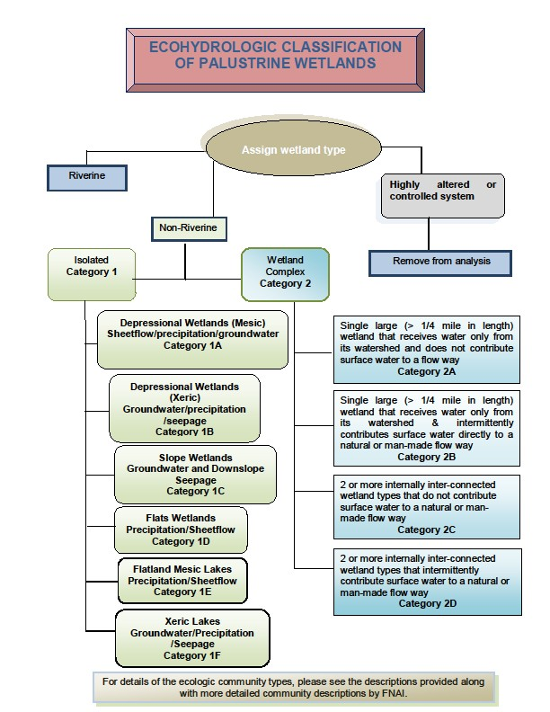

**Figure E‐1. Wetlands classification system developed by the EMT for use in the CFWI.**

The selected terminology was derived from the SWFWMD ecohydrologic classification based on a desire to apply the system using GIS.

In application, the system used the water management district FLUCFCS shape files to identify wetland areas. It also used physiographic provinces as a guide, but used USDA soils shape files to identify local setting based on soil types, since those were ground‐truthed at the time of classification and were available at a level of detail more suited to the EMT application than the more generalized physiographic province shape files. A shape file of wetlands connected along mapped streams was used as the basis for identifying floodplains. The non‐riverine FLUCFCS polygons were assessed in the context of adjacent polygons, combined with adjacent polygons when appropriate, and then assessed on the basis of size, shape, and dominant FLUCFCS in a guided classification. This classification was then reviewed for major misclassifications and corrected when appropriate based on aerial photointerpretation. Typical corrections included reconnection of slough and floodplain systems which were severed in the FLUCFCS by roads, water‐filled former mines that had been classified by FLUCFCS as lakes, stormwater systems mapped as wetlands and wetlands mapped as stormwater systems. Specific identification factors are discussed with each of the classified wetland types. The identified types were defined as follows:

#### Depressional Wetlands (Mesic) (Type 1A).

These wetland types, mainly located in “plains” physiographic settings”, historically often described as a “flatwoods landscape”. The dominant water source of these wetland types are precipitation and sheet flow. The wetlands typically interact with the surficial aquifer and at various times may lose water to or gain water from that aquifer. At least some studies have shown these wetlands to most often function as recharge wetlands for the surficial aquifer (Lee et al. 2009, Sun et al. 1995), but recharge rates are generally smaller than those for depressional wetlands in xeric (“ridge and upland”) physiographic settings. These wetland types, especially cypress domes can be sub‐classified hydrologically according to the hydro‐geologic settings determined by Watson et al. (1990) as: shallow depressions, shallow depressions with solution features and relict sinkhole type systems or ecologically as dome swamps and depression marshes (FNAI 2010) or tupelo or mixed wetland forest (FDOT 1999).

Variations include cypress domes, dome swamps, cypress marsh (marsh surrounded by a ring of cypress), depression marsh, basin marsh, and basin swamp. Multiple cover types are common within any one wetland, often in concentric rings that relate to depth. In GIS, these systems were recognized as having a perimeter/area ratio less than 2 coupled with a level III FLUCFCS of 621, 611, 643, 641, 613, 617, or combinations thereof, plus either being in a “plains” physiographic province and being surrounded by uplands with soils that are poorly to moderately well drained (i.e., not well or excessively well drained) soils (this latter handles the case where small areas of mesic flatlands with historic flatwoods interspersed with wetlands are embedded in areas that are generally “xeric” in character.

Floodplains were excluded. Following classification with GIS, these systems were review using aerial photography. It was apparent that these are best considered to be isolated or semi‐isolated with any connections consisting of ditches or un‐mapped flats wetlands. In undisturbed settings with natural upland communities and lack of significant agriculture, these systems are typically unditched and any connections consist of flats wetlands. Where agriculture is present, most connections are ditches, and review of the landscape suggests that the wetlands are generally smaller than those historically present. Sometimes they are minor residuals, often consisting of soft‐rush marsh. Review of aerial photography suggests that large systems (basin swamps) are typically at least occasionally connected to other systems either via wet flatlands or via ditches.

#### Depressional Wetlands (Xeric) (Type 1B).

These wetland types are located predominantly in physiographic provinces described as “ridge” or upland” and in high recharge areas variously classified as xeric pine, xeric hammock, sandhill and scrub landscape settings by FNAI (2010) or FLUCFCS 421, 412, or 413. This landscape setting exhibits very dry, deep well‐drained hills of sand that support xeric‐adapted vegetation (FNAI 2010). Most are believed to have a relatively direct connection to the surficial or Floridan aquifer (Watson et al. 1990). Using the hydrogeologic definitions of Watson et al. (1990), these wetlands are mainly those with solution features or relict sinkhole type systems. These wetlands do not always exhibit the common indicators of moderately long term standing water (cypress buttresses, hummock formation, restriction of *Lyonia lucida* roots and *Myrica cerifera* roots to hummocks, sharp palmetto line, etc.) and therefore may require differentiation of edges based on soil characteristics or less distinct indicators such as absence of upland trees within the wetland limits. The distinction between these xeric depressional wetlands and xeric lakes is predominantly size and a depth normally consistent with a permanent or semi‐permanent open water pool.

In GIS, these systems are typically mapped as marshes (641), sometimes with shrub marsh or wet prairie (643) on the fringes. They are not in floodplains and they are in either ridge or upland physiographic provinces (they may also occur in pockets on uplands/ridges, i.e., surrounding soils characterized as well or excessively well drained soils, or in plains provinces, but this is not common). No shape restrictions were placed on these wetlands, though there are some located in obvious, round sink holes.

#### Slope Wetlands (Type 1C).

These systems are defined as “Seepage Wetlands” by FNAI (2010), that are sloped with a high moisture level maintained by seepage from the underlying aquifer. The primary water source is the surficial aquifer (though obviously aquifer levels are driven by rainfall, and some overland flow and direct rainfall are received by these wetlands). A key distinction is that the water is moving through the wetland, not standing in pools. These wetlands are located at the edges of floodplains and in headwaters where and are characterized by long hydroperiods where the water is slightly above to slightly below the land surface. There is always some form of drain, though it may vary from a headwater stream to a downslope floodplain, lake, or open sink. These wetlands may not always exhibit the characteristic wetland edge indicators that are generally evident in flatwoods landscapes; therefore a baygall forest may have a moss collar to the ground, for instance, and may be perfectly healthy as long as the water table is high. Baygalls are often characterized by deep muck soils. A baygall may be replaced by a wet flatwoods if the peaty soil has been oxidized or removed (FNAI 1990), and some areas of low flatwoods may take on baygall characteristics if natural fire is removed.

Slope wetlands were difficult to identify in GIS as the FLUCFCS 611 code (bay swamp) has been applied to any wetland area with an evergreen hardwood canopy. GIS identification was done in two steps. First any FLUCFCS 611 code was considered to be a candidate. If it was not located in an area where seepage was possible (such as in islands out in the middle of larger swamps or marshes), they were considered not to be slope wetlands. If they were located in areas where slope wetlands could occur (edges of larger systems, entire wetlands with outfalls, they were reviewed on aerial photography and most were accepted as baygalls, the most typical slope wetland type in the CFWI. Wetlands mapped as floodplain edges and upper reaches of stream systems were inspected for bays (which had not been mapped as such in FLUCFCS), and relatively large areas were identified along the eastern edge of the Lake Wales Ridge (Reedy Creek and Lake Marian Creek systems) especially. Areas known to be seepage systems but with non‐bay canopies (often highly disturbed areas with residual bay vegetation overrun with grape vines) were included as slope wetlands. The aerial photographic inspection was backed up by on‐the‐

ground knowledge. It is probable that the area of slope wetlands was under‐mapped, but that most un‐ mapped slope wetlands are likely highly disturbed.

#### Flats Wetlands (Type 1D).

Variants of this classification located within the CFWI include wet flatwoods, wet prairies, prairie‐ hammock areas near the St. Johns River, and a variety of disturbed, wet settings. Flats wetlands are defined by FNAI (1990) as occurring on relatively flat, poorly drained soils that are typically underlain by an organic hardpan or clay lens. Broad areas of hydric hammock occur along the eastern edge of the CFWI along the St. Johns River floodplain. Slash pines can invade wet prairies during drought conditions or when fire is excluded, when this occurs, wet prairies become wet flatwoods (P. Elliott, personal communication, March 9, 2011). FNAI subtypes include wet flatwoods, wet prairie (savannah), and hydric hammock.

It was apparent that most of these systems were not well delineated in the available GIS layers. An inspection of current aerial photography shows that most were either included within larger mesic depressional wetlands, typically as shallow connectors between the larger wetlands, or were included in the surrounding uplands, usually identified as flatwoods. Hydric hammocks along the St. Johns River were identified. Areas of wet pasture were sometimes given this designation, but the majority of areas that would have met this categorization were not mapped in the base wetland areas. Some areas were assigned this classification during QA/QC of the coverage, but no such areas were included in the study sites. Due to the spotty coverage with almost all (that were mapped) occurring along the St. Johns River, these flats wetlands were excluded from consideration.

#### Flatland Mesic Lakes (Type 1E).

Flatland lakes are defined as lakes in physiographic provinces defined as “flatlands” or “plains”. These generally shallow lakes (a lake being defined as having a permanent open center 6 ft or more deep), often surrounded by a ring of cypress. They are similar in origin to mesic depressional wetlands, but deeper and typically larger in area. Some have muck layers in the bottom. Some likely formed as interdunal lakes, but most are likely located in single‐to‐multiple relic sinkholes. Relative to “ridge” or “upland” province lakes, they are typically low fluctuation lakes.

Flatland Mesic lakes were identified in the GIS as having a level 2 FLUCFCS code of 500, 520, or 530, being isolated (not in a floodplain or obvious flow‐way) and being in a “plains” physiographic province. Based on the GIS analysis, there are relatively few flatland mesic lakes, and based on review of their locations and aerial photography, these lakes may intergrade into xeric lakes, especially those located in “upland” physiographic provinces. Most flatland mesic lakes were inspected using aerial photography. Most ultimately turned out to be man‐made features, mostly mines, and were re‐classified accordingly.

#### Xeric Lakes (Type 1F).

Xeric Lakes are defined as lakes in “ridge” or “upland” physiographic provinces. They are wide fluctuation lakes that in most ways are deeper systems otherwise similar to xeric depressional wetlands. Most are located in obvious old sink hole features and are nearly round, though large ones are often located in multiple sinkholes and may have shallower connections between the sinks within them. Few have cypress fringes (most of those that do are in “upland” physiographic provinces). Most are large enough to be named lakes. Most isolated lakes (versus flow‐through lakes) in the CFWI were classified as xeric lakes. Xeric Lakes were identified in the GIS as having a level 2 FLUCFCS code of 500, 520, or 530, being isolated (not in a floodplain or obvious flow‐way) and being in an “ridge” or “upland” physiographic province. Depending on the water level at the time of mapping, many include FLUCFCS 641, 644, and 643 polygons.

Xeric lakes were reviewed using the most currently available aerial photography. A few were man‐made (mines) but most appeared to be natural. It was apparent from looking at photography from multiple years that there is no clear‐cut distinction between xeric lakes and xeric depressional marshes in the FLUCFCS mapping. The classification used is based on the dominant FLUCFCS.

This category was used for wetlands with obvious connectivity to other wetlands and drainages.

#### Wetland Complex Category (Type 2).

This category was used for wetlands with obvious connectivity to other wetlands and drainages to the extent that inflows (including overland flow, inflows from other wetlands, rainfall) and outflows to other wetlands and or/floodplains are major contributors to the wetland hydrology. Other wetland complexes are large and may include several types of connected wetlands that receives water from the watershed but does not contribute flow to other systems. These types of complexes may themselves flow similar to FNAI described Strands. Wetland complexes are not the uppermost systems in a drainage basin, but they may also be systems with natural incised channels (they may also have been ditched). They may also include wetlands that ultimately drain into lakes or large wetlands in closed basins, but are not themselves closed. Interconnected Wetlands were not restricted to physiographic province as these receive a major component of their water from more upslope systems. On the upslope end, these wetlands are fed be some combination of other interconnected wetlands, semi‐isolated xeric setting lakes and wetlands, semi‐isolated mesic depressional wetlands, and baygalls. On the downslope end, they feed other interconnected wetlands and floodplains. Some would feed wetlands or lakes in basins that have no surface outfall.

Interconnected Wetlands were identified in GIS as having a high perimeter to acreage ratio, having FLUCFCS 621, 617, 615, 630, 643 and/or 643. Floodplains were excluded. The GIS classification was reviewed using aerial photography looking specifically for connections. This review was needed as large, elongated natural wetlands are often broken in the land use classification at roads, railroads, and other man‐made features, and sometimes the breaks cause small “pieces” that would sometimes be classified as isolated based only on the GIS. These pieces were re‐assembled reclassified manually. These wetlands were also inspected for potential inclusion of seepage areas which were reclassified as seepage when observed.

#### Riverine.

Riverine, floodplain wetlands were considered to be those areas mapped as floodplains on the basis of wetland polygons being contiguous or continuous with mapped streams. With the exception of small areas remapped based on aerial interpretation (slope wetlands on areas known to be well above flood level), these areas were left unchanged. They include forested floodplains, floodplain marshes, and lakes. They generally terminate at the upper end at the closes break (usually a road) above which the stream channel was not mapped. Above the region of mapped stream channel, these systems are mapped as Interconnected Wetlands (Type 2).

#### Anthropogenic.

Anthropogenic systems were excluded from classification. Some of these were classified as marshes and shrub swamps by the FLUCFCS system. Upon review with aerial photography, numerous stormwater ponds, swales, mines, borrow pits, ditches, cattle ponds, and similar features were reclassified and excluded from analysis. Some of these systems undoubtedly have some wetland function, but there is no reason to suspect that they would function like a natural wetland. In urban areas, most mapped “wetlands” an acre or less in size are actually surface water management systems (stormwater and/or water quality management or drainage ditches) of some form. In agricultural areas, most rectangular

features are human created. It is a widely held assumption that flowing floodplain wetlands are more difficult to use in the assessment of groundwater withdrawals in opposition to those wetlands that are more isolated in nature and therefore have a stronger connection to the effects of groundwater withdrawal. The CFWI EMT did not include floodplain wetlands in the analysis.

## References

Brinson, Mark M. 1993. A hydrogeomorphic classification for wetlands. Wetlands Research Program Technical Report WRP‐DE‐4. U.S. Army Corps of Engineers, Waterways Experiment Station, Vicksburg, MS.

Cowardin, L. M., V. Carter, F. C. Golet, E. T. LaRoe. 1979. Classification of wetlands and deepwater habitats of the United States. USDI, US Fish and Wildlife Service., Office of Biological Services, Washington, DC.

Fennessy, M. S., A. D. Jacobs and M. E. Kentula. 2007. An evaluation of rapid methods for assessing the ecological condition of wetlands. Wetlands 27:504‐521.

Florida Department of Transportation (FDOT). 1999. Florida Land Use, Cover and Forms Classification System Handbook. Florida Department of Transportation, Surveying and Mapping Office, Geographic Mapping Section. January 1999. 95 pp.

Florida Natural Areas Inventory (FNAI). 2010. Guide to the natural communities of Florida: 2010 edition.

Florida Natural Areas Inventory, Tallahassee, Florida, USA. 228 pp. <http://www.fnai.org/pdf/nc/FNAI_NatComGuide_2010.pdf>

Lee, T.M., K.H. Haag, P.a. Metz, and L.A. Sacks. 2009. Comparative Hydrology, Water Quality, and Ecology of Selected Natural and Augmented Freshwater Wetlands in West‐Central Florida. Prepared in cooperation with Pinellas County, Southwest Florida Water Management District, Tampa Bay Water. U.S. Department of the Interior, U.S. Geological Survey. Professional Paper 1758.

Stein, E.D., Brinson, M., Rains, M.C., Kleindl, W., and Haure, F.R. 2009. Wetland Assessment Alphabet Soup: <http://www.epa.gov/owow/wetlands/monitor/> How to Choose (or not Choose) the Right Assessment Method. Wetland Science and Practice, V26(4) 20‐25.

Sun, G., H. Riekerk and L.V. Korhnak. 1995. Shallow groundwater table dynamics of cypress wetland/pine upland systems in Florida flatwoods. Soil and Crop Science Society of Florida. Proceedings ‐ Soil Crop Sci. Soc. Fla. 54: 66‐71.

Uranowski, C. 2012. Wetland Hydrologic Classification and Assessment Procedure. Narrative, Rationale, Approach. Unpublished manuscript.

Watson, J., D. Stedje, M. Barcelo and M.Stewart. 1990. Hydrogeologic Investigations of cypress dome wetlands in wellfield areas north of Tampa, Florida. In: proc. Focus Eastern Conference, National Well Water Assoc. Dublin, OH: 163‐176.

.

# Environmental Measures Team Final Report

*Attachment F –*

*Statistical Analyses to Discriminate between Stressed and Non‐Stressed Wetlands and Determine Whether EMT Wetlands are a Representative Sample of CFWI Wetlands*

*November, 2013*

## Attachment F. Statistical Analyses to Discriminate between Stressed and Non‐Stressed Wetlands and Determine Whether EMT Wetlands are a Representative Sample of CFWI Wetlands

Tony Janicki, Ph.D. Janicki Environmental, Inc.

## Objective

The St. Johns River, Southwest Florida, and South Florida water management districts collectively conducted a survey of more than 400 wetlands within the CFWI area. The data collected included a series of variables that took on values of “Yes” or “No”. These variables are generally accepted as indicators of wetland stress. As discussed above, these data along with examination of a series of historical photos were used to identify a wetland as being either “stressed” or “non‐stressed”.

The objective of this analysis was to examine the wetland EMT variables and the hydrologic characteristics to identify those variables and water surface elevations (WSE) that best discriminate stressed from non‐stressed wetlands.

## Methods

The primary method used to identify those variables and characteristics that best discriminate stressed from non‐stressed wetlands was changepoint analysis. Changepoint methods are rapidly evolving from simple data mining tools to predictive models using advanced statistical algorithms to evaluate conditional probabilities in the stressor‐response relationships. Collectively referred to as “Decision Trees”, this methodology provides an intuitive and easily conveyed approach to identify threshold responses to environmental stressors that may be used in the development of protective water quality or water quantity standards. The classification version of the conditional inference tree methodology (Hothorn et al., 2006) was used as one line of evidence for identifying potential stressors as well as threshold values for WSE in wetlands resulting in stressed conditions within the wetland. Conditional inference trees are a form of regression tree analysis (RTA) that has been successfully used to assist in many environmental issues including the development of numeric nutrient criteria (e.g., Soranno et al., 2008). The approach is based on recursive partitioning. The partitioning process iteratively searches for a point in the stressors variable which maximizes the difference in the response values between two groups of response data. No *a priori* threshold is specified. The classification tree approach defines the breakpoint as that which minimizes the misclassification bias between groups. The point in the stressor variable at which the p value is minimized, after adjustment for multiple comparisons, is assigned as the breakpoint defining the split of the of the response variable into 2 groups. Once the first split is made the process continues to test for subsequent splits that are conditional on the first split. Hence, the term “conditional inference” or “conditional probability analysis” that has been popularized recently by the USEPA as a potential approach for establishing numeric nutrient criteria.

Conditional inference trees embed tree‐structured regression models into a well‐defined theory of conditional inference procedures (Hothorn et al., 2006). This class of regression trees is applicable to all kinds of regression problems, including nominal, ordinal, numeric, censored as well as multivariate response variables and arbitrary measurement scales of the covariates.

The EMT variable analysis was conceptually similar to the use of a dichotomous key with the major difference being that the nodes (i.e., decision points) are probability distributions. This analysis answers

the question: what EMT variables (or combination) best predict an outcome (e.g., characterization of a wetland as “stressed”).

For the WSE analysis, the classification tree approach was selected to identify the distributional statistics of WSE and the specific threshold value of that distributional statistic that maximizes the classification success of sites as either stressed on unstressed. The results suggest that the difference between the wetland edge and the 80th percentile of WSE (i.e., WE‐P80) was the best choice to discriminate between stressed and unstressed sites, and furthermore, that a threshold value of 3.398 was the best “changepoint” to discriminate between stressed and unstressed sites. Sites with WE‐P80 values greater than 3.398 had an 81% chance of being classified as “stressed” while those sites with lower values had only an 8% chance of being classified as stressed.

## Results

The EMT variables examined included the following:

* Soil subsidence,
* Soil fissures,
* Exposed roots,
* Successional stage,
* Leaning/falling trees,
* Dead/dying trees,
* Percent native vegetation,
* Confoundedness, and
* Basin alteration.

As shown in Figure 1, the primary EMT variable that best discriminated between stressed and non‐ stressed wetlands was invading species. In **Figure F‐1**, Y=the probability of being stressed and therefore, if the invading species variable is positive (i.e., invading species were found) there is a 96% probability of being stressed.

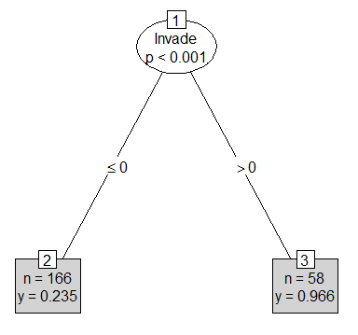

**Figure F‐1. Results of EMT variable changepoint analysis on wetland classification indicating stressed wetland condition.**

The full decision tree model is shown in **Figure F‐2**. This model identifies that after accounting for the effect of invading species subsidence and leaning/falling trees further improved the discrimination of stressed from non‐stressed wetlands.

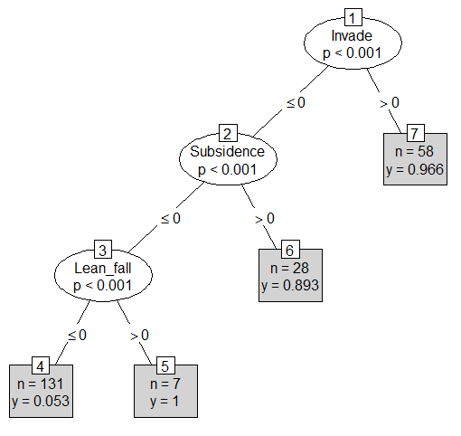

**Figure F‐2. Results of full model of the EMT variable changepoint analysis on wetland classification indicating stressed wetland condition.**

The WSE variables used in these analyses included the following:

* + wetland edge,

• P5,

• P50,

• P80,

* + wetland edge – P5,
  + wetland edge – P50, and
  + wetland edge – P80.

For this analysis, the classification tree approach identified the distributional statistics of WSE and the specific threshold value of that distributional statistic that maximizes the classification success of wetlands as either stressed on unstressed. The results suggest that the difference between the wetland edge and the 80th percentile of WSE (i.e., WE‐P80) was the best choice to discriminate between stressed and unstressed sites. Furthermore, a threshold value of 3.398 was the best “changepoint” to discriminate between stressed and unstressed sites (**Figure F‐3**). Wetlands with WE‐P80 values greater than 3.398 had an 81% chance of being classified as “stressed” while those sites with lower values had only an 8% chance of being classified as stressed.

### Representativeness of Wetland Sites to the Entire CFWI

The spatial characteristics of the subset of wetland sites being used by the EMT for stress probability assessment were examined based on regional GIS coverage data to determine whether they were statistically similar to all wetlands within the CFWI**. Table F‐1** presents a summary of the distributions of wetland areas, perimeters, and the ratio of the square root of the area to the perimeter (√area/perimeter) for the isolated wetlands within the Plains and Ridge areas within the CFWI. **Table F‐ 2** presents similar data for the Class I, Class II, and Class III wetlands within the CFWI.

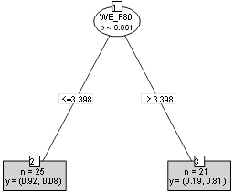

**Figure F‐3. Results of changepoint analysis of the WSE distributions on wetland classification indicating stressed wetland condition.**

**Table F‐1. Percentage distribution of physical wetland characteristic by wetland group.**

|  |  |  |  |  |  |  |  |
| --- | --- | --- | --- | --- | --- | --- | --- |
| **Group** | **Cumulative Percentage Statistic** | | | | | | |
| 5% | 10% | 25% | 50% | 75% | 90% | 95% |
| **Area (acres)** | | | | | | | |
| Plains Isolated | 0.3 | 0.47 | 0.91 | 1.99 | 4.59 | 11.12 | 19.34 |
| Ridge Isolated | 0.26 | 0.41 | 0.94 | 2.59 | 8.11 | 26.42 | 55.86 |
| **√area/perimeter** | | | | | | | |
| Plains Isolated | 0.16 | 0.17 | 0.21 | 0.24 | 0.27 | 0.27 | 0.28 |
| Ridge Isolated | 0.12 | 0.14 | 0.19 | 0.23 | 0.26 | 0.27 | 0.28 |
| **Perimeter (ft)** |  |  |  |  |  |  |  |
| Plains Isolated | 456 | 563 | 806 | 1224 | 2048 | 3575 | 5101 |
| Ridge Isolated | 427 | 541 | 858 | 1529 | 3005 | 6117 | 9965 |

**Table F‐2. Percentage distribution of physical wetland characteristic by wetland knowledge class.**

|  |  |  |  |  |  |  |  |
| --- | --- | --- | --- | --- | --- | --- | --- |
| **Group** | **Cumulative Percentage Statistic** | | | | | | |
| 5% | 10% | 25% | 50% | 75% | 90% | 95% |
| **Area (acres)** | | | | | | | |
| Class I | 1.45 | 3.39 | 6.54 | 111.54 | 299.45 | 607.98 | 2184.72 |
| Class II | 1.05 | 1.68 | 3.86 | 11.15 | 31.99 | 86.83 | 156.66 |
| Class III | 0.29 | 0.46 | 0.91 | 2.05 | 4.89 | 12.47 | 22.91 |
| **√area/perimeter** | | | | | | | |
| Class I | 0.07 | 0.10 | 0.14 | 0.25 | 0.26 | 0.27 | 0.27 |
| Class II | 0.09 | 0.12 | 0.17 | 0.22 | 0.26 | 0.27 | 0.28 |
| Class III | 0.15 | 0.17 | 0.20 | 0.24 | 0.27 | 0.27 | 0.28 |
| **Perimeter (ft)** | | | | | | | |
| Class I | 922 | 1408 | 2067 | 11063 | 24471 | 30135 | 139826 |
| Class II | 822 | 1048 | 1625 | 3601 | 6432 | 15410 | 24530 |
| Class III | 450 | 558 | 809 | 1252 | 2147 | 3860 | 5670 |

The first notable observation is that the distributions of wetland perimeters across Ridge and Plains wetlands and across knowledge classes are very similar. In terms of wetland area, Ridge wetlands tend to be somewhat greater than those in the Plains region. With respect to wetland area, as expected the Class I wetlands tend to be greater than both of the other knowledge class wetlands, while the distributions of wetland area in these latter two classes are much more similar.

The third physical characteristic of the wetlands examined, the ratio of the square root of the area (√area) to the wetland perimeter, is a unit‐less characteristic that describes the geometry of a wetland. More convoluted perimeters will result in lower ratios than those with a simpler boundary or outline. The distributions of the √area/perimeter are generally similar in the Ridge and Plains wetlands, except in the upper portions of the distributions (>90%) where the Plains wetlands tend to be display a more complex geometry than the isolated wetlands within the Ridge region. As seen with the other physical wetland characteristics, the distribution of the √area/perimeter characteristic is greatest in the knowledge Class III wetlands.

References

Hothorn T., K. Hornik, and A. Zeileis. 2006. unbiased recursive partitioning: a conditional inference framework. Journal of Computational and Graphical Statistics. 15:651–674.

Soranno, P.A., K.S. Cheruvelil, R.J. Stevenson, S.L. Rollins, S.W. Holden, S. Heaton, and E. Tong. 2008. A framework for developing ecosystem specific nutrient criteria: Integrating biological thresholds with predictive modeling. Limnology and Oceanography 53:773‐787.

# Environmental Measures Team Final Report

*Attachment G –*

*Hydrologic Analysis: Methodology Summary*

*November, 2013*

## Attachment G ‐ Hydrologic Analysis: Methodology Summary

#### Introduction

James Bays, CH2MHILL;

David MacIntyre, P.E., D.WRE, Parsons Brinkerhoff; Shirley Denton, Ph.D., Cardno Entrix;

John Zahina‐Ramos, Ph.D., South Florida Water Management District

As a component of the Central Florida Water Initiative (CFWI) project, the Environmental Measures Team (EMT) comprised of District and utility representatives and consultants was assembled and assigned two objectives: 1) evaluate current environmental conditions of wetlands and surface waters in the CFWI area, and develop quantitative relationships of environmental conditions to hydrologic conditions using appropriate scientific methods; and 2) apply the quantitative assessment relationships to hydrologic model output. Beginning in 2011, regular meetings were initiated to characterize and quantify the hydrologic characteristics of water bodies in the CFWI area in relation to environmental stress classification.

With the input of EMT members, a study was proposed to confirm the applicability of the wetland database for evaluating current environmental conditions in the CFWI area, and to develop a set of quantitative assessment relationships. Five tasks were agreed upon, as listed below, with all results to be summarized in a final report:

* Task 1. Selection and study of a subset of wetlands for combined ecological and hydrological assessment.
* Task 2. Quantitative statistical characterization of the EMT data set.
* Task 3. Quantitative statistical analysis of the ecological data within the EMT data set.
* Task 4. Hydrological analysis of the subset of wetlands.
* Task 5. Development of statistical interrelationships between wetland ecological and hydrological conditions.

The outcome of the study was expected to be a set of quantitative relationships that would ultimately be tested for use as constraints on the CFWI area groundwater flow model developed by the US Geological Survey and updated by the CFWI HAT.

This Attachment summarizes the methodology and presents an overview of results of Task 4, Hydrologic Analysis. The data base comprising the basis for analysis within this document underwent a series of modifications through a continuing process of analysis between initial data collection in September 2011 through final data set development and analysis in early 2013. The primary authors of this Attachment gratefully acknowledge and appreciate the combined input and technical comment and review received from the EMT members during the course of study.

#### Methods

Most of the wetland sites in the EMT database do not have an associated record of water levels that can be used to characterize the hydrology of the wetland. Therefore a preliminary list of sites selected for this study was developed in August‐September 2011 through the collective input of the EMT, with a goal of identifying water bodies with water level records (e.g., piezometer, staff gage) and ecological (e.g., transect) data. Most of the study sites are distributed throughout the CFWI within SJRWMD, SFWMD, and SWFWMD boundaries, but twelve sites outside the CFWI were added in order to expand the sample

size of sites which had both ecological and hydroperiod data. Within this distribution, sites are located within most of the component physiographic regions.

Cumulatively, a total of 44 lakes and wetlands were selected based upon availability of historic water level data and the location and ecological condition of each site. Of this total, 24 were classified as ridge and 20 as plains.

Most sites had been visited previously by teams of District scientists in 2006 and 2007 during initial Central Florida Coordination Area (CFCA) activities. An environmental assessment was performed at each using the Districts’ methodology. An essential component to the field analysis included identification and elevation survey of the wetland edge of a lake or wetland. This indicator is a historic descriptor of an elevation where water remains long enough to preclude establishment of upland species and below which there are predictable vegetation adaptations to flooding and development of specific wetland soil indicators. This elevation is persistent over long time periods, and therefore provides a basis of normalizing water level data between widely different types of systems. Common wetland edge indicators utilized included the uppermost elevation of hydric soils, and where they exist, long‐term vegetative indicators. Sites exhibiting trends consistent with long‐term lowering of water levels with associated vegetative change and organic soil loss were classified by EMT members as stressed. This classification was drawn from a review of the site environmental data, a review of available historical photographs, and review of available hydrologic data. Some sites were classified as “substantially hydrologically altered (SHA)”, where physical changes to the wetland or its basin have altered its surface water hydrology sufficiently to create a water regime inconsistent with the historic hydrologic regime.

A key variable used to classify the different sites was classification as depressional marshes or lakes in mesic or xeric settings, using the classification method described in **Attachment E** of this report. The occurrence of a site in a sandhill ridge or otherwise xeric soil type has been shown to yield a hydrologic relationship to underlying aquifers different than in the floodplains, flatwoods, or other physiographic regions. Through a process of continued review, the initial list of 34 sites developed in 2011 was further augmented with an additional 10 lakes and wetlands assembled primarily from the ridge physiographic region to create a more balanced data set.

**Table G‐1** shows each site characterized by their CFWI ID, waterbody type, classification of stress, classification of confoundedness, physiographic setting, water level data period of record (POR) P80, and wetland edge elevation. New sites were assigned IDs to be consistent with the prior method of CFCA wetland identification, and the remainder of the sites already had IDs from the CFCA data base.

**Figure G‐1** shows the location of the study sites superimposed on available GIS coverage of physiographic regions. For the purpose of this analysis, stations were grouped as ridge or plains depending on their site‐specific xeric or mesic attributes. As a result, the ridge and plains wetland physiographic type designations are strongly correlated to the more generalized ridge and plains physiographic province designations, but do not match them perfectly.

#### Data Sources

Because the study lakes and wetlands are distributed across central Florida, multiple data sources were accessed to obtain available historic stage data information. Sources included the Orlando Utilities Commission (OUC), the City of Cocoa, Seminole County, Orange County, SFWMD DBHYDRO database, SWFWMD Water Management Information System (WMIS), the Water Atlas website, USGS National Water Information System, and the SJRWMD Hydrologic Data Search.

**Table G‐1. Site Identification and Characterization**

**Site**

**Site Name CFCA ID Physio-**

**P80 (2006-**

**Edge Reference**

**Stressed? Confounded?**

|  |  |  |  |  |  |  |  |
| --- | --- | --- | --- | --- | --- | --- | --- |
|  | **Identifier** |  |  | **Region** | **2011)** | **Elevation** |  |
|  |  |  |  | **(ft NGVD 29)** | **(ft NGVD 29)** |
| 61 | Unnamed Cypress | SJ-LA | Plain | 69.26 | 70.44No | No |
| 146 | Green Swamp Marsh #304 | SW-LI | Plain | 92.64 | 93.90No | No |
| 161 | Green Swamp #1, #298 | SW-LM | Plain | 98.43 | 100.6No | No |
| 111 | City of Cocoa, Well 9T | SJ-LL | Plain | 71.38 | 74.14No | No |
| 31 | Walker Ranch - WR9 | SF-XZ | Plain | 65.57 | 68.34No | No |
| 116 | Green Swamp 7 | SW-AA | Plain | 103.19 | 106.37No | No |
| 6 | Walker Ranch - WR6 | SF-LB | Plain | 61.65 | 64.47No | No |
| 156 | Green Swamp #5, #302 | SW-LK | Plain | 95.28 | 98.80No | No |
| 1 | Walker Ranch - WR11 | SF-LA | Plain | 64.11 | 67.68No | No |
| 151 | Green Swamp #6, #303 | SW-LJ | Plain | 94.07 | 98.10No | No |
| 126 | Cypress Creek #199, W17 | SW-LE | Plain | 63.34 | 64.95Yes | No |
| 36 | Tibet Butler - TB2 | SF-YK | Plain | 98.72 | 102.63Yes | No |
| 51 | Lake Gem | SJ-AJ | Plain | 48.74 | 53.39Yes | Yes |
| 141 | Cypress Creek #211, W33 | SW-LH | Plain | 65.92 | 70.79Yes | No |
| 71 | Boggy Marsh | SJ-LC | Plain | 113.82 | 118.82Yes | No |
| 96 | Island Lake - 2774 | SJ-LH | Plain | 81.86 | 87.49Yes | No |
| 131 | Cypress Creek #190 "E" Marsh | SW-LF | Plain | 65.09 | 72.03Yes | No |
| 136 | Cypress Creek #223 "B" W46 | SW-LG | Plain | 60.87 | 68.93Yes | No |
| 216 | Lake Leonore (Patrick) | SW-QH | Ridge | 85.08 | 86.23No | No |
| 191 | Lake Annie (Highlands) | SW-QE | Ridge | 109.95 | 111.49No | No |
| 211 | Gator Lake | SW-QD | Ridge | 129.89 | 131.8No | No |
| 256 | Lake Apthorpe | SW-QF | Ridge | 68.93 | 71.28No | Yes |
| 246 | Lake Van | SW-QK | Ridge | 131.08 | 134.32No | No |
| 236 | Lake Streety | SW-QJ | Ridge | 103.21 | 105.95No | No |
| 201 | Bonnet Lake | SW-QB | Ridge | 89.29 | 92.04No | No |
| 221 | Parks Lake | SW-QO | Ridge | 99.83 | 102.81No | No |
| 241 | Surveyors Lake | SW-QN | Ridge | 130.30 | 133.36No | No |
| 121 | Lake Garfield | SW-JJ | Ridge | 101.39 | 105.53No | Yes |
| 76 | Hopkins Prairie | SJ-LD | Ridge | 23.71 | 27.50No | No |
| 181 | Johns Lake | SJ-QB | Ridge | 93.39 | 97.42No | No |
| 206 | Buck Lake (Highlands) | SW-QC | Ridge | 89.87 | 95.05No | No |
| 226 | Lake Placid | SW-QI | Ridge | 89.44 | 94.91No | No |
| 186 | Trout Lake | SJ-QC | Ridge | 90.59 | 97.60No | No |
| 231 | Polecat Lake | SW-QM | Ridge | 139.50 | 144.37Yes | No (recovered) |
| 106 | Lake Louisa | SJ-LJ | Ridge | 92.41 | 97.29Yes | No |
| 196 | Big Gum Lake | SW-QA | Ridge | 89.96 | 95.95Yes | Yes |
| 171 | Crooked Lake | SW-QQ | Ridge | 115.12 | 121.29Yes | Yes / Regulated |
| 86 | Lake Apshawa | SJ-LF | Ridge | 81.13 | 87.65Yes | No |
| 176 | Church Lake | SJ-QA | Ridge | 82.66 | 90.37Yes | Yes |
| 66 | Unnamed Wetland | SJ-LB | Ridge | 61.41 | 69.37Yes | No |
| 166 | Lake Wales | SW-MM | Ridge | 102.65 | 111.35Yes | No |
| 56 | Long Lake | SJ-QD | Ridge | 58.43 | 68.81Yes | No |
| 81 | Lake Avalon | SJ-LE | Ridge | 86.30 | 96.68Yes | No |
| . | 251 | Lake Walker | SW-QL | Ridge | 137.36 | 150.28Yes | No (recovered) |

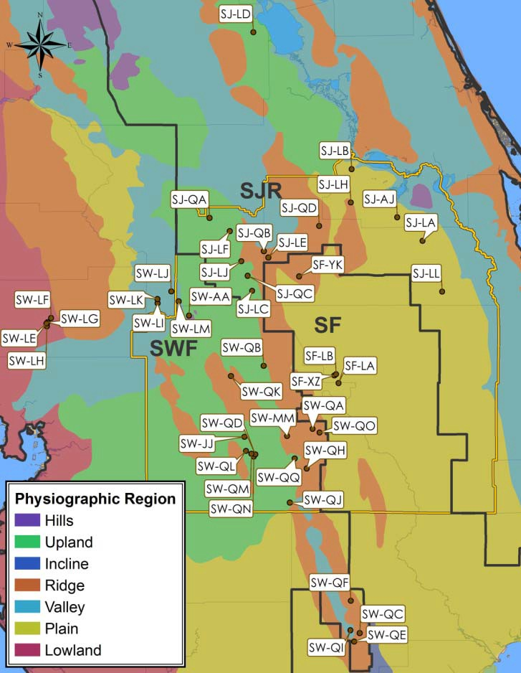

**Figure G‐1. EMT Wetland Hydrologic Analysis Study Site Locations. Base map coverage of physiographic regions as defined in White, W.A. (1970).The Geomorphology of the Florida Peninsula, Florida Geological Survey Bulletin 5. Tallahassee Fl.**

The period of 1991‐2011 was defined as the target time frame for analysis to meet several objectives: 1) a time period to overlap most of the CFWI model assessment period (1996‐2008), thereby allowing direct comparisons to simulated aquifer levels calibrated under the same rainfall conditions; 2) a duration sufficiently long to include the dry (1999‐2001) and the wet (2004‐2005) years; and 3) to allow the use of wetland water elevation data collected more recently through water use permit monitoring. The initial analysis of water levels was performed using all available data for the period 1991‐2011.

Within this two‐decade target period, however, it was found that relatively few sites had sufficient data to support a 20‐year frequency analysis of water levels, and that a shorter period of record was capable of providing reasonably similar P80 water level estimates. The minimum POR in the data set was six years. Prior analyses in the northern Tampa Bay area indicated that six years would be an appropriate minimum length to capture a wet and dry rainfall cycle. However, the hydroperiod for relatively infrequently flooded wetlands can be expected to require a longer period of time to capture the full range of water level fluctuations. Ultimately, the 6‐year period from 2006 through 2011 was chosen because it appeared to provide the best compromise between providing a small sample of wetlands with P80 elevations based on a

longer period of record or a significantly larger sample of wetlands with P80 elevations based on a shorter period of record. Since the P80 elevation estimate varies somewhat based on the period of

record, and this variation tends to be more significant for shorter periods of record, it was considered important to select a consistent period of record for all the locations that were included in the final assessment of relationships between ecological conditions and water levels

#### Data Analysis

Graphical analysis was utilized to show the percentage of time a measured stage was equaled or exceeded and is referred to here as the Cumulative Frequency Distribution (CFD). In order to compare hydroperiod characteristics across the sites, the CFDs were calculated and summarized relative to wetland edge elevation. If a given stage value is exceeded by only five observations out of 100, it would have a corresponding label of P05. Similarly, if a certain stage is exceeded 90 observations out of 100 water level measurements, it would be labeled as P90. The P50 corresponds to the median value in the data set.

**Table G‐2** summarizes CFD percentile data relative to the wetland edge grouped into four major categories: stressed plains, unstressed plains, stressed ridge and unstressed ridge. Sample means and estimates of the 90%, 95%, and 99% confidence intervals of the population are provided for each group.

#### Results

**Water Level Trends and Seasonality**

**Figure G‐2** presents the water level POR for all of the water bodies in this study. These data are shown as hydrographs of water elevation data on the same vertical scale to illustrate the range of topographic elevations incorporated into the data set, and the relative range in water level fluctuation between water bodies. Analyses summarized below utilized only the six‐year period from 2006‐2011.

Attachment G Environmental Measures Team Final Report

**Table G‐2. Wetland Stage Exceedance Values Relative To The Wetland Edge Elevation, Six‐Year Data Analysis Period, 2006 Through 2011.**

**Means and estimated population confidence intervals are summarized by stress and physiographic type category.**

|  |  |  |  |  |  |  |  |  |  |  |  |  |  |  |
| --- | --- | --- | --- | --- | --- | --- | --- | --- | --- | --- | --- | --- | --- | --- |
| **CFCA ID** | **Site Name** | **Class** | **County** | **SHA?** | **WMD Basin** | **P10** | **P20** | **P30** | **P40** | **P50** | **P60** | **P70** | **P80** | **P90** |

|  |  |  |  |  |  |  |  |  |  |  |  |  |  |  |
| --- | --- | --- | --- | --- | --- | --- | --- | --- | --- | --- | --- | --- | --- | --- |
| **Unstressed Plains – 10 Sites** | | | | | | | | | | | | | | |
| SJ‐LA | Unnamed Cypress | Wetland | Orange | No | St. Johns | ‐0.31 | ‐0.44 | ‐0.49 | ‐0.59 | ‐0.68 | ‐0.82 | ‐0.93 | ‐1.18 | ‐1.41 |
| SW‐LI | Green Swamp Marsh #304 | Wetland | Polk | No | Southwest | ‐0.43 | ‐0.52 | ‐0.60 | ‐0.72 | ‐0.80 | ‐1.01 | ‐1.09 | ‐1.26 | ‐1.54 |
| SW‐LM | Green Swamp #1, #298 | Wetland | Polk | No | Southwest | ‐0.38 | ‐0.46 | ‐0.61 | ‐0.80 | ‐1.00 | ‐1.23 | ‐1.60 | ‐2.17 | ‐3.56 |
| SJ‐LL | City of Cocoa, Well 9T | Wetland | Orange | No | St. Johns | ‐0.55 | ‐0.79 | ‐0.88 | ‐1.18 | ‐1.68 | ‐1.84 | ‐2.14 | ‐2.76 | ‐3.17 |
| SF‐XZ | Walker Ranch ‐ WR9 | Wetland | Osceola | No | South | ‐0.15 | ‐0.63 | ‐0.95 | ‐1.25 | ‐1.78 | ‐2.20 | ‐2.63 | ‐2.77 | ‐2.93 |
| SW‐AA | Green Swamp 7 | Wetland | Polk | No | Southwest | ‐0.27 | ‐0.37 | ‐0.55 | ‐0.66 | ‐0.87 | ‐1.20 | ‐2.36 | ‐3.18 | ‐4.18 |
| SF‐LB | Walker Ranch ‐ WR6 | Wetland | Osceola | No | South | ‐0.22 | ‐0.63 | ‐0.79 | ‐1.19 | ‐1.63 | ‐2.04 | ‐2.53 | ‐2.82 | ‐3.57 |
| SW‐LK | Green Swamp #5, #302 | Wetland | Polk | No | Southwest | ‐0.06 | ‐0.17 | ‐0.46 | ‐0.85 | ‐1.21 | ‐1.75 | ‐3.11 | ‐3.52 | ‐4.53 |
| SF‐LA | Walker Ranch ‐ WR11 | Wetland | Osceola | No | South | ‐0.47 | ‐0.63 | ‐0.88 | ‐1.35 | ‐1.95 | ‐2.31 | ‐2.86 | ‐3.57 | ‐3.88 |
| SW‐LJ | Green Swamp #6, #303 | Wetland | Polk | No | Southwest | ‐0.33 | ‐0.51 | ‐0.66 | ‐0.89 | ‐1.04 | ‐1.93 | ‐2.95 | ‐4.03 | ‐4.71 |
|  |  |  |  |  | Mean | ‐0.32 | ‐0.52 | ‐0.69 | ‐0.95 | ‐1.26 | ‐1.63 | ‐2.22 | ‐2.73 | ‐3.35 |
|  |  |  |  |  | +90% CI | 0.24 | 0.27 | 0.28 | 0.42 | 0.71 | 0.82 | 1.21 | 1.49 | 1.77 |
|  |  |  |  |  | +95% CI | 0.28 | 0.32 | 0.33 | 0.50 | 0.85 | 0.98 | 1.43 | 1.77 | 2.10 |
|  |  |  |  |  | +99% CI | 0.37 | 0.42 | 0.43 | 0.66 | 1.12 | 1.29 | 1.89 | 2.32 | 2.77 |
| **Stressed Plains – 8 Sites** | | | | | | | | | | | | | | |
| SW‐LE | Cypress Creek #199, W17 | Wetland | Pasco | No | Southwest | ‐0.88 | ‐1.01 | ‐1.06 | ‐1.16 | ‐1.29 | ‐1.43 | ‐1.55 | ‐1.61 | ‐1.64 |
| SF‐YK | Tibet Butler ‐ TB2 | Wetland | Orange | No | South | ‐2.50 | ‐2.80 | ‐2.91 | ‐3.24 | ‐3.31 | ‐3.49 | ‐3.71 | ‐3.91 | ‐4.25 |
| SJ‐AJ | Lake Gem | Lake | Seminole | Yes | St. Johns | ‐3.58 | ‐3.84 | ‐3.95 | ‐4.02 | ‐4.14 | ‐4.24 | ‐4.39 | ‐4.65 | ‐5.13 |
| SW‐LH | Cypress Creek #221, W33 | Wetland | Pasco | No | Southwest | ‐0.47 | ‐0.69 | ‐1.08 | ‐1.73 | ‐2.39 | ‐3.09 | ‐3.97 | ‐4.87 | ‐5.68 |
| SJ‐LC | Boggy Marsh | Wetland | Lake | No | St. Johns | ‐1.41 | ‐1.59 | ‐1.86 | ‐2.03 | ‐2.48 | ‐2.95 | ‐4.36 | ‐5.00 | ‐5.34 |
| SJ‐LH | Island Lake ‐ 2774 | Lake | Seminole | No | St. Johns | ‐4.46 | ‐4.64 | ‐4.79 | ‐4.96 | ‐5.16 | ‐5.31 | ‐5.47 | ‐5.63 | ‐5.82 |
| SW‐LF | Cypress Creek #190 "E" Marsh | Wetland | Pasco | No | Southwest | ‐3.15 | ‐4.21 | ‐4.99 | ‐5.52 | ‐5.86 | ‐6.17 | ‐6.61 | ‐6.94 | ‐7.79 |
| SW‐LG | Cypress Creek #223 "B" W46 | Wetland | Pasco | No | Southwest | ‐4.60 | ‐5.61 | ‐5.86 | ‐6.32 | ‐6.69 | ‐7.12 | ‐7.49 | ‐8.06 | ‐9.20 |
|  |  |  |  |  | Mean | ‐2.63 | ‐3.05 | ‐3.31 | ‐3.62 | ‐3.91 | ‐4.22 | ‐4.69 | ‐5.08 | ‐5.61 |
|  |  |  |  |  | +90% CI | 2.45 | 2.80 | 2.87 | 2.92 | 2.90 | 2.89 | 2.84 | 2.99 | 3.48 |
|  |  |  |  |  | +95% CI | 2.91 | 3.32 | 3.41 | 3.47 | 3.45 | 3.44 | 3.37 | 3.55 | 4.13 |
|  |  |  |  |  | +99% CI | 3.83 | 4.38 | 4.49 | 4.57 | 4.54 | 4.52 | 4.43 | 4.67 | 5.44 |
| **Unstressed Ridge – 15 Sites** | | | | | | | | | | | | | | |
| SW‐QH | Lake Leonore (Patrick) | Lake | Polk | No | Southwest | ‐0.48 | ‐0.58 | ‐0.68 | ‐0.76 | ‐0.83 | ‐0.93 | ‐1.03 | ‐1.15 | ‐1.35 |
| SW‐QE | Lake Annie | Lake | Highlands | No | Southwest | ‐1.04 | ‐1.19 | ‐1.24 | ‐1.29 | ‐1.35 | ‐1.39 | ‐1.45 | ‐1.54 | ‐1.65 |
| SW‐QD | Gator Lake | Lake | Polk | No | Southwest | ‐0.53 | ‐0.70 | ‐0.82 | ‐0.92 | ‐1.17 | ‐1.40 | ‐1.73 | ‐1.91 | ‐2.37 |
| SW‐QR | Lake Apthorpe | Lake | Highlands | Yes | Southwest | ‐1.48 | ‐1.66 | ‐1.80 | ‐1.87 | ‐1.97 | ‐2.08 | ‐2.19 | ‐2.35 | ‐2.58 |
| SW‐QK | Lake Van | Lake | Polk | No | Southwest | ‐1.59 | ‐1.77 | ‐1.93 | ‐2.21 | ‐2.42 | ‐2.52 | ‐2.76 | ‐3.24 | ‐3.41 |
| SW‐QJ | Lake Streety | Lake | Polk | No | Southwest | ‐1.05 | ‐1.46 | ‐1.71 | ‐1.85 | ‐2.09 | ‐2.20 | ‐2.42 | ‐2.74 | ‐3.29 |
| SW‐QB | Bonnet Lake | Lake | Highlands | No | Southwest | ‐2.00 | ‐2.27 | ‐2.36 | ‐2.45 | ‐2.52 | ‐2.55 | ‐2.67 | ‐2.75 | ‐2.81 |
| SW‐QO | Parks Lake | Lake | Polk | No | Southwest | ‐1.57 | ‐1.77 | ‐2.01 | ‐2.30 | ‐2.53 | ‐2.64 | ‐2.74 | ‐2.98 | ‐3.24 |
| SW‐QH | Surveyors Lake | Lake | Polk | No | Southwest | ‐1.90 | ‐2.07 | ‐2.18 | ‐2.28 | ‐2.49 | ‐2.68 | ‐2.90 | ‐3.06 | ‐3.43 |
| SW‐JJ | Lake Garfield | Lake | Polk | Yes | Southwest | ‐2.33 | ‐2.68 | ‐2.98 | ‐3.28 | ‐3.45 | ‐3.68 | ‐3.86 | ‐4.14 | ‐4.64 |
| SJ‐LD | Hopkins Prairie | Wetland | Marion | No | St. Johns | ‐0.88 | ‐1.49 | ‐1.77 | ‐2.05 | ‐2.66 | ‐2.99 | ‐3.23 | ‐3.79 | ‐3.97 |
| SJ‐QB | Johns Lake | Lake | Lake | No | St. Johns | ‐0.25 | ‐0.69 | ‐1.17 | ‐1.58 | ‐2.01 | ‐2.48 | ‐3.23 | ‐4.03 | ‐4.71 |
| SW‐QC | Buck Lake (Highlands) | Lake | Highlands | No | Southwest | ‐2.42 | ‐3.16 | ‐3.73 | ‐4.26 | ‐4.43 | ‐4.65 | ‐4.93 | ‐5.18 | ‐5.54 |
| SW‐QI | Lake Placid | Lake | Highlands | No | Southwest | ‐2.88 | ‐3.65 | ‐4.03 | ‐4.47 | ‐4.72 | ‐4.99 | ‐5.23 | ‐5.47 | ‐5.70 |
| SJ‐QC | Trout Lake | Lake | Lake | No | St. Johns | ‐1.26 | ‐3.18 | ‐5.48 | ‐5.79 | ‐6.08 | ‐6.58 | ‐6.68 | ‐7.01 | ‐7.71 |

Environmental Measures Team Final Report Attachment G

Table G‐2. Wetland Stage Exceedance Values (Cont.)

|  |  |  |  |  |  |  |  |  |  |  |  |  |  |  |
| --- | --- | --- | --- | --- | --- | --- | --- | --- | --- | --- | --- | --- | --- | --- |
| **CFCA ID** | **Site Name** | **Class** | **County** | **SHA?** | **WMD Basin** | **P10** | **P20** | **P30** | **P40** | **P50** | **P60** | **P70** | **P80** | **P90** |

|  |  |  |  |  |  |  |  |  |  |  |  |  |  |  |
| --- | --- | --- | --- | --- | --- | --- | --- | --- | --- | --- | --- | --- | --- | --- |
| Mean  +90% CI | | | | | | ‐1.44 1.22 | ‐1.89 1.52 | ‐2.26 2.09 | ‐2.49 2.23 | ‐2.71 2.27 | ‐2.92 2.40 | ‐3.14 2.41 | ‐3.42 2.50 | ‐3.76 2.68 |
| +95% CI | | | | | | 1.45 | 1.80 | 2.48 | 2.65 | 2.69 | 2.85 | 2.86 | 2.97 | 3.18 |
| +99% CI | | | | | | 1.91 | 2.37 | 3.26 | 3.49 | 3.54 | 3.75 | 3.76 | 3.92 | 4.18 |
| **Stressed Ridge – 11 Sites** | | | | | | | | | | | | | | |
| SW‐QM | Polecat Lake | Lake | Polk | No* | Southwest | ‐2.66 | ‐2.89 | ‐3.13 | ‐3.37 | ‐3.68 | ‐4.05 | ‐4.36 | ‐4.87 | ‐5.49 |
| SJ‐LJ | Lake Louisa | Lake | Lake | No | St. Johns | ‐1.47 | ‐2.24 | ‐3.34 | ‐3.52 | ‐3.82 | ‐4.26 | ‐4.55 | ‐4.88 | ‐5.04 |
| SW‐QA | Big Gum Lake | Lake | Polk | Yes | Southwest | ‐1.55 | ‐1.94 | ‐2.52 | ‐3.21 | ‐4.27 | ‐5.00 | ‐5.46 | ‐5.99 | ‐6.28 |
| SW‐QQ | Crooked Lake | Lake | Polk | Yes** | Southwest | ‐0.84 | ‐2.68 | ‐3.82 | ‐4.63 | ‐5.20 | ‐5.65 | ‐5.84 | ‐6.17 | ‐6.59 |
| SJ‐LF | Lake Apshawa | Lake | Lake | No | St. Johns | ‐1.55 | ‐3.00 | ‐4.32 | ‐5.57 | ‐5.88 | ‐6.05 | ‐6.21 | ‐6.52 | ‐6.77 |
| SJ‐QA | Church Lake | Lake | Lake | Yes | St. Johns | ‐5.98 | ‐6.83 | ‐7.18 | ‐7.27 | ‐7.32 | ‐7.37 | ‐7.48 | ‐7.71 | ‐7.96 |
| SJ‐LB | Unnamed Wetland | Wetland | Seminole | No | St. Johns | ‐3.59 | ‐4.69 | ‐5.14 | ‐5.63 | ‐6.26 | ‐7.13 | ‐7.66 | ‐7.96 | ‐8.47 |
| SW‐MM | Lake Wales | Lake | Lake | No | Southwest | ‐1.32 | ‐2.61 | ‐5.70 | ‐6.53 | ‐7.17 | ‐7.82 | ‐8.23 | ‐8.70 | ‐8.95 |
| SJ‐QD | Long Lake | Lake | Orange | No | St. Johns | ‐4.32 | ‐4.39 | ‐4.61 | ‐4.81 | ‐4.86 | ‐4.89 | ‐4.96 | ‐5.07 | ‐5.12 |
| SJ‐LE | Lake Avalon | Lake | Orange | No | St. Johns | ‐5.56 | ‐5.95 | ‐6.30 | ‐6.77 | ‐7.32 | ‐7.78 | ‐9.69 | ‐10.38 | ‐11.39 |
| SW‐QL | Lake Walker | Lake | Polk | No* | Southwest | ‐6.55 | ‐8.54 | ‐9.72 | ‐10.44 | ‐11.38 | ‐11.72 | ‐11.98 | ‐12.92 | ‐13.49 |
|  | |  |  |  | Mean | ‐3.22 | ‐4.16 | ‐5.07 | ‐5.61 | ‐6.11 | ‐6.52 | ‐6.95 | ‐7.38 | ‐7.78 |
|  | |  |  |  | +90% CI | 1.22 | 1.22 | 1.22 | 1.22 | 1.22 | 1.22 | 1.22 | 1.22 | 1.22 |
|  | |  |  |  | +95% CI | 1.45 | 1.45 | 1.45 | 1.45 | 1.45 | 1.45 | 1.45 | 1.45 | 1.45 |
|  | |  |  |  | +99% CI | 1.91 | 1.91 | 1.91 | 1.91 | 1.91 | 1.91 | 1.91 | 1.91 | 1.91 |
| *= recovered; **= regulated | |  |  |  |  |  |  |  |  |  |  |  |  |  |

G‐7 November, 2013

Environmental Measures Team Final Report

160

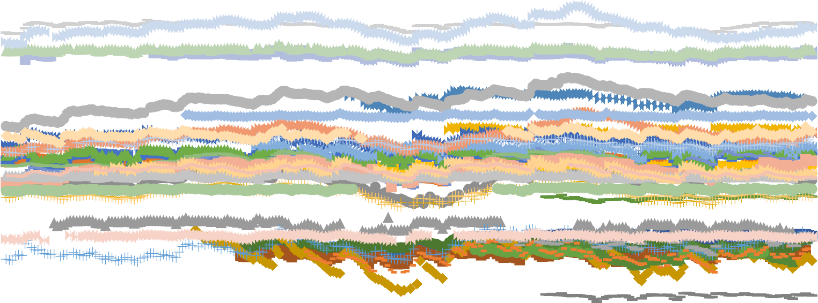

140

120

100

**Stage (ft NGVD29)**

80

60

40

20

0

1990 1991 1992 1993 1994 1995 1996 1997 1998 1999 2000 2001 2002 2003 2004 2005 2006 2007 2008 2009 2010 2011

Walker Ranch ‐ WR11 Walker Ranch ‐ WR6 Walker Ranch ‐ WR9 Tibet Butler ‐ TB2 Lake Gem Long Lake Unnamed Cypress Unnamed Wetland Boggy Marsh Hopkins Prairie Lake Avalon Lake Apshawa Island Lake ‐ 2774 Lake Louisa City of Cocoa, Well 9T

Green Swamp 7 Lake Garfield Cypress Creek #199, W17 Cypress Creek #190 "E" Marsh Cypress Creek #223 "B" W46 Cypress Creek #221, W33 Green Swamp Marsh #304 Green Swamp #6, #303 Green Swamp #5, #302 Green Swamp #1, #298 Lake Wales Crooked Lake Church Lake Johns Lake Trout Lake

Lake Annie Big Gum Lake Bonnet Lake Buck Lake (Highlands) Gator Lake Leonore (Partick) Parks Lake Lake Placid Polecat Lake Lake Streety Surveyors Lake Lake Van Lake Walker Lake Apthorpe

**Figure G‐2. Hydrographs of site stage records ‐data are shown for full periods‐of‐record for each site.**

**Figures G‐3 and G‐4** depict the stage level records of selected water bodies representative of typical water level trends in this region. Data shown include the monthly average stage elevation, the wetland edge elevation, and the P05, P50 and P90 stage elevations.

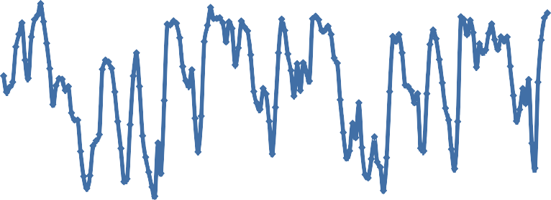

70

69

68

67

66

65

64

63

62

61

60

Walker Ranch ‐ WR11

WE P05 P50 P90

**Year**

**Stage (Feet Relative to NGVD29)**

**Figure G‐3. Walker Ranch WR 11 period of record: an example of plains wetland water level trends. Vertical line delineates start of six‐year data analysis period.**

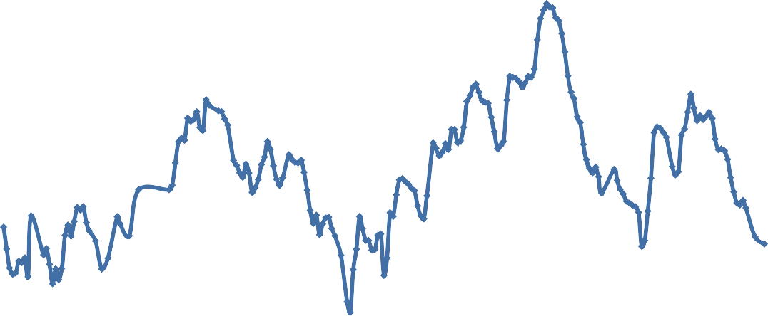

30

29

28

27

26

25

24

23

22

21

20

**Year**

**Stage (Feet Relative to NGVD29)**

1990

1991

1992

1993

1994

1995

1996

1997

1998

1999

2000

2001

2002

2003

2004

2005

2006

2007

2008

2009

2010

2011

|  |  |  |  |  |  |  |  |  |  |  |  |  |  |  |  |  |  |  |  |  |  |
| --- | --- | --- | --- | --- | --- | --- | --- | --- | --- | --- | --- | --- | --- | --- | --- | --- | --- | --- | --- | --- | --- |
|  |  |  |  |  |  |  |  |  |  |  |  |  |  |  |  | |  |  |  |  |  |
|  |  |  |  |  |  |  |  |  |  |  |  |  |  |  |  | |  |  |  |  |  |
|  |  |  |  |  |  |  |  |  |  |  |  |  |  |  |  | |  |  |  |  |  |
|  |  |  |  |  |  |  |  |  |  |  |  |  |  |  |  | |  |  |  |  |  |
|  |  |  |  |  |  |  |  |  |  |  |  |  |  |  |  | |  |  |  |  |  |
|  |  |  |  |  |  |  |  |  |  |  |  |  |  |  |  | |  |  |  |  |  |
|  |  |  |  |  |  |  |  |  |  |  |  |  |  |  |  | |  |  |  |  |  |
|  |  |  |  |  |  |  |  |  |  |  |  |  |  |  |  | |  |  |  |  |  |
|  |  |  |  |  |  |  |  |  |  |  |  |  |  |  |  | |  |  |  |  |  |
|  |  |  |  |  |  |  |  |  |  |  | Hopkins Prairie WE  P05 P50 P90 | | | | |  |  |  |  |  |  |
|  |  |  |  |  |  |  |  |  |  |  |  |  |  |  |  |  |
|  |  |  |  |  |  |  |  |  |  |  |  |  |  |  |  |  |

**Figure G‐4. Hopkins Prairie period of record 1990 through 2011: an example of ridge wetlands water level trends. Vertical line delineates start of data analysis period.**

1990

1991

1992

1993

1994

1995

1996

1997

1998

1999

2000

2001

2002

2003

2004

2005

2006

2007

2008

2009

2010

2011

As an unstressed wetland in an undeveloped reserve, with no apparent hydrologic alteration, Walker Ranch WR 11 illustrates the annual cycle of water level variation for a plains type system, with a

generally consistent return to the wetland edge elevation during wet months and years in association with typical seasonal rainfall variation. The ridge type hydrograph is illustrated by Hopkins Prairie, with a greater long‐term water level fluctuation range (>8 ft) than the plains (~5 ft), and an inter‐annual range in water levels that achieves the wetland edge elevation much less frequently. The beginning of the six‐ year period of data used for comparison of site water level analysis is shown as a vertical line. The CFDs for Walker Ranch 11 and Hopkins Prairie are provided in **Figures G‐5 and G‐6**.

70

68

66

64

62

60

0

10

20

30

40

50

60

70

80

90

100

**Percent of Time Stage is Exceeded**

**Stage (Feet Relative to NGVD29)**

|  |  |  |  |  |  |  |  |  |  |  |  |
| --- | --- | --- | --- | --- | --- | --- | --- | --- | --- | --- | --- |
|  |  |  |  |  |  | |  |  |  | |  |
|  |  |  |  |  |  | |  |  |  | |  |
|  |  |  |  |  |  | |  |  |  | |  |
|  |  |  |  |  |  | |  |  |  | |  |
|  |  |  |  |  |  | Walker Ranch ‐ WR11 WE  P05 P50 P90 | | | |  |  |
|  |  |  |  |  |  |  |  |

**Figure G‐5. Cumulative frequency distribution for Walker Ranch 11, Six‐year data analysis period . Wetland edge = WE.**

30

29

28

27

26

25

24

23

22

21

20

0

10

20

30

40

50

60

70

80

90

100

**Percent of Time Stage is Exceeded**

**Stage (Feet Relative to NGVD29)**

|  |  |  |  |  |  |  |  |  |  |  |  |
| --- | --- | --- | --- | --- | --- | --- | --- | --- | --- | --- | --- |
|  |  |  |  |  |  | |  |  |  | |  |
|  |  |  |  |  |  | |  |  |  | |  |
|  |  |  |  |  |  | |  |  |  | |  |
|  |  |  |  |  |  | |  |  |  | |  |
|  |  |  |  |  |  | |  |  |  | |  |
|  |  |  |  |  |  | |  |  |  | |  |
|  |  |  |  |  |  | |  |  |  | |  |
|  |  |  |  |  |  | |  |  |  | |  |
|  |  |  |  |  |  | Hopkins Prairie WE  P05 P50 P90 | | | |  |  |
|  |  |  |  |  |  |  |  |
|  |  |  |  |  |  |  |  |
|  |  |  |  |  |  |  |  |

**Figure G‐6. Cumulative frequency distribution for Hopkins Prairie, six‐year data analysis period. Wetland edge = WE.**

**Cumulative Frequency Distribution of Water Levels**

Separate CFDs of water levels were prepared for all water bodies and categorized in the ridge and plains physiographic settings to account for regional variation in soils, elevations, and hydrologic characteristics of these settings. **Figures G‐7 and G‐8** represent the CFDs for unstressed and stressed plains sites, respectively, and include average values for each percentile. The average P10, P50 and P80 for unstressed plains systems are 0.3, 1.3 and 2.7 feet below wetland edge, respectively. For stressed plains systems, the average P10, P50 and P80 values are 2.6, 3.9, and 5.1 feet below the wetland edge, respectively.

**Stage Relative to WE (ft)**

**Figure G‐7. Unstressed plains physiographic region cumulative frequency distributions. WE = wetland edge; six‐year data analysis period 2006 through 2011.**

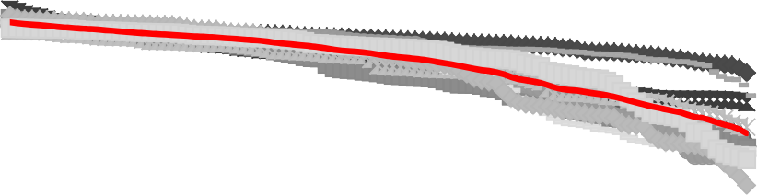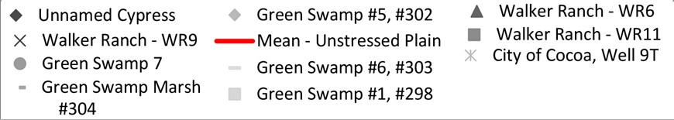

2

0

‐2

‐4

‐6

‐8

‐10

‐12

0

20

**Percent of Time Stage is Exceeded**

40

60

80

100

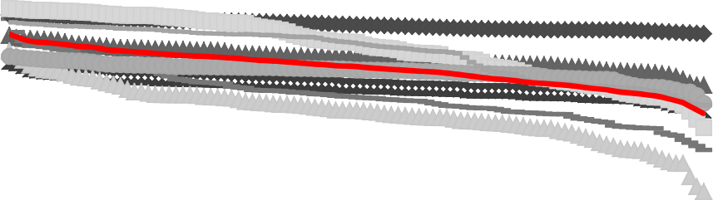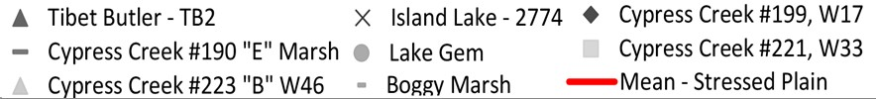

5

0

‐5

‐10

‐15

‐20

0

20

**Percent of Time Stage is Exceeded**

40

60

80

100

**Stage Relative to WE (ft)**

**Figure G‐8. Stressed plains physiographic region cumulative frequency distribution. Wetland edge = WE; Six year data analysis period 2006 through 2011.**

**Figures G‐9 and G‐10** present similar summaries for the ridge category. The average P10, P50 and P80 for unstressed ridge systems are 1.4, 2.7 and 3.4 feet below the wetland edge, respectively. For stressed ridge systems, the average P10, P50 and P80 values are 3.2, 6.1 and 7.4 feet below the wetland edge, respectively. A wide range of variation is apparent around both means across all percentile exceedance values within plains and ridge categories and for stressed and unstressed classes. This difference is

**Stage Relative to WE (ft)**

**Figure G‐9. Unstressed ridge physiographic region cumulative frequency distributions. Wetland edge = WE; six‐year data analysis period 2006 through 2011..**

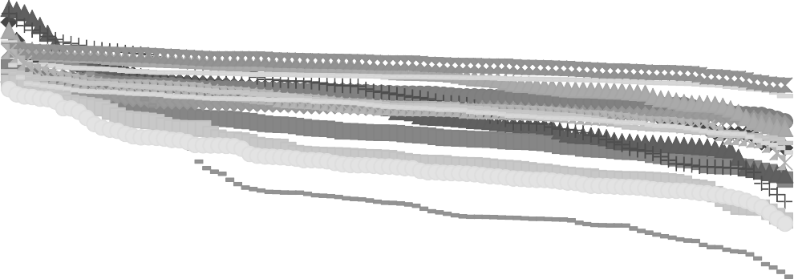

2

0

‐2

‐4

‐6

‐8

‐10

‐12

0

20

40

60

80

100

Lake Streety

Lake Apthorpe Trout Lake

Buck Lake (Highlands) Lake Van

Mean ‐ Unstressed Ridge

**Percent of Time Stage is Exceeded**

Lake Garfield Bonnet Lake Gator Lake

Lake Leonore (Partick) Lake Placid

Hopkins Prairie

Johns Lake Lake Annie Parks Lake Surveyors Lake

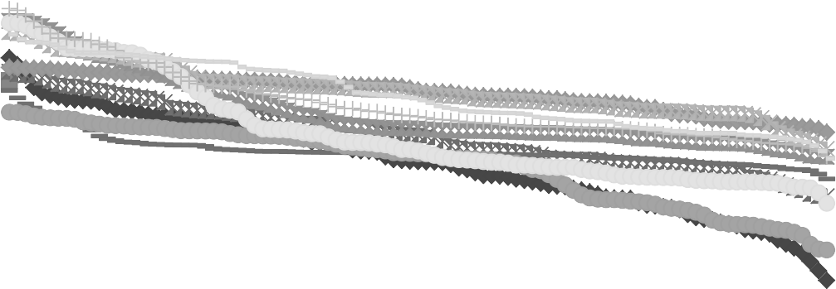

5

0

‐5

‐10

‐15

‐20

0

10

20

30

40

50

60

70

80

90

100

**Percent of Time Stage is Exceeded**

**Stage Relative to WE (ft)**

|  |  |  |  |  |  |  |  |  |  |
| --- | --- | --- | --- | --- | --- | --- | --- | --- | --- |
|  |  |  |  |  |  |  |  |  |  |
|  |  |  |  |  |  |  |  |  |  |
|  |
|  |  |  |  |  |  |  |  |  |  |
|  |  |  |  |  |  |  |  |  |  |
|  |  |  |  |  |  |  |  |  |  |

|  |  |  |
| --- | --- | --- |
| Long Lake | Lake Walker | Unnamed Wetland |
| Polecat Lake | Church Lake | Lake Avalon |
| Lake Apshawa | Lake Louisa | Lake Wales |
| Crooked Lake | Big Gum Lake | Mean ‐ Stressed Ridge |

**Figure G‐10. Stressed ridge physiographic region cumulative frequency distributions. Wetland edge = WE; Six‐year data analysis period 2006 through 2011.**

attributed to natural variation in wetland type, surface catchment, wetland topographic shape (stage vs. storage volume), and underlying soil and hydrogeologic characteristics, and to the extent of artificial modification. To show the general trend in cumulative water elevations relative to the wetland edge by percentile, mean cumulative frequency distributions for the stressed and unstressed sites are presented in **Figures G‐11 and G‐12,** respectively.

0

‐2

‐4

‐6

‐8

‐10

‐12

0

20

40

60

80

100

**Percent of Time Stage is Exceeded**

Mean ‐ Unstressed Plain

Mean ‐ Stressed Plain

**Stage Relative to WE (ft)**

**Figure G‐11. Plains wetlands average cumulative frequency distributions for stressed and unstressed wetlands. Wetland edge = WE. Six‐year data analysis period, 2006 through 2011.**

0

‐2

‐4

‐6

‐8

‐10

‐12

0

20

40

60

80

100

**Percent of Time Stage is Exceeded**

Mean ‐ Unstressed Ridge

Mean ‐ Stressed Ridge

**Stage Relative to WE (ft)**

**Figure G‐12. Ridge wetlands average cumulative frequency distribution for stressed and unstressed wetlands. Wetland edge**

**= WE. Six‐year data analysis period, 2006 through 2011.**

#### Summary

The availability of long‐term data sets on wetlands and lakes within the region, coupled with site‐specific determination of wetland edge elevations, allowed a preliminary assessment of water elevation ranges associated with hydrologic stress to wetlands and lakes in the CFWI.

Hydrologic records and wetland edge values were assembled for a total of 50 wetlands and lakes. Through analysis and refinement of the data set by the EMT, the final number of lakes and wetlands assessed totaled 44. Of these, 26 lakes and wetlands were categorized as ridge and 18 as plains. While similar data sets from more sites would yield greater information, this sample size was deemed sufficient to establish preliminary relationships for testing and evaluation, within the constraints of time and resources.

Plains and ridge sites differ in that plains‐type system exhibit a consistent range and return frequency in water levels that differ from the ridge systems, which appear to have a decadal or greater water level fluctuation influenced by tropical storm‐related precipitation.

Through discussion and data analysis by EMT members, P80 percentile values were considered to be most appropriate for characterizing wetland stress for both plains and ridge systems. Based on findings summarized in Attachment E, the P80 was found to be better predictor of stress than P50 and a water level elevation frequently encountered during typical water years, even during relatively brief PORs. A data analysis period comprising the final 6 years of available data was selected for formal characterization of the P80 criterion and risk‐based analysis reported elsewhere in this report.

The P80 water level values for plains wetlands averaged 2.7 ft and 5.1 ft below wetland edge for unstressed and stressed sites, respectively. Similarly, values of P80 averaged 3.4 ft and 7.4 ft below wetland edge for unstressed and stressed ridge wetlands, respectively. Considerable variation was observed around these central tendencies. Lower 95% confidence intervals of the population of unstressed wetlands overlapped with upper 95% confidence intervals of stressed wetlands for both plains and ridge categories. As described elsewhere in this report, categorization of probable stress response in wetlands due to altered water levels must be evaluated on a probabilistic basis, given the extent of overlap between the stressed and unstressed populations.

Exceptions were noted during all attempts at categorizing lakes and wetlands into discrete groups, and there will always be a need to evaluate individual water bodies for sensitivity to hydrologic alteration. However, collectively, these values and general findings appear suitable to use in establishing a model estimator for allowable drawdown in surface systems, when coupled with predicted groundwater model output.

# Environmental Measures Team Final Report

*Attachment H –*

*Analysis to Determine Future Change in Wetland Stress*

*November, 2013*

Environmental Measures Team Final Report

## Attachment H ‐ Development of Probability Functions for Change in Wetland Stress Status Due to Altered Water Levels

David MacIntyre, P.E., D.WRE Parsons Brinckerhoff, Inc.

##### Introduction

This memo describes the method used to determine the probability that a wetland within the ridge and plains physiographic divisions of the CFWI might change stress status under future hydrologic conditions resulting from changes in water levels within the wetlands induced by future increases or decreases in groundwater withdrawals. A change of wetland stress status can result from changing hydrologic conditions that allow a stressed wetland to become unstressed, or (more commonly) changing hydrologic conditions that cause an unstressed wetland to become stressed.

##### Use of a Hydrologic Index for Prediction of Wetland Stress

Work done by the CFWI Environmental Measures Team showed that the probability of hydrologic stress in occurring in wetlands could be related to a hydrologic index, θ, which is defined as:

8 = ERE - P80

Where:

|  |  |  |
| --- | --- | --- |
| EWE | = | Wetland Edge Reference Elevation (ft NGVD 29); and |
| P80 | = | The water elevation that is exceeded 80% of the time (ft NGVD 29). |

The EMT sorted wetland sites into three broad classes, based on the types of information available at each site, as shown in Table H‐1.

Table H‐1. Summary of Wetland Data Class Definitions

|  |  |  |  |
| --- | --- | --- | --- |
| **Wetland Data Class** | **Data Class Characteristics** | | |
| **Wetland Type** | **Current Stress Condition** | **Water Level Hydrograph** |
| Class 1 | Known | Known | Known |
| Class 2 | Known | Known | Unknown |
| Class 3 | Known | Unknown | Unknown |

The EMT identified 44 wetland locations with recent stress status evaluations and sufficient water level data available to calculate a P80 water elevation based on water levels for the period 2006 through 2001. While a longer period of record would have been preferred, we were constrained by the need to find a consistent period in order to calculate consistent P80 values for as many sites as possible. This 6‐year period was chosen as the best compromise between longer records on fewer sites vs. shorter records on more numerous sites. These sites were referred to as Class 1 wetland sites, and the methods used to

determine edge reference elevations for the sites are presented in Attachment D. The sites were divided into two types based on their hydro‐biological characteristics: plains wetlands and ridge wetlands. For each type, the statistical distribution of the hydrologic index, θ, was assessed separately for stressed and unstressed wetland systems. The number of wetlands in each subclass and the calculated means and standard deviations of the θ values in each subclass are summarized in Table H‐2.

Table H‐2. Summary of Class 1 Wetland Hydrologic Index Statistics

|  |  |  |
| --- | --- | --- |
|  | **Unstressed Wetlands** | **Stressed Wetlands** |
| **Plains Wetlands** | Number of wetlands = 10 Mean value of θ = 2.82 ft. Standard deviation of θ = 1.01 ft. | Number of wetlands = 8 Mean value of θ = 5.08 ft.  Standard deviation of θ = 1.94 ft. |
| **Ridge Wetlands** | Number of wetlands = 15 Mean value of θ = 3.42 ft. Standard deviation of θ = 1.57 ft. | Number of wetlands = 11 Mean value of θ = 7.86 ft. Standard deviation of θ = 2.55 ft. |

It was shown that the θ value distributions were all reasonably approximated by the normal distribution, and the fitted normal distribution probability density functions are shown in Figures H‐1 through H‐4.

0.45

|  |  |  |  |  |  |
| --- | --- | --- | --- | --- | --- |
|  |  |  |  |  |  |
|  |  |  |  |  |  |
|  |  |  |  |  |  |
|  |  |  |  |  |  |
|  |  |  |  |  |  |
|  |  |  |  |  |  |
|  |  |  |  |  |  |
|  |  |  |  |  |  |
|  |  |  |  |  |  |

0.40

0.35

0.30

**Probability Density**

0.25

0.20

0.15

0.10

0.05

0.00

‐15 ‐10 ‐5 0 5 10 15

**Initial Value of θ (ft)**

**Figure H‐1. Unstressed plains wetlands probability density function, pu**

0.30

|  |  |  |  |  |  |
| --- | --- | --- | --- | --- | --- |
|  |  |  |  |  |  |
|  |  |  |  |  |  |
|  |  |  |  |  |  |
|  |  |  |  |  |  |
|  |  |  |  |  |  |
|  |  |  |  |  |  |

0.25

0.20

**Probability Density**

0.15

0.10

0.05

0.00

‐15 ‐10 ‐5 0 5 10 15

**Initial Value of θ (ft)**

**Figure H-2. Unstressed ridge wetlands probability density function, pu**

0.25

|  |  |  |  |  |  |
| --- | --- | --- | --- | --- | --- |
|  |  |  |  |  |  |
|  |  |  |  |  |  |
|  |  |  |  |  |  |
|  |  |  |  |  |  |
|  |  |  |  |  |  |

0.20

0.15

**Probability Density**

0.10

0.05

0.00

‐15 ‐10 ‐5 0 5 10 15

**Initial Value of θ (ft)**

**Figure H-3. Stressed plains wetlands probability density function, ps**

0.18

|  |  |  |  |  |  |
| --- | --- | --- | --- | --- | --- |
|  |  |  |  |  |  |
|  |  |  |  |  |  |
|  |  |  |  |  |  |
|  |  |  |  |  |  |
|  |  |  |  |  |  |
|  |  |  |  |  |  |
|  |  |  |  |  |  |
|  |  |  |  |  |  |
|  |  |  |  |  |  |

0.16

0.14

0.12

**Probability Density**

0.10

0.08

0.06

0.04

0.02

0.00

‐15 ‐10 ‐5 0 5 10 15

**Initial Value of θ (ft)**

**Figure H-4. Stressed ridge wetlands probability density function, ps**

Using the data from the Class 2 wetlands as a random sample of the relative frequency of occurrence of unstressed and stressed wetland sites. In the field assessment of wetland systems, wetlands were noted as “significantly hydrologically altered” (SHA) if there were obvious alterations that would significantly alter the hydrology that originally gave rise to the wetland system. It was observed that the designation of SHA appeared to have little impact on occurrence of stress in the isolated ridge wetlands, and that the hydroperiod of these systems were generally thought to be more susceptible to groundwater alterations than to the observed surface water alterations, therefore the SHA ridge wetlands were analyzed in the same manner as non‐SHA ridge wetlands. In the plains wetland systems it was observed that the designation of SHA was very strongly correlated with stress in wetlands (94% of SHA plains wetlands were stressed, compared to 18% of non‐SHA plains wetlands). Assessment of the hydrology of these systems also suggests that their water levels are dominated by surface water effects, and that it is not possible to accurately assess the effects of moderate changes in groundwater elevations on surface water levels in these wetland systems. Therefore SHA plains wetland systems were excluded from the analysis.

After removal of the SHA Plains wetlands, the relative occurrence of stressed and unstressed wetlands in the Class 2 data for the CFWI area is summarized in Table H‐ 3.

**Table H‐3. Summary of Frequency of Stressed and Unstressed Wetlands in CFWI Class 2 Wetland Data Set**

|  |  |  |  |  |  |
| --- | --- | --- | --- | --- | --- |
| **Wetland Type** | **Not Stressed** | **Stressed** |  | **Not Stressed** | **Stressed** |
| Plains (non‐SHA) | 42 | 9 |  | 82% | 18% |
| Ridge (All) | 43 | 28 |  | 61% | 39% |

##### Development of Stress Probability functions for Wetlands with Known Initial Conditions

Using the data from Tables H‐1 & H‐2, a series of curves was developed to show the probability of causing unstressed plains wetlands to become stressed due to a change in the hydrologic index, θ. Probability of stress is shown as a function of the initial value of θ and of Δθ, the amount of future change in the value of θ. The function for probability of inducing stress in an initially unstressed wetland is represented as ζu‐

s. The ζu‐s probability curves for negative values of Δθ (future water levels higher than current water levels) are shown in **Figures H‐5 and H‐6**, while the ζu‐s probability curves for positive values of Δθ (future water levels lower than current water levels) are shown in **Figure H‐7 and H‐8**.

**1**

**Probability of Initially Unstressed Wetland**

**Becoming Stressed, ζu‐s**

**0.9**

**0.8**

**0.7**

**0.6**

**0.5**

**0.4**

**0.3**

**0.2**

**0.1**

**0**

#### Unstressed Plains Wetlands

**Probability of Becoming Stressed for Multiple Negative Values of Δθ**

|  |  |  |  |  |  |
| --- | --- | --- | --- | --- | --- |
|  |  |  |  |  |  |
|  |  |  |  |  |  |
|  |  |  |  |  |  |
|  |  |  |  |  |  |
|  |  |  |  |  |  |
|  |  |  |  |  |  |
|  |  |  |  |  |  |
|  |  |  |  |  |  |
|  |  |  |  |  |  |
|  |  |  |  |  |  |

**‐15 ‐10 ‐5 0 5 10 15**

#### Initial Value of θ (ft)

**∆θ**

‐0.1

‐0.2

‐0.3

‐0.4

‐0.5

‐0.7

‐1.0

‐1.5

‐2.0

**Figure H‐5. Unstressed plains wetland probability of becoming stressed for multiple negative values of ∆θ.**

|  |  |  |  |  |  |
| --- | --- | --- | --- | --- | --- |
|  |  |  |  |  |  |
|  |  |  |  |  |  |
|  |  |  |  |  |  |
|  |  |  |  |  |  |
|  |  |  |  |  |  |
|  |  |  |  |  |  |
|  |  |  |  |  |  |
|  |  |  |  |  |  |
|  |  |  |  |  |  |
|  |  |  |  |  |  |

**Figure H‐6. Stressed ridge wetland probability of becoming stressed for multiple negative values of ∆θ.**

**Unstressed Ridge Wetlands**

**Probability of Becoming Stressed for Multiple Negative Values of Δθ**

**1**

**0.9**

**0.8**

**0.7**

**0.6**

**0.5**

**0.4**

**0.3**

**0.2**

**0.1**

**∆θ**

‐0.1

‐0.2

‐0.3

‐0.4

‐0.5

‐0.7

‐1.0

‐1.5

‐2.0

‐2.5

**0**

**‐15**

**‐10**

**‐5**

**0**

**Initial Value of θ (ft)**

**5**

**10**

**15**

‐3.0

**Probability of Initially Unstressed Wetland**

**Becoming Stressed, ζu‐s**

#### Unstressed Plains Wetlands

**Probability of Becoming Stressed for Multiple Positive Values of Δθ**

**100%**

**Probability of Initially Unstressed Wetland**

**Becoming Stressed, ζu‐s**

|  |  |  |  |  |  |
| --- | --- | --- | --- | --- | --- |
|  |  |  |  |  |  |
|  |  |  |  |  |  |
|  |  |  |  |  |  |
|  |  |  |  |  |  |
|  |  |  |  |  |  |
|  |  |  |  |  |  |
|  |  |  |  |  |  |
|  |  |  |  |  |  |
|  |  |  |  |  |  |
|  |  |  |  |  |  |

**90%**

**80%**

**70%**

**60%**

**50%**

**40%**

**30%**

**20%**

**10%**

**0%**

**‐15 ‐10 ‐5 0 5 10 15**

#### Initial Value of θ (ft)

**∆θ**

3.0

2.5

2.0

1.5

1.0

0.7

0.5

0.4

0.3

0.2

0.1

**Figure H-7. Unstressed plains wetlands probability of becoming stressed for multiple positive values of ∆θ.**

**1**

**Probability of Initially Unstressed Wetland**

**Becoming Stressed, ζu‐s**

**0.9**

**0.8**

**0.7**

**0.6**

**0.5**

**0.4**

**0.3**

**0.2**

**0.1**

**0**

#### Unstressed Ridge Wetlands

**Probability of Becoming Stressed for Multiple Positive Values of Δθ**

|  |  |  |  |  |  |
| --- | --- | --- | --- | --- | --- |
|  |  |  |  |  |  |
|  |  |  |  |  |  |
|  |  |  |  |  |  |
|  |  |  |  |  |  |
|  |  |  |  |  |  |
|  |  |  |  |  |  |
|  |  |  |  |  |  |
|  |  |  |  |  |  |
|  |  |  |  |  |  |
|  |  |  |  |  |  |

**‐15 ‐10 ‐5 0 5 10 15**

#### Initial Value of θ (ft)

**∆θ**

3.0

2.5

2.0

1.5

1.0

0.7

0.5

0.4

0.3

0.2

0.1

**Figure H-8. Unstressed ridge wetlands probability of becoming stressed for multiple positive values of ∆θ**

Similarly, there are curves in **Figures H‐9 through H‐12** that show the probability of (eventually) inducing recovery of an initially hydrologically stressed wetlands to an unstressed condition, for negative and positive values of Δθ, respectively. The function for probability of inducing recovery in an initially stressed wetland is represented as ζs‐u.

#### Stressed Plains Wetlands

**Probability of Becoming Unstressed for Multiple Positive Values of**

**Δθ ∆θ**

**Probability of Initially Unstressed**

**Wetland Becoming Stressed, ζs‐u**

**100%**

**90%**

**80%**

**70%**

**60%**

**50%**

**40%**

**30%**

**20%**

**10%**

**0%**

|  |  |  |  |  |  |
| --- | --- | --- | --- | --- | --- |
|  |  |  |  |  |  |
|  |  |  |  |  |  |
|  |  |  |  |  |  |
|  |  |  |  |  |  |
|  |  |  |  |  |  |
|  |  |  |  |  |  |
|  |  |  |  |  |  |
|  |  |  |  |  |  |
|  |  |  |  |  |  |
|  |  |  |  |  |  |

**‐15 ‐10 ‐5 0 5 10 15**

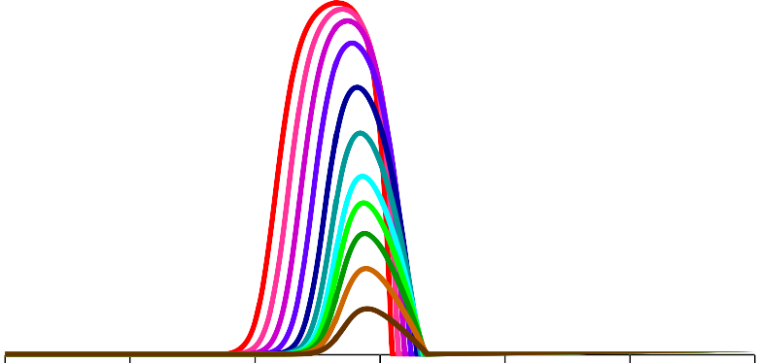

#### Initial Value of θ (ft)

3.0

2.5

2.0

1.5

1.0

0.7

0.5

0.4

0.3

0.2

**Figure H-9. Stressed plains wetlands probability of becoming unstressed for multiple negative values of ∆θ.**

#### Stressed Ridge Wetlands

**Probability of Becoming Unstressed for Multiple Positive Values of**

**Δθ ∆θ**



**Probability of Initially Unstressed**

**Wetland Becoming Stressed, ζs‐u**

**100%**

**90%**

**80%**

**70%**

**60%**

**50%**

**40%**

**30%**

**20%**

**10%**

**0%**

|  |  |  |  |  |  |
| --- | --- | --- | --- | --- | --- |
|  |  |  |  |  |  |
|  |  |  |  |  |  |
|  |  |  |  |  |  |
|  |  |  |  |  |  |
|  |  |  |  |  |  |
|  |  |  |  |  |  |
|  |  |  |  |  |  |
|  |  |  |  |  |  |
|  |  |  |  |  |  |
|  |  |  |  |  |  |

**‐15 ‐10 ‐5 0 5 10 15**

#### Initial Value of θ (ft)

3.0

2.5

2.0

1.5

1.0

0.7

0.5

0.4

0.3

0.2

**Figure H-10. Stressed ridge wetlands probability of becoming unstressed for multiple negative values of ∆θ.**

#### Stressed Plains Wetlands

**Probability of Becoming Unstressed for Multiple Negative Values of Δθ**

**Probability of Initially Unstressed**

**Wetland Becoming Stressed, ζs‐u**

**1**

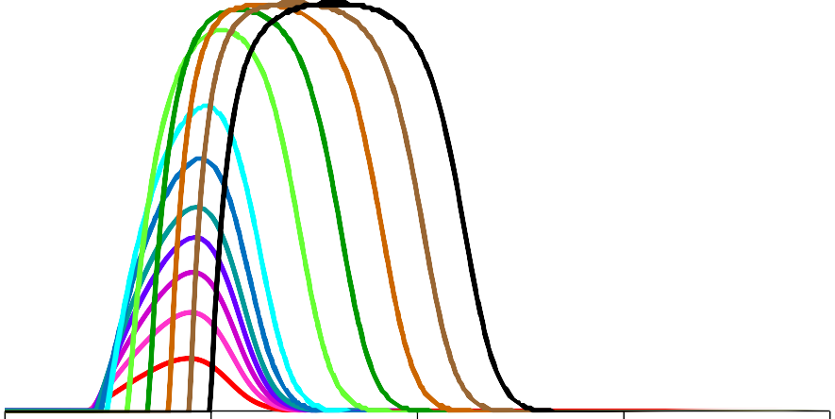

|  |  |  |  |
| --- | --- | --- | --- |
|  |  |  |  |
|  |  |  |  |
|  |  |  |  |
|  |  |  |  |
|  |  |  |  |
|  |  |  |  |
|  |  |  |  |
|  |  |  |  |
|  |  |  |  |
|  |  |  |  |

**0.9**

**0.8**

**0.7**

**0.6**

**0.5**

**0.4**

**0.3**

**0.2**

**0.1**

**0**

**0 5 10 15 20**

#### Initial Value of θ (ft)

**∆θ**

‐0.2

‐0.1

‐0.3

‐0.4

‐0.5

‐0.7

‐1.0

‐2.0

‐3.0

‐4.0

‐5.0

‐6.0

**Figure H-11. Stressed plains wetlands probability of becoming unstressed for multiple positive values of ∆θ.**

#### Stressed Ridge Wetlands

**Probability of Becoming Unstressed for Multiple Negative Values of Δθ**

**Probability of Initially Unstressed**

**Wetland Becoming Stressed, ζs‐u**

**1**

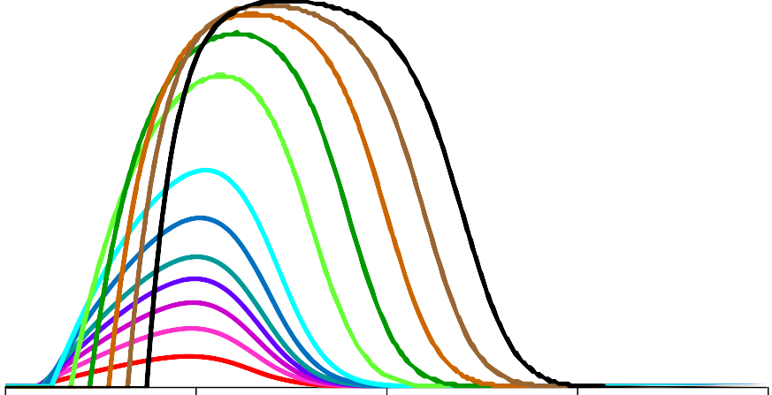

|  |  |  |  |
| --- | --- | --- | --- |
|  |  |  |  |
|  |  |  |  |
|  |  |  |  |
|  |  |  |  |
|  |  |  |  |
|  |  |  |  |
|  |  |  |  |
|  |  |  |  |
|  |  |  |  |
|  |  |  |  |

**0.9**

**0.8**

**0.7**

**0.6**

**0.5**

**0.4**

**0.3**

**0.2**

**0.1**

**0**

**0 5 10 15 20**

#### Initial Value of θ (ft)

**∆θ**

‐0.1

‐0.2

‐0.3

‐0.4

‐0.5

‐0.7

‐1.0

‐2.0

‐3.0

‐4.0

‐5.0

**Figure H-12. Stressed ridge wetlands probability of becoming unstressed for multiple positive values of ∆θ.**

Note that significant probabilities of inducing recovery are obtained by changing an initial θ value in a stressed wetland from a relatively extreme high or low value towards the mean θ value that’s characteristic of unstressed wetlands. Therefore these recovery (benefit) functions have their highest values within the range of θ values that are observed in our data set, and become numerically insignificant as we extrapolate to final condition θ values (θ2 = θ1 + Δθ) that lie outside the observed data set.

##### Development of Stress Probability functions for Wetlands with Unknown Initial Conditions

As shown in the figures above, the probability of inducing a stress change is strongly dependent on the initial stress status and the initial hydrologic condition (i.e., the initial θ value) of the wetland; this applies to both plains and ridge wetlands, and the creation of both stress and recovery. This dependency is extremely inconvenient because we don’t know these two initial condition values for the overwhelming majority of the wetlands. We are obliged to treat the problem statistically: we can calculate population‐ weighted average values of ζu‐s and ζs‐u, and can we estimate the density of initially stressed and unstressed wetlands from our survey sample of wetlands (the Class 2 wetlands). The population‐ weighted average values of ζu‐s and ζs‐u are denoted as ζ̅u‐s and ζ̅s‐u, respectively, and are calculated as:

zu-s =

f-*∞* pu (u-s d8 f*∞* p d8

*∞*

*∞*

- u

zs-u =

f-*∞* ps (s-u d8 f*∞* p d8

*∞*

*∞*

- s

These two functions allow us to calculate the average probability of inducing a stress change (creating stress or recovery) for any given value of Δθ. The resulting values of ζ̅u‐s and ζ̅s‐u for plains and ridge wetlands are shown as functions of Δθ in **Figures H‐13 and H‐14**.

110%

**Population‐Weighted Average Percentage of Unstressed Wetlands Becoming Stressed**

100%

90%

80%

70%

60%

50%

40%

30%

20%

10%

0%

#### Population‐Weighted Zu‐s for Unstressed Class 2 & Class 3 Wetlands

|  |  |  |  |  |  |  |  |  |  |  |  |  |  |  |  |  |  |  |  |  |  |
| --- | --- | --- | --- | --- | --- | --- | --- | --- | --- | --- | --- | --- | --- | --- | --- | --- | --- | --- | --- | --- | --- |
|  |  |  |  |  |  |  |  |  |  |  |  |  |  | |  |  |  |  |  | |  |
|  |  |  |  |  |  |  |  |  |  |  |  |  |  | |  |  |  |  |  | |  |
|  |  |  |  |  |  |  |  |  |  |  |  |  |  | |  |  |  |  |  | |  |
|  |  |  |  |  |  |  |  |  |  |  |  |  |  | |  |  |  |  |  | |  |
|  |  |  |  |  |  |  |  |  |  |  |  |  |  | |  |  |  |  |  | |  |
|  |  |  |  |  |  |  |  |  |  |  |  |  |  | |  |  |  |  |  | |  |
|  |  |  |  |  |  |  |  |  |  |  |  |  |  | |  |  |  |  |  | |  |
|  |  |  |  |  |  |  |  |  |  |  |  |  |  | Plains Ridge | | | | | |  |  |
|  |  |  |  |  |  |  |  |  |  |  |  |  |  |  |  |
|  |  |  |  |  |  |  |  |  |  |  |  |  |  |  |  |
|  |  |  |  |  |  |  |  |  |  |  |  |  |  | |  |  |  |  |  | |  |

‐10 ‐9 ‐8 ‐7 ‐6 ‐5 ‐4 ‐3 ‐2 ‐1 0 1 2 3 4 5 6 7 8 9 10

#### Δθ (ft)

**Figure H-13. Population‐averaged probabilities of unstressed plains and ridge wetlands becoming stressed, for use with**

**wetlands where the initial condition is unknown.**

110%

**Population‐Weighted Average Percentage of Stressed Wetlands Becoming Unstressed**

100%

90%

80%

70%

60%

50%

40%

30%

20%

10%

0%

#### Population‐Weighted Zs‐u for Stressed Class 2 & Class 3 Wetlands

Plains Ridge

‐10 ‐9 ‐8 ‐7 ‐6 ‐5 ‐4 ‐3 ‐2 ‐1 0 1 2 3 4 5 6 7 8 9 10

#### Δθ (ft)

**Figure H-14. Population‐averaged probabilities of stressed plains and ridge wetlands becoming unstressed, for use with**

**wetlands where the initial condition is unknown.**

##### Predicted Areas of Wetlands Subject to Change in Stress Status

From the ζ̅u‐s and ζ̅s‐u functions we can calculate a population‐weighted average probability of stress change at each wetland location in each cell of the ECFT model, based on the value of Δθ for that cell. **The resulting predicted probability of stress status change is extremely unreliable at any individual wetland location or group of wetland locations because the actual local probabilities of stress status change are strongly dependent on the unknown initial conditions of the wetland or group of wetlands**. The usefulness of this calculation is that the estimated **total** areas of wetlands that will undergo a stress status change can be calculated as:

n

Au-s = I [cζ̅u-s )

i

. ( ai)]

i=1

n

As-u = I [cζ̅s-u )

i

. ( ai)]

Where:

i=1

Au-s = The total area of wetland predicted to change status from unstressed to stressed; As-u = The total area of wetland predicted to change status from stressed to unstressed; i = Index counter value for wetland segments in individual ECFT model cells;

n = The total number of wetland segments in individual ECFT model cells;

cζ̅u-s ) cζ̅s-u )

i

i

= The population‐weighted value of the probability of inducing stress, calculated for wetland segment number “i” based on the predicted value of Δθ for that type of wetland in that ECFT model cell;

= The population‐weighted value of the probability of inducing recovery from stress, calculated for wetland segment “i” based on the predicted value of Δθ for that type of wetland in that ECFT model cell; and

ai = The area of wetland of specified type (plans/ridge) for wetland segment number “i”.

The value of each increment of wetland area subject to a predicted stress status change will likely bear only a weak statistical correlation to the actual area of wetland in that location for which stress will occur. However, so long as the errors in the incremental values of wetland area subject to a predicted stress status change are randomly and independently distributed with a mean value of zero, the **cumulative total** area subject to a predicted stress status change, (Au-s or As-u) should have relatively small cumulative total error because all the random local increments of error will tend to cancel each other out when summed for large values of “n”.

##### In general, the appropriate interpretation of any data generated by this process is limited to an observation that the probability of significant contribution to the total area of wetlands subject to stress status change is highest in areas with extensive zones showing higher values of predicted incremental area contributions per cell of wetlands predicted to change stress status.

From an impact management perspective, management options that will produce more favorable values of Δθ*i*, with corresponding more favorable values of ζ̅u‐s and ζ̅s‐u, across such extensive zones are likely to show a beneficial change in the predicted future total value of stressed wetland area. The smaller the total number and area of contiguous affected wetland cells, the less statistically significant the predicted

amount of change, even though individual areas per cell may be relatively large. The challenge is that **unless the total number of wetland cells and the area over which they are located is relatively large, the assumptions of randomly distributed error with zero mean cannot be justified, and the total error in the predicted wetland area subject to stress status change is likely to be relatively large**.

##### ECFT Water Level Predictor Variables for Δθ in Wetlands

The value of Δθ for a wetland is the change of θ from some initial condition 1 to some other future condition 2. Since θ = EWE – P80, and EWE is a constant value that remains the same for any given wetland, it follows that Δθ = ΔP80. In order to predict a Δθ value, we need to be able to predict a ΔP80 water level value for the specified wetland.

**Plains Wetlands.** We have previously discussed that for plains wetlands, independent review of hydrologic conditions and review of the ECFT model results both lead us to a conclusion that water levels in the surficial aquifer system (SAS) are generally dominated more by local surface hydrology than by the influence of changes in the underlying Upper Floridan Aquifer (UFA) potentiometric elevation. Therefore our best predictor of long term groundwater‐induced changes in plains wetland water levels is the predicted change in SAS water tables at the location of the wetland. Consequently, our best current predictor for Δθ in wetlands resulting from groundwater alterations is the ΔP80 water level from reference condition to future condition calculated for the SAS water table in ECFT model cells that contain plains wetland segments.

**Ridge Wetlands.** We have previously speculated that for ridge wetland systems, the localized leakance heterogeneity in the ridge areas might make the potentiometric surface of the UFA a better predictor of long term changes in ridge wetland water levels than the SAS water table. For that reason, results for ridge wetlands are best represented in the form of two alternative assessments of the future predicted areas of stressed ridge wetlands:

1. An extreme worst case based on the assumption that all ridge wetlands are so leaky that their P80 water levels will move on a 1:1 basis with P80 potentiometric levels in the underlying UFA; and
2. A possibly under‐conservative case based on the assumption that all ridge wetland P80 water levels will move on a 1:1 basis with P80 water table levels in the underlying SAS.

Initially, it was anticipated that option 1 above, incorporating some average scaling factor, C, would be the best option; where Δθ = ΔP80[ridge wetland] = C. ΔP80[UFA] and C < 1. On further consideration, it was noted that the SAS water levels used for calibration of the ECFT model in ridge areas tend to be dominated by known lake levels and observations from wells ad piezometers that tend to be close to wetlands or water bodies, i.e. in locations where data is most available. Because of this distribution of calibration targets, I suspect that calibrated leakance values in the ridge may be dominated by water levels that are more characteristic of the areas close to lakes and wetlands, and less characteristic of the zones furthest from these features. If so, response of the SAS water levels in the ridge areas of the ECFT model may be a better fit to the leakier depressional areas than was originally anticipated.

On this basis, we suspect that overall, the predicted future areas of stressed wetlands in the ridge areas, based on changes in the SAS water levels, are probably closer to reality than those based on UFA potentiometric elevations. The assumption of a universal 1:1 correspondence between wetland Δθ values and ΔP80 potentiometric elevations in the UFA (no scaling factor) seems likely to yield overly conservative estimates.